Biology from Hawaii Name
2014

Speciation Game

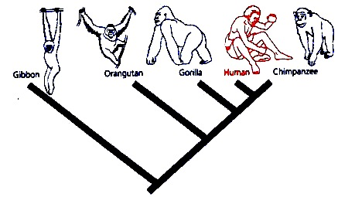Introduction
Cladograms show the history of evolution. One ancestral species evolves into many descendant species. Every time a branch forks, one species became two; this is called speciation. But how can one species split and evolve into two different species?

Procedure
Students act as moths with only one thing on their minds: reproduction!
1. Each student randomly chooses 2 checkers to represent their genes.
Red–Red = moist belly that absorbs oxygen from water; survives flash floods
Red–Black = dry, scaly belly; dies in both flash flood and droughts
Black–Black = dry, solid belly that is completely waterproof; survives droughts
2. Count and record the initial number of red and black checkers in the class. Calculate the proportion of red checkers (#red/total).
3. Genes are secret. Keep the checkers hidden in your palms.
4. Roam around the classroom to find a mate.
5. When moths meet and want to reproduce, they each trade one checker. Pick a hand.
6. After trading, you become the new, baby moth. Continue reproducing, keep your genes alive!
7. Round I: a large, diverse island. Roam around the entire classroom as a single population. Mate with any other moth. Periodically, flash floods or droughts will kill moths in different areas of the classroom.
8. Round II: two small islands. Divide the class into two isolated populations. One population will reproduce on a wet island with periodic flash floods. The other population will reproduce on a dry island with periodic droughts.
9. Count and record the final number of red and black checkers in each population. Calculate the proportion of red checkers (#red/total).

Results
Graph 1: single large population
1.0

0.5

0.0
Round I: record and graph change in the proportion of red checkers (#red/total)

Initial proportion of red checkers

Final proportion of red checkers

Graph 2: two isolated populations
1.0

0.5

0.0
Round II: record and graph change in the proportion of red checkers (#red/total)

Initial proportion of red checkers

Final proportion of red checkers

Discussion
1. Describe the importance of isolation in making new species. Use Hawaii as an example.

Grading | points worth | points earned
Participation  actively circulate and trade checkers  keep genes (checkers) hidden from view  honestly capitulate when disaster strikes | 1
Results  accurately record the various proportions of red checkers  bar graph includes axis labels | 2
Discussion  thoughtful answers use vocabulary from the class/reading | 2
Total | 5

