AP Biology Standard Deviation Practice worksheet
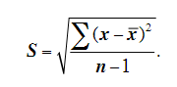
1. The formula for the standard deviation, S(SD), is on the right: Identify what each of the following parts of the formula mean by explaining it in words.
(a) n
(b) x
(c) ∑
(d) A name for the quantity n –1 is

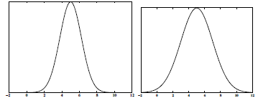
2. Consider the two figures. Each shows a distribution of data with a mean, x, of 5. Which has a bigger standard deviation and why?

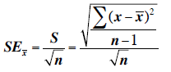
The formula for the standard error is:

3. You have three data sets with the same standard deviation, S = 3.298. Data Set 1 has ten observations in it (n=10), Data Set 2 has twenty (n=20), and Data Set 3 has fifty observations in it (n=50). For each of these calculate the standard error.

Data Set 1: __________ Data Set 2: ____________ Data Set 3: ____________

4. Explain how the standard error changes when the sample size changes (but the standard deviation stays the same). Then, explain how the formula for the standard error justifies this change.

5. You and your lab partner record the following counts of stomata in sunflower leaves.

Sunflower Plant | 1 | 2 | 3 | 4 | 5 | 6
Stomata (per examination area) | 88 | 93 | 90 | 92 | 75 | 78

(a) Calculate the standard deviation of the number of stomata for the sunflower leaves.

(b) Calculate the standard error in the number of stomata for the sunflower leaves.
6. Three classes study when fruit fly populations choose Food A over Food B. Each pair of partners in the classes record the number of times that Food A is chosen in preference to Food B in a total of 25 trials. The data from each pair for the three classes is shown below. Use the data to answer the questions below.

 | Group 1 | Group 2 | Group 3 | Group 4 | Group 5 | Group 6 | Group 7 | Group 8
Class 1 | 12 | 16 | 11 | 11 | 13 | 14 | 12 | 15
Class 2 | 10 | 9 | 18 | 8 | 16 | 18 | 13 | 12
Class 3 | 4 | 19 | 6 | 20 | 12 | 13 | 23 | 7

(a) Based on the data that is given, which do you expect to have a bigger standard deviation? Which do you expect to have the smallest standard deviation? Explain your answer.

(b) Find the standard deviation for each data set. If your answers do not match your predictions, make sure to go back and explain how you can predict the ranking (i.e. smallest and largest) standard deviations from the data that are given.

7. Two different AP Biology instructors compute the means and standard errors for the first exam score for their classes. The means and the SE bars are shown in the graphs below. For each of the teacher’s sets determine whether the difference between the means of the two classes is (a) definitely significantly different, (b) not significantly different, or (c) unknown based on the graph. Justify your answer.
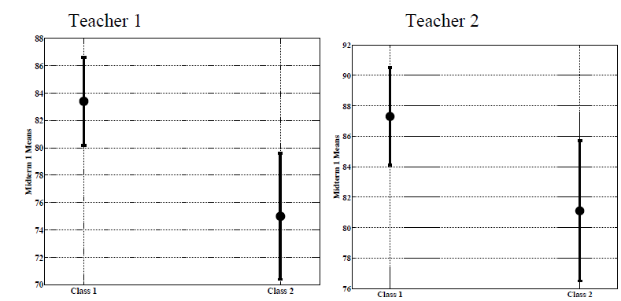
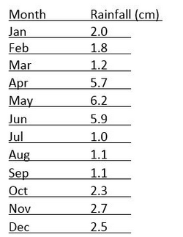
Calculate the mean and SD for the data set of annual monthly rainfall. Use the data to make a graph.
Mean =
Standard deviation =

