For front upper right hand side

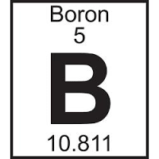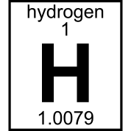

**Sulfur**

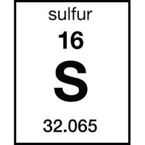

32.066

Science Olympiad Team

For back

aldwin

igh

**Sulfur**



32.066

chool