Biology from Hawaii Name
2014
Ecological Pyramids
Introduction
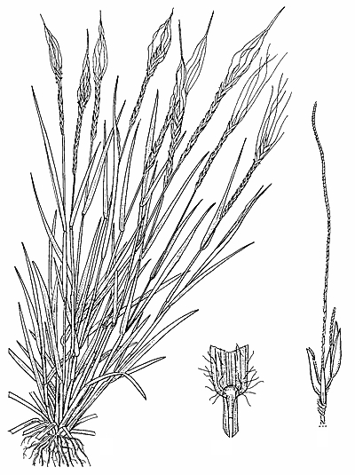
Pili grass (Heteropogon contortis)
Manana Island is suitable habitat for many species: grasses, bushes, rabbits, mice, iwa birds, ants, etc. But which species are common and which ones are rare? For example, if you wanted to collect pili grass to thatch a roof, would you be able to get a lot on Manana Island?
To answer such questions, scientists estimated the biomass of different species on Manana Island. They randomly chose 12 sample areas that could represent the rest of the island. Every living thing in the 10m x 10m areas was collected, species sorted, dried, then weighed. Multiplying to the full area of Manana Island, scientists could estimate the total biomass of each species on the entire island. The data (below) are in pounds for greatest reification.

Procedure
1. Group the Manana Island species by trophic level:
• producers (can obtain energy and raw materials from non-living things)
• primary (1°) consumers (only eat producers)
• secondary (2°) consumers (eat 1° consumers and below)
• tertiary (3°) consumers (eat 2° consumers and below)
• quaternary consumers (you get the idea)
2. Graph the total mass of each trophic level on the axes provided.
Producers

Results
1. Group these modern species by trophic level.
Scientific name | Common name | Mass (lbs)
Argemone glauca | pua kala/Hawaiian poppy | 2071  1° consumers
Boerhavia coccinea | red spiderling | 302
Cenchrus echinatus | sandspur grass | 10722
Ctenocephalides felis | cat flea (can live on rabbits) | 7
Fregata minor | ‘iwa/frigate bird | 121
Gryllodes sigillatus | cricket | 464
Heteropogon contortus | pili grass | 4190  2° consumers
Mus musculus | mouse | 451
Oryctolagus cuniculus | European rabbit | 909
Prosopis pallida | keawe/Mesquite | 1631
Solenopsis geminata | red fire ant | 49
Xenopsylla cheopis | rat flea (can live on mice) | 4

Results (continued)
2. Graph the biomass of each modern trophic level on the axes provided.

Title:
2° consumers

1° consumers

producers
0 2000 4000 6000 8000 10000 12000 14000 16000 18000 20000
Biomass (lbs)

Producers

3. Group these ancient species by trophic level.
1° consumers
Scientific name | Common name | Mass (lbs)
Argemone glauca | pua kala/Hawaiian poppy | 1937
Asio flammeus sandwicensis | pueo/Hawaiian owl | 156
Buteo solitaris | ‘io/Hawaiian hawk | 377
Ciridops anna | ‘ula‘aihawane | 2170
Eupithecia orichloris | carniverous caterpillar | 39  2° consumers
Heteropogon contortus | pili grass | 16290
Jacquemontia sandwicensis | pa‘uohi‘iaka | 10901
Pritchardia martii | loulu palm | 27851
Sida fallax | ‘ilima | 1104
Thambetochen xanion | moa nalo | 3609

4. Graph the biomass of each ancient trophic level on the axes provided.

Title:
2° consumers

1° consumers

producers
0 5000 10000 15000 20000 25000 30000 35000 40000 45000 50000
Biomass (lbs)

Discussion
1. Compare the modern and ancient trophic level graphs. Why are the same shape?

2. Compare the modern and ancient trophic level graphs. Why is the ancient graph bigger?

3. As animals eat, they take mass from a lower trophic level and add it to their own. On average, how many pounds of producers are needed to support 1 pound of primary consumer? Calculate using both modern and ancient data. Please show your work.

4. How many pounds of primary consumer are needed to support 1 pound of secondary consumer? Again, use both modern and ancient data. Please show your work.

5. During the modern era, rabbits were introduced to Manana Island for food. The hope was that humans may one day inhabit the island, but there were never enough rabbits to feed a family. Why?

6. If the family from question #5 ate plants instead of rabbits, how many pounds of humans could Manana Island support?

7. Why is being a vegetarian better for the environment than being a carnivore?

Grading | points worth | points earned
Results  group species by trophic level  clearly graph the mass in each trophic level, title the graphs | 4
Discussion  thorough answers use vocabulary from class  show work where appropriate | 6
Total | 10

