Biology from Hawaii Name
2014
Population Genetics
Introduction
The science of allele frequencies is called population genetics. A population that undergoes a large change in an allele frequency is evolving! There are 4 main ways a population evolves:
1. Natural Selection. Some individuals reproduce more than others, either by living longer, being more attractive, or producing more children per reproductive event. Repeatedly flooding the population with their alleles, successful reproducers eventually overwhelm their less fecund counterparts.
2. Migration. Immigrants bring their alleles. If these are different than their host population, then allele frequencies change. Most importantly, immigrants can bring new alleles, introducing new genetic powers to their host population. Emigrants take their alleles, again changing allele frequencies of their home population.
3. Genetic Drift. Allele frequencies randomly change a little bit every generation. However, as a population grows larger, these random changes have less and less of an effect on the overall allele frequency.
4. Mutation: the source of new alleles. The actual mutation event seldom changes allele frequencies noticeably; there is only one mutant born. However, the new allele(s) that the mutant carries can kick off major natural selection changes in allele frequencies.
If a population is not experiencing any of the above evolution, it is in genetic equilibrium. Allele frequencies will remain the same over many generations. It's the opposite of evolution. However, no population is 100% in equilibrium, as mutation and genetic drift are always present. Thus, scientists discuss how close a population is to genetic equilibrium versus how much a population is evolving.

Procedure
Check your understanding of population genetics by answering the following questions.

Results
1. Matching: correctly title each graph using the phrases in the box.

1.0

0
generation

1.0

0
generation

Natural selection

Migration

Genetic drift

1.0

0
generation

1.0

0
generation
Genetic equilibrium

2. Calculate the frequency of R¹ allele in the following population. frequency R¹ =
Genotype | Phenotype | # of Plants
RR | red flowers | 378
RR¹ | pink flowers | 1090
R¹R¹ | white flowers | 532

3. Draw populations of birds matching the given criteria. The alleles are A and a.
example: population size = 5
frequency A = 0.5

AA Aa Aa

Aa aa
a. population size = 20
frequency A = 0.2

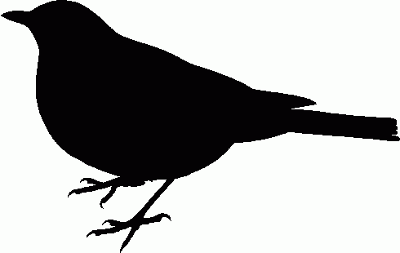
b. population size = 20
frequency A = 0.7

c. population size = 5
frequency A = 0.7

4. Timeline. Match the population drawings (above) to events on the ‘Amakihi timeline.
1750 1800 1850 1900 1950 2000
‘Amakihi populations grow to match pre-malaria levels. Birds are descended from survivors of the malaria plague.
Before avian malaria, ‘Amakihi with efficient immune systems survive best (don't waste energy producing extra antibodies).
Avian malaria is introduced, ‘Amakihi numbers plummet. Most survivors carry A allele.

