Name Date _____________ Period ___
PHOTOSYNTHESIS
Photosynthesis is divided into 2 parts- Photosynthesis I & II.

The overall chemical reaction of photosynthesis is:
An overview of Photosynthesis:
Label the parts of photosynthesis illustrated below. Write the correct terms in the spaces provided.

THE LIGHT REACTIONS take place in the of the .
Match the following steps with the term that correctly completes
each step of the light reactions. Then fill in the blanks on the
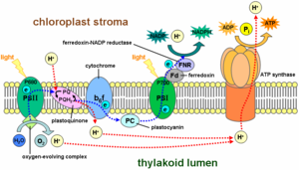
illustration at the right, for the metabolic processes that occur
inside the thylakoid membrane.
- Light is absorbed by… a.) energy- rich electrons
- Reactions center loses… b.) hydrogen carrier NADP⁺
- Electrons flow along… c.) pigment molecules
- Electrons and proteins join… d.) electron transport system
- Water is split into… e.) chemical energy
- Light energy is stored as… f.) H⁺ and O₂

THE CALVIN CYCLE The dark reactions are not QUESTIONS:
Illustrate the Calvin Cycle directly powered by the 1.) Which word equation represents the process of photosynthesis
In the space below. absorption of light energy, but by (1) carbon dioxide + water glucose + oxygen + water
byproducts of the light reactions. (2) glucose alcohol + carbon dioxide (3) maltose + water glucose + glucose
CO₂ (4) glucose + oxygen carbon dioxide + water 2.) The raw materials used by green plants for photosynthesis are
(1) oxygen and water (3) carbon dioxide and water
(2) oxygen and glucose (4) carbon dioxide and glucose
3.) An important function of chlorophyll molecules during photosynthesis
Is
- Absorbing and storing water in root cells
- Converting water into carbon dioxide
- Absorbing certain wavelengths of light energy
- Converting chemical bond energy to light energy
4.) The broad flat structure of the leaves of most plant makes them well
adapted to
- Store large quantities of starch for later use as food
- Absorb sunlight used in the photosynthesis reactions
- Support the upper portions of the plant
- Carry out the process of chemical regulation
5.) The size of stomate openings is regulated by the
Define each term below, and explain its role in photosynthesis. (1) palisade cells (3) guard cells
ATP= adenosine triphosphate (2) spongy cells (4) xylem cells
Used for: 6.) The openings on the lower surface of some leaves, which allow for the
exchange of gases, are called
NADP⁺= (1) stomates (3) lenticels
Used for: (2) guard cells (4) vascular bundles
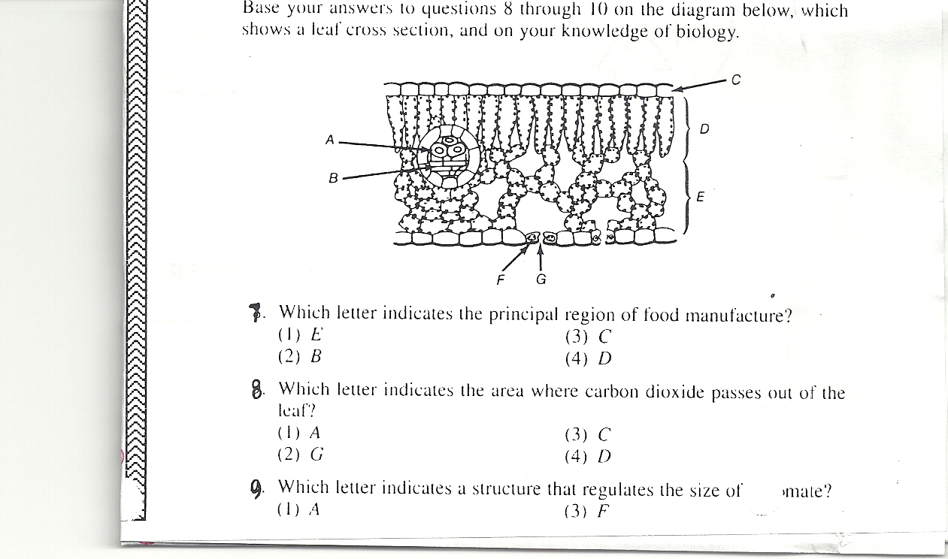

RuBP=
Used for:

G3P=
Used for:

