Cellular Respiration/Photosynthesis Project
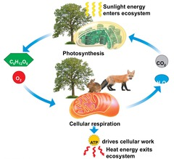
50points

Due Date:__________________________________

Your fun filled task is to create a project that shows your understanding of photosynthesis and/or cellular respiration. You may choose one of the following options for this assignment. If you have a project in mind that is not listed here, please get your teachers approval before proceeding.

Option 1: Interactive Concept Map
You can create an interactive concept map. If you need some ideas, check out Pinterest.

Option 2: Songs with Process drawing or action
You can use a cellular respiration or photosynthesis song written by someone else and show the process either by gestures/action or by drawing the process out. Youtube has many songs written by students and teachers you might want to use. Please video tape your drawing or action with music/lyric in the background.

Option 3: Original Song Lyric (i.e. rap song)
Why not write your original song or a rap? You can. Record the song and share in class. If you want to create a music video, even better.

Option 4: 3D Model
Similar to cell model project, produce a 3D project to show the process of photosynthesis or cellular respiration.

Option 5: Children Toys Box Set or Book
If you are making a children’s book or toy set, be sure that your project is age appropriate without leaving out the important content.

For all options the following must be included
Description: Describe the process including all reactants, products, and cell parts involved in the description. If you are doing a model, submit a separate description paper. (15points)
Content Accuracy: The process is accurately described and appropriate for your audience. (15 points)
Graphic and Pictures/Visual: Your project must be attractive so your audience wants to learn the process (10 points)
Sources: List websites or resources used. (5pts)
Knowledge Gained: Your classmates will determine knowledge gained after reviewing your project. (5 pts)

