Natural Selection Lab- PhET Simulation

Pre-Lab Questions
- What variables can you influence in this lab?
- Define what a genetic mutation is. How do genetic mutations happen? How often?
- What do the terms fitness and adaptation mean? What is the difference between the two?
- What selection factors might effect an animal population besides the ones used in this lab?

Designing The Experiment
In this Lab you will be controlling the mutations and environment of a population of rabbits. Your will create four hypotheses and design an experiment to test each one. Your hypothesis will follow the format where you fill in the (...) with your own ideas and reasons.

I hypothesize that (select a rabbit phenotype) rabbits will be (more/ less) likely to survive under (type of selective factor) within the (select type of environment) environment, because..... (explain how their trait will help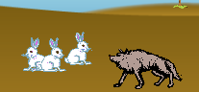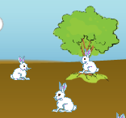 them to survive or not)

***You must make at least one hypothesis for each of the three different types of phenotype mutations***

For each experiment you must have a control (no mutation) and fill in the following chart
Experiment  and  Hypothesis | Pheno  type | Selective Factor | CONTROL  Group  Initial Population at F3 | CONTROL  Group  Final Population | Experment  Group  Initial Population at F3 | Experiment  Group  Final Population | Conclusion/  Observation
- For each of the experiments, begin by adding a friend and a mutation. Wait until the F3 generation before adding the selective factor. After adding the selective factor let the simulation run for another 3 or 4 generations.
- Use the population numbers from the chart to get you numbers for the table, remember you can zoom in and out on the chart to get more accurate reads.
- Repeat for experiments 2, 3 and 4

Post-Lab Questions
- Based upon your evidence from the simulation what conclusion are you able to make about each of the three different types of phenotypes in rabbits?
- What happens to animals that cannot compete as well with other animals in the wild?
- Sometimes animals that are introduced into an area that they never lived in before, out-compete and endanger resident species, why do you think this happens?
- If only one species is considered the "fittest", why do we still have so many variations among species. Why do some birds have very long pointy beaks, while other birds have short flat beaks?
- How do you think diseases can affect natural selection?
- How does this simulation mimic natural selection? In what ways does this simulation fail to represent the process of natural selection?

Extension- Changing the Dominance and Recessive Alleles

Take one of the experiments from the lab. Recreate the same experiment, EXCEPT when you add the mutation EDIT THE GENES by switching the dominant and recessive allele for that trait. Make a hypothesis, fill in the chart again and compare the results to your initial experiment.

Experiment  and  Hypothesis | Pheno  type | Selective Factor | CONTROL  Group  Initial Population at F3 | CONTROL  Group  Final Population | Experment  Group  Initial Population at F3 | Experiment  Group  Final Population | Conclusion/  Observation

- Did switching the alleles for dominant and recessive have any impact on the population of 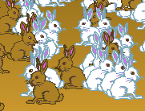rabbits? If so Why? In nothing changed Why not?
- Two parent rabbits are both heterozygous for the trait. Create Punnet squares for the original experiment and the new experiment (with the changed alleles). What are the phenotype ratios of the Punnet squares? Does this evidence support your finding? and how?
- If this new experiment were to run longer would the end result be the same or different from the original experiment?

Extension- Working with Pedigrees- Switch from the population chart to the pedigree chart

Begin by adding a friend and a mutation. Wait until the F5 generation. Copy the Pedigree for two rabbits (described below) using the key. Assume that male rabbits are on the left and female rabbits are on the right.

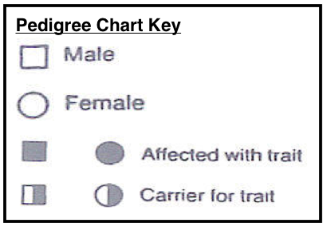

Find these two rabbits, make sure they have at least four generations:
- Select a 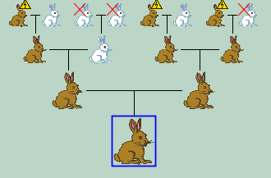rabbit that has the mutation.
- Select a rabbit without the mutation but with parents or grandparent with the mutation.

Answer the following questions:
- How could using a pedigree be helpful?
- What does it mean to have a yellow triangle above the rabbit?
- What does it mean when a rabbit has a red X over it?
- How accurate are the pedigrees used in this lab? Did each couple only have one baby?

