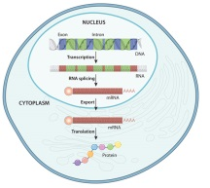
Name: ________________________

Gene Expression- the Basics

Use a search engine and search for “phet gene expression basics”, open the link, click on the green “run now” box and open the simulation.
Your are going through the basic processes of transcription and translation to produce 3 different proteins. Follow the steps below and answer the questions.
HAVE FUN EXPRESSING YOUR GENES!!
Remember, a gene is a piece of DNA that codes for a protein!!
Gene #1:

1. Examine the piece of DNA that runs across the screen. What are the 2 parts of Gene 1?

_____________________________ and ____________________________

2. Look in the biomolecule tool box on the left and grab a negative transcription factor, place it
on the DNA. If you don’t put it in the right spot; it will float off the DNA and away. Where
does the negative transcription factor stick to the DNA?
_____________________________

3. Click on the negative transcription factor and drag it back to the tool box. Click on a positive
transcription factor and put it on the DNA. Where does the positive transcription factor stick?
______________________________

4. Transcription factors are proteins that help regulate (control) the expression of a gene.
When a gene is “expressed”, a messenger RNA is made and protein synthesis begins.
Click on and drag the RNA polymerase from the biomolecule tool box and place it next to the
positive transcription factor on the DNA. Describe what happens:

5. You have just “transcribed” gene 1. What does the black squiggly line represent?
______________________________

6. Transcribe gene 1, three more times. What does the word part “trans” mean? ____________
What does the word part “script” mean? ___________________. Explain how the term
“transcription” fits with the process of making a mRNA.

7. Where in your cells does transcription take place? _____________________ In your cells,
where do the mRNA’s go after they are made? _____________________Grab a ribosome
from the tool box and get it close to one of the free floating mRNA’s.
Describe what happens:

8. What did the ribosome help make? __________________ Can you use the same mRNA
more than once? ______________ Grab 2 more ribosomes and bring each one close to the
other mRNAs that are free floating. Take each of the “proteins” and drag them into the
“protein collection box”.

9. The process of using a mRNA to make a protein is called: ________________________.
Where in your cells does this process take place? ___________________________. Grab
some of the RNA destroyers, bring them near the mRNA’s and clean up your “cytoplasm”.

10. Click over to the second gene. How is it different from gene #1? (2 ways)
a)

b)

11. Transcribe gene #2 five times and put 5 proteins in your “protein collection box”.

12. Click over to the 3rd gene. How is gene 3 different from the first two genes?

13. Transcribe gene #3, seven times and put 7 proteins in your “protein collection box”.

Show your teacher your protein collection box and have them initial your paper: _________

14. Trace the flow of information from DNA to a protein, write the names of the processes above
each arrow.

DNA (gene) mRNA protein

15. What you created above is known as “The Central Dogma of Biology”!! It is a BIG idea,
remember it!! What is a “dogma”? Use a resource to find out:

16. In the beginning of the year, we talked about biomolecules. Proteins are a type of
biomolecule. What are proteins made of ? _______________________ How many different
types of those things are there? _______________
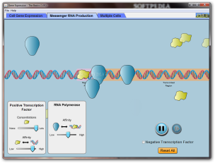
17. What is the major role or function of proteins in your body?

18. Use a resource to find out the following:
a) What is one of the smallest proteins in your body? (Begins with an “I”)
_____________________ Made up of how many amino acids? _________

b) What is the largest protein in your body? (Begins with a “T”)
_____________________ Made up of how many amino acids? ___________________
Describe the function of this protein:

