Biology from Hawaii Name
2014
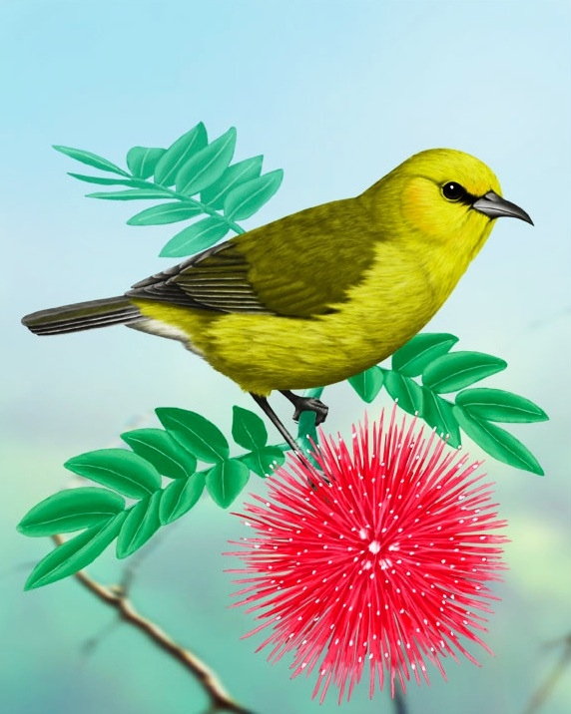Narrate a Bird Video

Introduction
The Hawaiian Islands have 113 endemic birds species, unique creatures that only exist in Hawaii. These ranged from gentle red honeycreepers to sharp-eyed predatory hawks. Today, 80% of these species are either endangered or already extinct!

None of the common birds around Honolulu are endemic to the Hawaiian Islands. Mynahs, pigeons, sparrows and many others were brought to the islands by humans. Seeing an endemic bird in nature
can be very difficult; today we will use video. You will teach your lab group about one species of native Hawaiian bird by narrating a short video.

Procedure
1. Observe some good narration. Watch 15 minutes of any episode of Life of Birds.
YouTube search: Life of Birds or http://www.youtube.com/channel/SWS3vPSi1o5nM
The narrator describes many species of birds. What facts do you find interesting? List them here:

2. Bird research
Choose one of the following species of native Hawaiian bird and obtain a video:
1. ‘Akiapola‘au 2. ‘Amakihi 3. ‘Apapane 4. I‘iwi 5. Palila
Each member of your lab group should choose a different species. Watch your video. Learn about the lifestyle of your species. HINT: use your bird's scientific name as a search term

3. Write a script
Watch your video and figure out what your bird is doing. Write a script that could include:
• Hawaiian name of your bird
• habitat (what kind of nature it likes)
• diet
• what makes this bird special
• conservation status (common, rare, endangered)
• threats to the future of this species

