**Name: ________________________ Period: ___ Date: ___________**

**Lip Prints - Cheiloscopy**

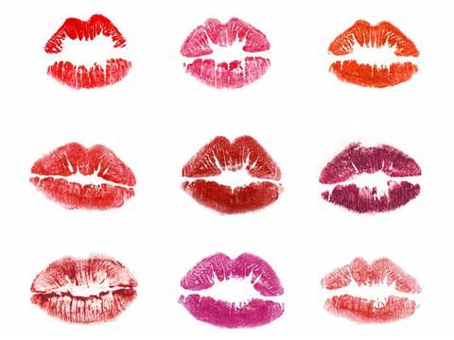

The study of lip prints is called **cheiloscopy**. A person's lip prints are unique, quite similar to fingerprints. The use of lip prints in criminal cases is limited because the credibility of lip prints has not been firmly established in our courts. Two ways of potentially using lip prints:

1. print patterns for identification

2. chromatography to match lipstick marks

My Lip Print











Classification: ___________________