1. **Purpose** – to locate, recognize the structure and functions of the organs of the dogfish shark.
2. **Materials**
3. Dissecting Tray/Pan E. Goggles
4. Dogfish Shark Preserved Specimen F. Gloves
5. Dissecting Probe G. Scissors/Scalpel
6. Forceps
7. **Pre- Lab Questions**
8. What phylum is the dogfish shark classified in? _________________
9. What class is the dogfish shark classified in? ___________________
10. How is the dogfish shark classified by body type: Acoelomate, Psuedocoelomate, or Eucoelomate? ___________________________
11. What type of symmetry does the dogfish shark have? _____________
12. Is the dogfish shark a protostome or a deuterostome? _____________
13. Name another organism that is the in the same phylum and class as the shark? ________________________
14. What is different about the skeleton of this organism compared to the skeleton of the yellow perch that was dissected previously?

________________________________________________________________________________________________________________

________________________________________________________

1. Squeeze the shark with your hand. What do you know about the shark when you squeeze it? ______________________________________
2. **Procedure**
3. **External Examination**
4. **Familiarize yourself with the following structures:**

External Nares, Spiracles, Mouth, Gill, Slits, Lateral Line, Cloaca, Clasper,

Fins, Rostrum, Dorsal Spines

1. **Label the external structures in figure 1**

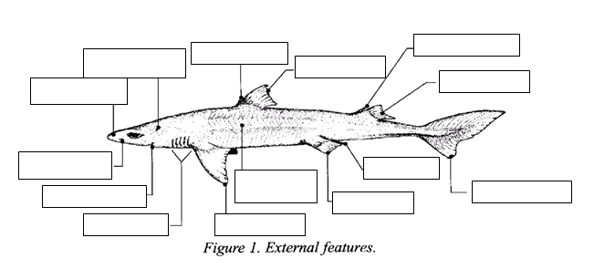

1. External Anatomy Questions
2. How is the anatomy of the gills on the shark different from the gills of the perch? _______________________________________

______________________________________________________

1. What is the function of the nares? __________________________

______________________________________________________

1. What are the structures known as spiracles on the shark? ______________________________________________________

______________________________________________________

1. Which shark organism will have a structure called a clasper, female or male? ______________________________________
2. Is your shark a male or a female? ________________________
3. What is the rostrum on the shark? ________________________

____________________________________________________

1. Is the lateral line visible on your shark? ____________________
2. How many paired fins does the shark have? _______Name them.
3. How many single fins does the shark have? _______ Name them.
4. What is the function of the gill slits of the shark? ____________________

_____________________________________________________________

1. **Dissection**

1. **Place your shark ventral side down to begin. You will need to flip the shark over after step one to complete this section.**

**2. Remove each of the dorsal spines by cutting where it meets the body. This will prevent you from stabbing yourself unintentionally.**

1. **Flip your shark over onto its back.** **Be sure to refer to figure 5 as you begin cutting into the skin.**

**4. Make a mid-ventral incision from the cloaca cranially to just below the jaw. Make your incisions shallow.**

**5. Cut around the head, around each fin, around the spircles, and around the cloaca.**

**6. From the cloaca cut dorsally around the shark – this will make a circle around the tail. Remember you are cutting through the skin only.**

**7. Using the handles of your scissors or your gloved fingers carefully peel off the skin to expose the muscles.**

**8. Compare your specimen with the figure 6 in the lab addendum.**



Figure 5

1. **Internal Examination**
2. **Familiarize yourself with the following structures:** Stomach, Liver, Spleen,

Spiral Intestine, Pancreas, Gall Bladder, and Rectum

1. **Label the internal structures in the figure on the next page.**

**E. Internal Anatomy Questions**

1. Was the shark’s skin as thick as you expected it to be? Why or why not? ___________________________________________________________

___________________________________________________________

1. What structure is the connection between the pharynx and the stomach? ___________________________________________________________
2. How many lobes does the liver of the shark have? ___________________
3. The Pancreas is divided into two parts the: ______________________ and

the _____________________________

1. What shape is the stomach of the shark? ___________________________
2. What system is the spleen of the shark in? __________________________
3. What is the duodenum of the shark? _______________________________

_____________________________________________________________

_____________________________________________________________

1. How is the shark’s digestive system different from a human’s? ___________

______________________________________________________________

______________________________________________________________

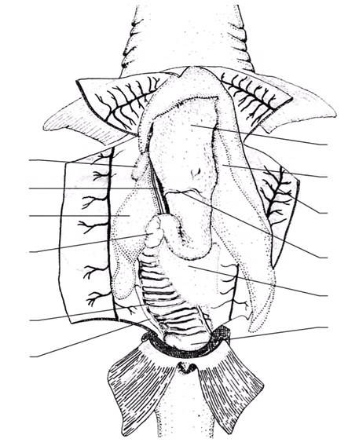

9. How is the shark’s circulatory system different from a human’s? __________

_______________________________________________________________

______________________________________________________________

10. Describe what the kidneys of the shark look like. ______________________

______________________________________________________________

_______________________________________________________________

11. What is the largest single part of the shark’s nervous system? _____________

_______________________________________________________________