H. saccophora
(sacco = bag, phora = to carry)

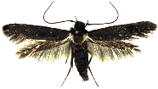

case type: cone
habitat: lives on exposed rocks, Wai‘anae volcano, O‘ahu island
diet: lichen and fungi
length: 10mm
case description: embedded with sand and pebbles, dark and rough on top, sliver and smooth underneath, has a hinged door
notes: pebbles along the top of the case resemble Stegosaurus plates

H. kahamanoa
(kaha = beside, manoa = stream on O‘ahu island)

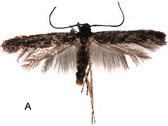

case type: cone
habitat: lives in and near streams of Ko‘olau volcano, O‘ahu island
diet: algae
length: 10mm
case description: embedded with pebbles, lichen, algae, dark and rough on top, smooth and sliver underneath, has a hinged door
notes: amphibious caterpillar that can breathe both water and air
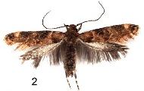H. pupumoehewa
(pupu = snail, moehewa = nightmare)

case type: cone
habitat: lives on trees, Haleakala volcano, Maui
diet: snails
length: 5mm
case description: very narrow, embedded with pebbles, lichen, and snail shells
notes: ties snails to leaves using silk, climbs into the shell and eats the snail alive

H. aumakuawai
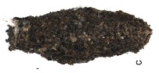(aumakua = ancestor spirit, wai = water)

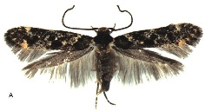

case type: burrito
habitat: lives in and near streams of east Kauai island
diet: algae
length: 7mm
case description: dark brown/gray, embedded with sand and pebbles, has a hinged door
notes: amphibious caterpillar that can breathe both water and air
H. papaiili
(papa‘i = crab, ili = bark)
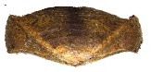

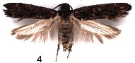

case type: crab
habitat: lives on tree bark, Haleakala volcano, Maui island
diet: lichen
length: 10mm
case description: brown color with lines that resemble wood grain, entrance at both ends
notes: very well camouflaged

H. lignivora
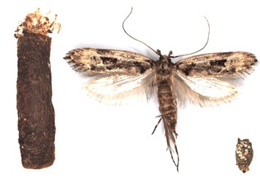(ligni = wood, vora = eater)

case type: giant purse
habitat: lives under bark of dead wood on O‘ahu island
diet: wood
length: 17mm
case description: dark brown and smooth, entrance at both ends
notes: largest Hyposmocoma species, no termites in ancient Hawaii, H. lignivora is the native wood recycler
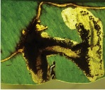E. trivitella

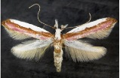

case type: does not make a chrysalis case
habitat: mines into leaves, Kauai island
diet: green tissue inside leaves
length: 3mm
notes: this species is not a Hyposmocoma, instead it is from a closely related subgenus called Euperissus

H. aumakuawai

H. kahamanoa

H. lignivora

H. papaiili

H. pupumoehewa

H. saccophora

E. trivitella

