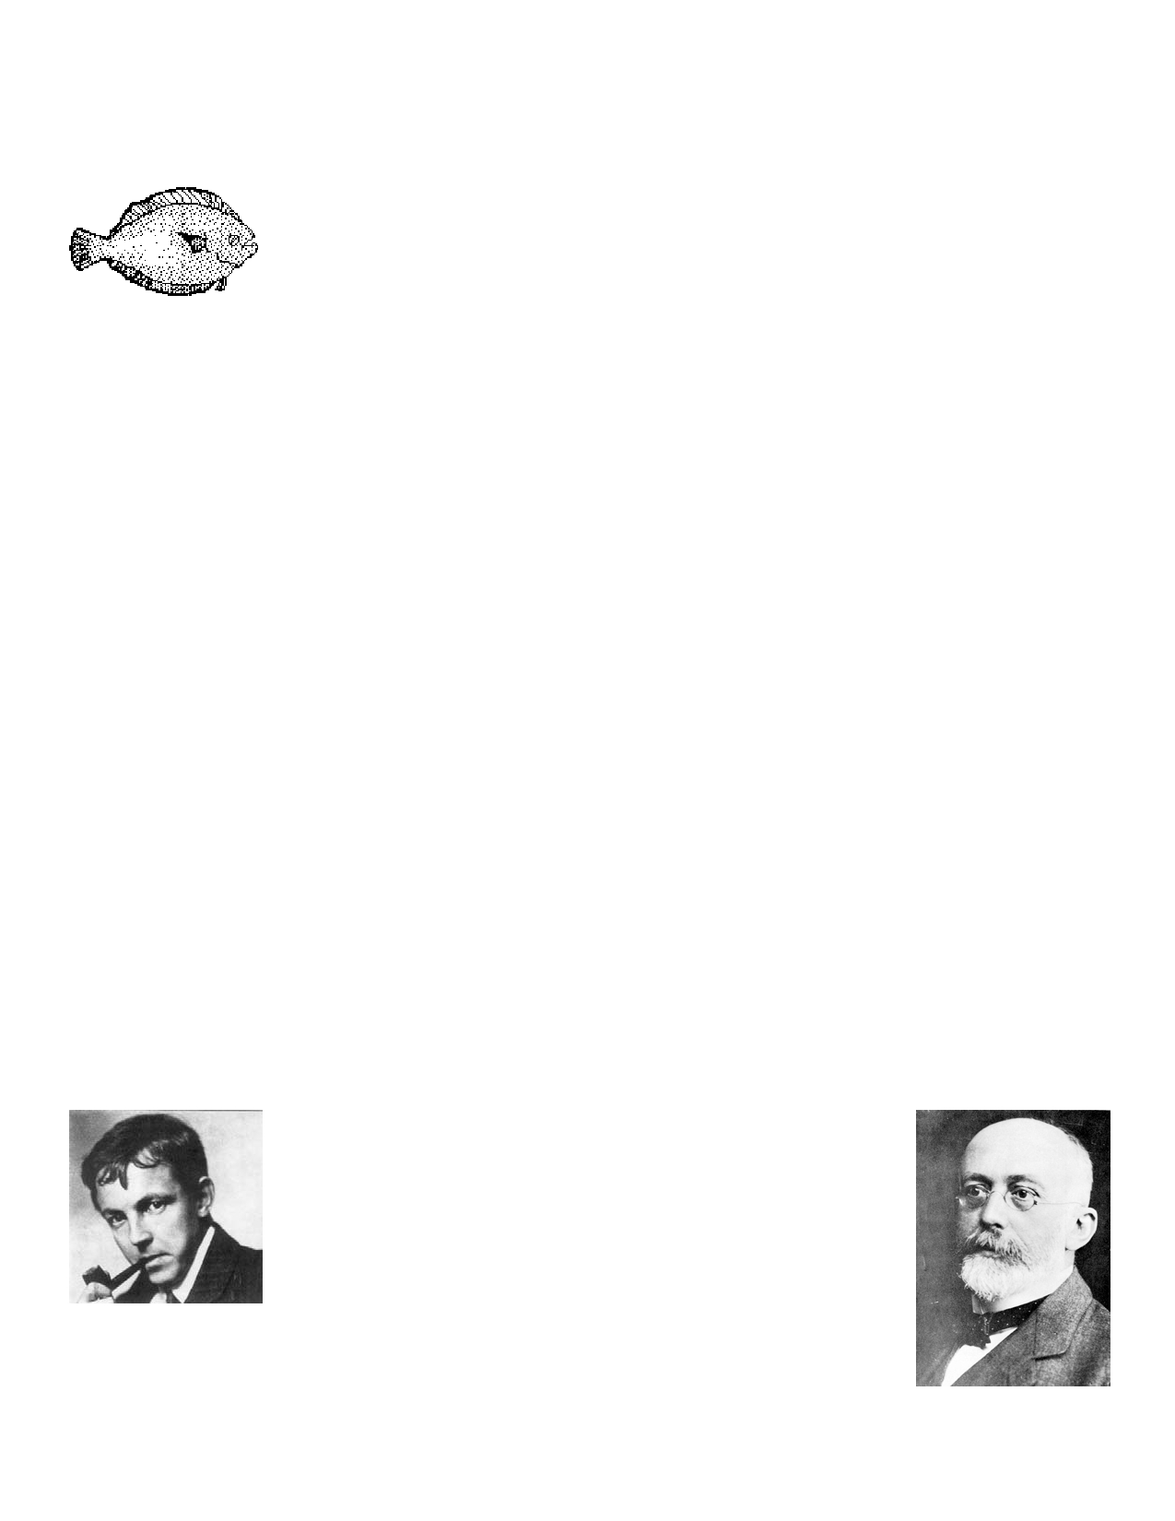AP Lab: Fishy Frequencies (Big Idea 1)
(or How Selection Affects the Hardy-Weinberg Equilibrium)

Introduction:
Understanding natural selection can be confusing and difficult. People often think that animals
consciously adapt to their environments—that the peppered moth can change its color, the
giraffe can permanently stretch its neck, the polar bear can turn itself white - all so that they
can better survive in their environments.
In this lab you will use goldfish crackers to help further your understanding of natural selection and the role of genetics and gene frequencies in evolution.

Background: Facts about the 'Fish'
1. These little fish are the natural prey of the terrible fish-eating sharks - YOU!
2. Fish come with two phenotypes: gold and brown:
a. Gold: this is a recessive trait (f); these fish taste yummy and are easy to catch.
b. Brown: this is a dominant trait (F); these fish taste salty, are sneaky and hard to
catch.
3. You, the terrible fish-eating sharks, much prefer to eat the yummy gold fish; you eat
ONLY gold fish unless none are available in which case you resort to eating brown fish in order to stay alive.
4. New fish are born every 'year'; the birth rate equals the death rate. You simulate births
by reaching into the container of 'spare fish' and selecting randomly.
5. Since the gold trait is recessive, the gold fish are homozygous recessive (ff). Because
the brown trait is dominant, the brown fish are either homozygous or heterozygous
dominant (FF or Ff).

Hardy-Weinberg:
G. H. Hardy, an English mathematician, and W.R.
Weinberg, a German physician, both independently
worked out the effects of random mating in successive
generations on the frequencies of alleles in a population. This is important for biologists because it is the basis of
hypothetical stability from which real change can be
measured.

For fish crackers, you assume that in the total population, you have the

AP Lab 8--Fishy Frequencies 2008.doc
Page 1 of 1

following genotypes, FF, Ff, and ff. You also assume that mating is random so that ff could mate
with ff, Ff, or FF; or Ff could mate with ff, Ff, or FF, etc. In addition, you assume that for the
gold and brown traits there are only two alleles in the population - F and f. If you counted all
the alleles for these traits, the fraction of 'f' alleles plus the fraction of 'F' alleles would add up to 1.

The Hardy-Weinberg equation states that: p2 + 2pq + q2 = 1.

This means that the fraction of pp (or FF) individuals plus the fraction of pq (or Ff) individuals plus the fraction of qq (ff) individuals equals 1. The pq is multiplied by 2 because there are two
ways to get that combination. You can get F from the male and f from the female OR f from the male and F from female.

If you know that you have 16% recessive fish (ff), then your qq or q2 value is .16 and q = the
square root of .16 or .4; thus the frequency of your f allele is .4 and since the sum of the f and
F alleles must be 1, the frequency of your F allele must be .6 Using Hardy Weinberg, you can
assume that in your population you have .36 FF (.6 x .6) and .48 Ff (2 x .4 x .6) as well as the original .16 ff that you counted.

Procedure:
1. Using a small Dixie cup, get a random population of 10 fish from the 'ocean.' Be sure
your hands are clean first!
2. Count gold and brown fish and record in your chart; you can calculate frequencies later. 3. Eat 3 gold fish; if you do not have 3 gold fish, fill in the missing number by eating brown
fish.
4. Add 3 fish from the 'ocean.' (One fish for each one that died.) Be random. Do NOT use
artificial selection.
5. Record the number of gold and brown fish.
6. Again eat 3 fish, all gold if possible.
7. Add 3 randomly selected fish, one for each death. 8. Count and record.
9. Repeat steps 6, 7, and 8 two more times.
10. Fill in the class results on your chart.
11. Fill in your data chart and calculation, prepare your graph, and answer the questions.

AP Lab 8--Fishy Frequencies 2008.doc
Page 2 of 2

Analysis: Answer these on a separate piece of paper.
1. GRAPHS: You will construct several graphs of the data you collected:
a. Change in allele frequency for each allele over generations: be sure to compare
your data to the class results.
b. Change in genotypic frequencies over generations: be sure to compare your data to
the class results.
2. Explain what conditions must be present in order for gene frequencies to remain constant
over time.
3. Which phenotype is not favorable to the fish and why? Phenotype means appearance.
4. What would happen if it were more advantageous to be heterozygous (Ff)? Would there
still be homozygous fish? Explain.
5. What condition allows for recessive genes to be preserved in the population?
6. Explain what would happen if selective pressure changed and the recessive gene was
selected for.
7. How would the following situations affect allele frequencies over several generations:
a. migration
b. isolation
c. no selection
d. no random mating
e. very small population
f. mutations

As usual discuss limitations that this activity has, as well as improvements that could be made.

AP Lab 8--Fishy Frequencies 2008.doc
Page 3 of 3

Data Charts
Individual Results

Generation Gold Brown p q P2 2 pq q2

1

2

3

4

5

Class Results
Generation Gold Brown p q P2 2 pq q2

1

2

3

4

5

AP Lab 8--Fishy Frequencies 2008.doc
Page 4 of 4

