**Permission granted for classroom use.**

© 2008 University of Utah

**S1**

**Print-and-Go™**

<http://learn.genetics.utah.edu>

**Name**

**Date**

*Complete the Dropping Signals activity on the Learn.Genetics website. Record the effect of each signal on each cell type in the table below.*

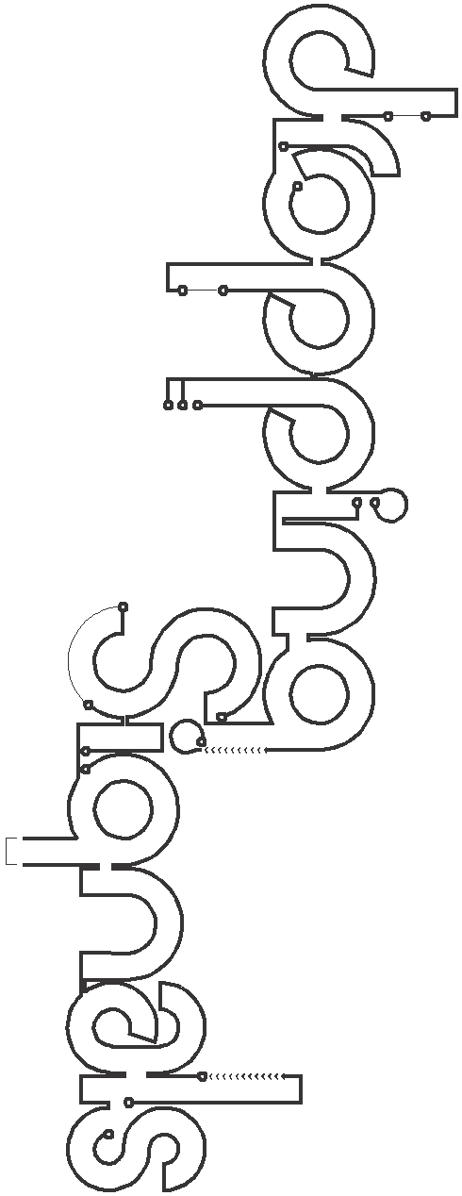

S I G N A L S

T Y P E S

C E L L

|  |  |  |  |  |  |
| --- | --- | --- | --- | --- | --- |
| a small protein molecule that travels through the blood stream | a growth factor in the form of a small protein molecule | a gas produced by cells | energy that travels freely through space | | |
| **Hormone** | **Cytokine** | **Nitric**  **Oxide** | **Light** |  | |
|  |  |  |  | **Muscle** | contain proteins that allow them to contract |
|  |  |  |  | **Photoreceptor** | specialized  cell type in the retina of the eye |
|  |  |  |  | **Skin**  **Cancer** | genetically changed skin cell with altered behavior |
|  |  |  |  | **Lea f** | produce sugar in plant leaves |
|  |  |  |  | **Fibroblast** | responsible for structural frameworks in body tissues |

**Parenchyma**