Biology from Hawaii Name
2014
Classification
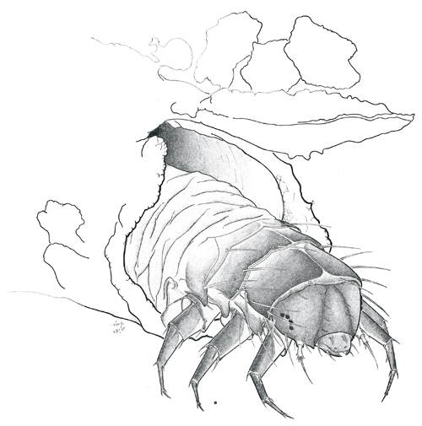Introduction
Hyposmocoma caterpillars are amazing animals. There are over 400 species, and each one is unique to a single environment. There is a lichen grazer from Waianae volcano, a wood eater from Waianae volcano, a different lichen grazer from Haleakala volcano, a bark crawler from Haleakala volcano, a snail hunter from Haleakala volcano... And these species have evocative, descriptive names: Hyposmocoma saccophora (carries a bag), H. lignivora (eats wood), H. waikamoi (from Waikamoi forest), H. papaiili (crab-bark), H. pupumoehewa (snail nightmare).
Every species of Hyposmocoma caterpillar is endemic to the Hawaiian Islands, meaning they are found here and nowhere else on Earth. 15 million years ago, a few adult moths arrived in Hawaii. They started to reproduce; the population grew then expanded into new habitat and onto new islands. With each new expansion, a fragment of the population could get separated and evolve into a new species. Then some of the new species expanded into new habitat or onto new islands and evolved into even newer species. This must have happened a lot because by now, there are more than 400 different species! And because every Hyposmocoma caterpillar/moth evolved in Hawaii, they are endemic to these islands.
Uncover the mystery of Hyposmocoma evolution. What unique powers did each species evolve? Which ancient species are the ancestors of each modern one?

Procedure
1. Read the description of 3 Hyposmocoma species (on back).
2. Decide, as a group, which 2 species are close relatives to each other.
3. Draw a family tree.
4. List the ways 2 relatives are similar and the other is different.
5. Rank the list by importance (which similarity/difference is most important, etc.)
6. Your teacher will provide more species to add to your family tree.

Grading | points worth | points earned
Participation  contribute to lab group debate over related species | 3
Results  clearly ranked list of at least 4 characteristics  family tree clearly shows close vs. distantly related species  new, additional species added to the family tree | 4
Discussion  thoughtful answers use vocabulary from class/reading | 3
Total | 10

Hyposmocoma saccophora
(sacco = bag, phora = to carry)

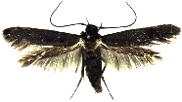

case type: cone
habitat: lives on exposed rocks, Wai‘anae volcano, O‘ahu island
diet: lichen and fungi
length: 10mm
case description: embedded with sand and pebbles, dark and rough on top, sliver and smooth underneath, has a hinged door
notes: pebbles along the top of the case resemble Stegosaurus plates

Hyposmocoma aumakuawai
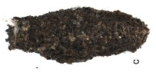(aumakua = ancestor spirit, wai = water)

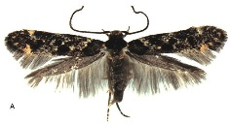

case type: burrito
habitat: lives in and near streams of east Kauai island
diet: algae
length: 7mm
case description: dark brown/gray, embedded with sand and pebbles, has a hinged door
notes: amphibious caterpillar that can breathe both water and air

Hyposmocoma papaiili
(papa‘i = crab, ili = bark)
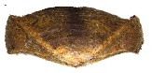

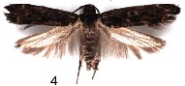

case type: crab
habitat: lives on tree bark, Haleakala volcano, Maui island
diet: lichen
length: 10mm
case description: brown color with lines that resemble wood grain, entrance at both ends
notes: very well camouflaged

Results draw your family tree here

Results (continued)

Closely related species (list them here) Distantly related species

Ranked list of similarities Differences

Discussion
1. What does it mean to be closely related versus distantly related? You may use the analogy of a family tree.

2. What knowledge do humans gain by knowing their own ancestry (knowing about your grandparents and great-grandparents, etc.)?

3. What knowledge do humans gain by knowing the ancestry of Hyposmocoma caterpillars?

