LABORATORY 5 - Cell Respiration

LABORATORY 5: CELL RESPIRATION

OVERVIEW
In this laboratory you will measure oxygen consumption during the respiration of peas. This will be done by
measuring the change in gas volume in respirometers that contain either germinating or nongerminating peas. In
addition, you will also measure the respiration of these peas at two different temperatures. You will then
compare these results, and draw conclusions about the rate of respiration as it is affected by different conditions.

OBJECTIVES
Before doing this lab you should understand:
- when conditions necessary to begin growth are achieved, germination occurs, cellular reactions are
accelerated, and the rate of respiration greatly increases
- how a respirometer works in terms of the gas laws
- the difference between germinating peas and nongerminating (desiccated) peas, as well as the difference
between peas and beads
- the general processes of metabolism in living organisms
- that dormant seeds are living

After doing this laboratory you should be able to:
- determine the effects of temperature on the rate of cell respiration of nongerminating peas, and compare
them to the results of germinating peas
- determine the significance of a control
- explain the relationship between dependent and independent variables
- calculate the rate of cell respiration from experimental data by using graphed data
- relate gas production to respiration rate

INTRODUCTION
Respiration refers to two different but related processes. Respiration is the active acquisition of oxygen by an
organism, usually involving the use of organs such as gills, lungs, or skin. Cellular respiration is the release of energy from organic compounds by metabolic chemical oxidation. It occurs in every cell in the mitochondria.
Cellular respiration therefore produces energy for the cell and depends on the first type of respiration for a supply of oxygen. This lab will examine cellular respiration.

The equation below shows the complete oxidation of glucose. Note that oxygen is required for this energy- releasing process to occur.

C6H12O6 + 6 O2 → 6 CO2 + 6 H2O + 686 kilocalories of energy/mole of glucose oxidized

By studying the above equation, you will notice there are three possible ways of measuring cellular respiration.
One could measure the:
1. Consumption of O2 during the oxidization of glucose
2. Production of CO2 during aerobic respiration
3. Consumption of O2 and the release of CO2 during cellular respiration

-1-

LABORATORY 5 - Cell Respiration

A number of physical laws relating to gases are important to the understanding of how the apparatus that you
will use in this exercise works. The laws are summarized in the general gas law that states:

PV = nRT
where
P = Pressure of the gas, V = Volume of the gas,
n = number of moles of gas,
R = gas constant (a fixed value), and T = Temperature of the gas.

This law implies the following important concepts about gases:

1. If temperature and pressure are kept constant, then the volume of the gas is directly proportional to the
number of molecules of the gas.
2. If the temperature and volume remain constant, then the pressure of the gas changes in direct proportion to the
number of gas molecules present.
3. If the number of gas molecules and the temperature remain constant, then the pressure is inversely
proportional to the volume.
4. If the temperature changes and the number of gas molecules is kept constant, then either pressure or volume
(or both) will change in direct proportion to the temperature.

It is also important to remember that gases and fluids flow from regions of high pressure to regions of low pressure.

In this experiment, the CO2 produced during cellular respiration will be removed by potassium hydroxide (KOH)
and will form solid potassium carbonate (K2CO3) by the following reaction:

CO2 (g) + 2 KOH (l) → K2CO3 (s) + H2O

The change in the volume of gas in the respirometer will be directly related to the amount of oxygen consumed. In the experimental apparatus (Figure 5.1 and 5.2), if water temperature and volume remain constant, the water
will move toward the region of lower pressure. During respiration, oxygen will be consumed. Its volume will be
lost, because the resultant CO2 produced will be converted to a solid. The net result is a decrease in gas volume
within the tube, and a related decrease in pressure in the tube. The vial with glass beads alone will permit detection of any changes in volume due to atmospheric pressure changes or temperature changes.

Set Up Picture
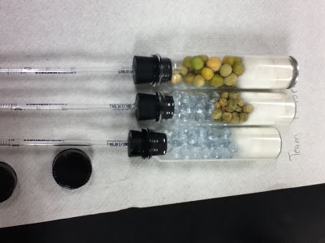

-2-

LABORATORY 5 - Cell Respiration

The amount of O2 consumed will be measured over a time course. The experiment requires six respirometers to
be set up as follows:

Respirometer

1
23456

Temperature

Room
Room Room 10°C 10°C 10°C

Contents

Germinating Seeds
Dry Seeds + Beads
Bea ds
Germinating Seeds Dry Seeds + Beads
Bea ds

MATERIALS (per group)
~ 6 respirometers. each with an attached stopper and pipette
~ germinating pea seeds
~ dry pea seeds
~ glass beads
~ 15% KOH
~ cotton wads (both absorbent and nonabsorbent)
~ masking tape
~ 2 tubs filled with water, each with a thermometer
~ ice
~ parafilm
~ 100 mL graduated cylinder
~ disposable pipettes

PROCEDURE
1. Both a room-temperature bath (approximately 25°C) and a 10°C bath should be set up immediately to allow for
time to adjust the temperature of each. (Add ice to attain the 10°C bath.)

2. Respirometer One: Obtain a 100-mL graduated cylinder and fill it with 50 mL of H2O. Place 25 germinating
peas into the graduated cylinder. Measure the amount of water that was displaced and record this number.
PEA VOLUME (#1-3) = _________ mL
This number is the volume of the peas, and will be used to determine the volume of peas and beads in the
other respirometers (all volumes should be equal). Remove the peas and place them on a paper towel. These peas will be used in Respirometer One.

3. Respirometer Two: Refill the graduated cylinder until it has 50 mL of water. Place 25 dried peas (they are
dormant, and not germinating) into the graduated cylinder and then add enough glass beads to reach a
volume equivalent to that of the germinating peas in Respirometer One. Remove the peas and beads and place them on a paper towel. These peas and beads will be used in Respirometer Two.

-3-

LABORATORY 5 - Cell Respiration

4. Respirometer Three: Refill the graduated cylinder until it has 50 mL of water. Fill it with glass beads alone
until the volume is equivalent to the volume of the germinating peas in Respirometer One. Remove these beads and place them on a paper towel. These beads will be used in Respirometer Three.
5. Repeat the above procedures (2-4) to prepare a second set of germinating peas, dry peas + beads, and beads for
use in Respirometers Four, Five, and Six, respectively.
PEA VOLUME (#4-6) = _________ mL

6. To assemble the 6 respirometers, obtain 6 vials, each with an attached stopper and pipette. Make sure that the
vials are dry on the inside. It is important that the amounts of cotton and KOH be the same for each
respirometer. Place a small wad of absorbent cotton in the bottom of each vial and, using a dropper, saturate
the cotton with 15% KOH. Do not get KOH on the sides of the respirometer. Place a small wad of dry nonabsorbent cotton on top of the KOH-soaked absorbent cotton (Figure 5.1a).

7. Place the first set of germinating peas, dry peas + beads, and beads in vials one, two, and three, respectively.
Place the second set of germinating peas, dry peas + beads, and beads in vials four, five, and six, respectively.
Insert the stopper fitted with the calibrated pipette. (Figure 5.1b)

8. Wrap parafilm tightly around each stopper (where it enters the vial and where the pipette is inserted). This is
necessary to ensure against any leaks.

Figure 5.1: Assembled Respirometers

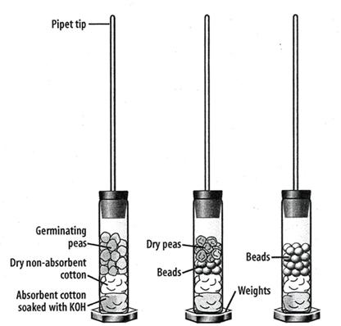

germinating peas/
dry peas + beads/glass beads

nonabsorbent cotton

absorbent cotton soaked
with 15% KOH

a b

9. Make a sling by attaching tape across the water bath and place your pipettes in the bath as shown in Figure 5.2.
Vials one, two and three should go into the room temperature bath and the other vials (four, five and six)
should go in the 10° bath. Let the respirometers equilibrate for seven minutes.

-4-

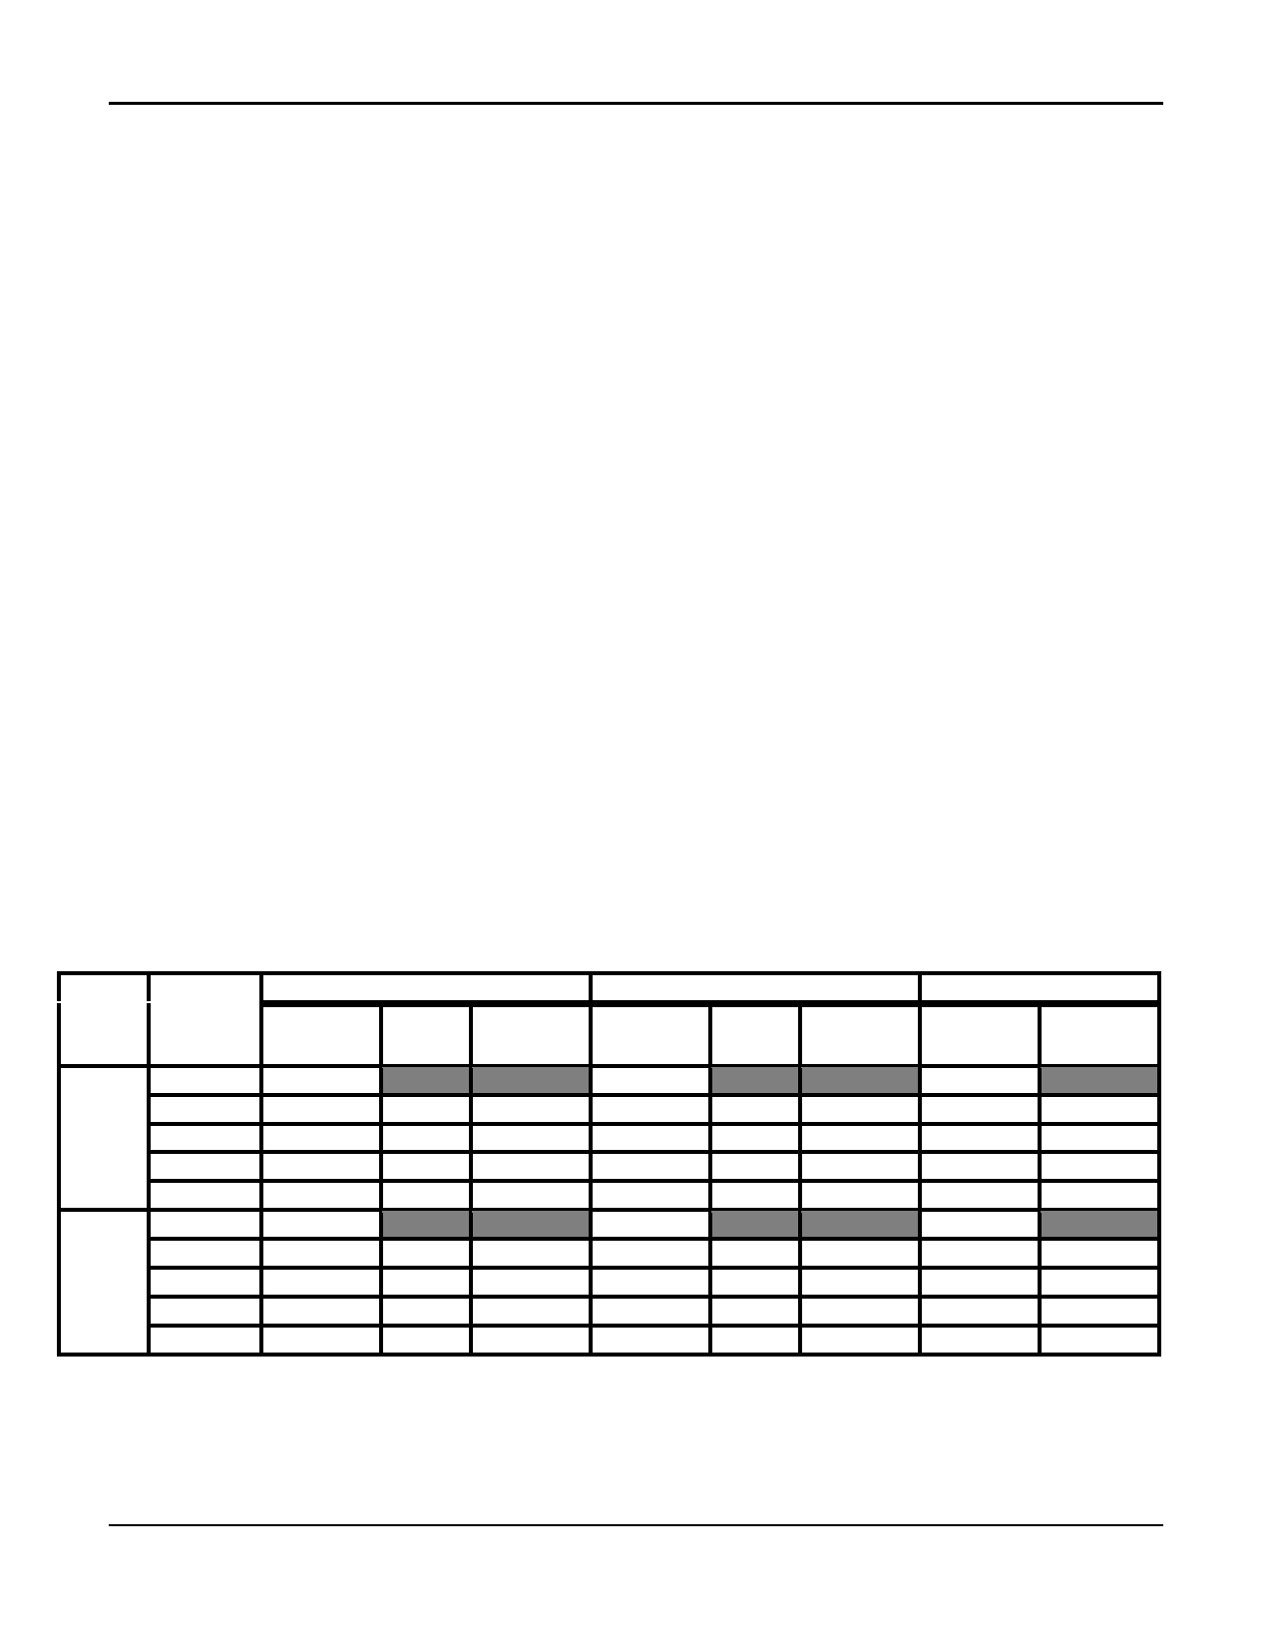
LABORATORY 5 - Cell Respiration

Figure 5.2: Respirometers in the Water Bath

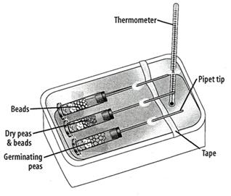

10. After the respirometers have equilibrated for seven minutes, all six should be immersed entirely in the water.
The pipettes must be in such a position so that the numbers can be read; their position should not be changed throughout the experiment. At this time, check to make sure the weights are completely on the bottom of the
respirometers, so that they will stay under water. When the respirometers are immersed, water will move into the pipette for a short time and then stop. Check again for leaks. (If water continues to move into the pipette there probably is a leak).

11. Allow the respirometers to equilibrate for 3 more minutes and then record, to the nearest 0.01 mL, the initial
position of water in each pipette (time 0). Check the temperature in both baths and record in Table 5.1. Every
5 minutes for 20 minutes, take readings of the position of water in each pipette. Record this data in Table 5.1.

Table 5.1: Measurement of O2 Consumption by Soaked and Dry Pea Seeds at Room
Temperature (~25°C) and 10°C Using Volumetric Methods

Germinating Peas Dry Peas and Beads Beads Alone

Temp.
(°C)
Time
(min.)
Initial - 0
0-5
0 - 10 0 - 15 0 - 20
Initial - 0
0-5
0 - 10 0 - 15 0 - 20
Reading at
Time X
Diff. *
Corrected
diff. ∆
Reading at
Time X
Diff. *
Corrected
diff. ∆
Reading at
Time X
Diff. *

* Difference = (initial reading at time 0) - (reading at time X)
∆ Corrected difference = (initial pea seed reading at time 0 - pea seed reading at time X) -
(initial bead reading at time 0 - bead reading at time X)

-5-

LABORATORY 5 - Cell Respiration

ANALYSIS OF RESULTS
1. Graph the results from the corrected difference column for the germinating peas and dry peas at both room
temperature and at 10°C. Be sure to label the x-axis and the y-axis and provide a descriptive title.
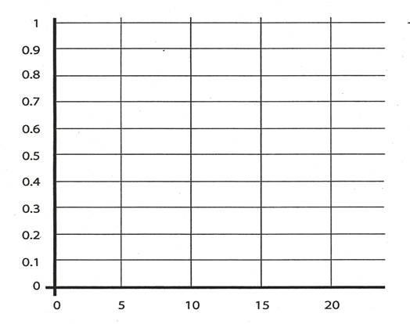

2. Identify the hypotheses being tested in this activity. Indicate the variable factor(s), the control(s), and the
purpose of each control.

3. Describe and explain the relationship between the amount of O2 consumed and time.

-6-

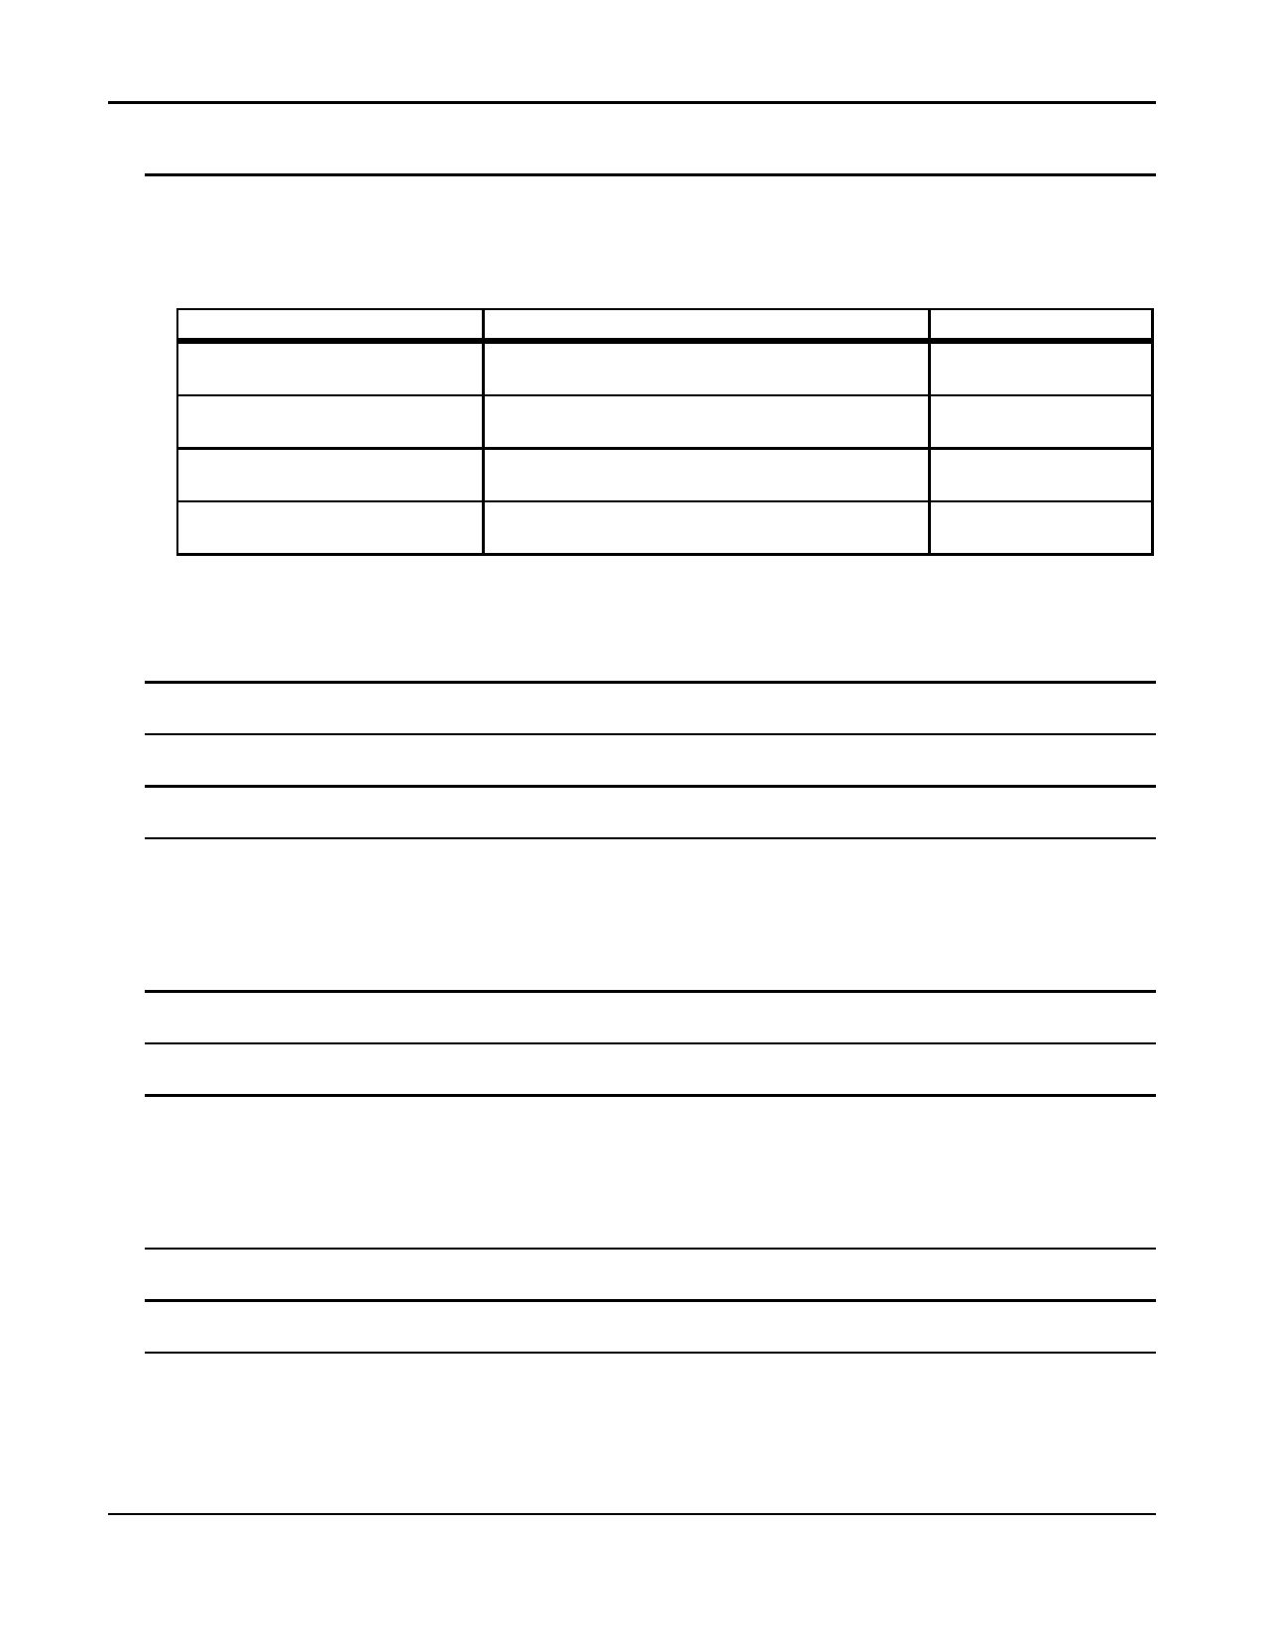
LABORATORY 5 - Cell Respiration

4. From the slope of the four lines on the graph, determine the rate of O2 consumption of germinating and dry
peas during the experiments at room temperature and at 10°C. Show your calculations.
Recall that rate = (y2-y1)/(x2-x1)

Condition
Germinating Peas - 10°C

Germinating Peas - room temp.

Dry Peas - 10°C

Dry Peas - room temp.

Show Calculations Here

Rate in mL O2/min

5. Explain the effect of germination (versus nongermination) on pea seed respiration.

6. What is the purpose of KOH in this experiment?

7. Why did the vial have to be completely sealed around the stopper?

-7-

LABORATORY 5 - Cell Respiration

8. If you used the same experimental design to compare the rates of respiration of a 25g reptile and a 25g
mammal at 25°C and 10°C, what results would you expect? Be sure to fully explain your reasoning. (It may
be helpful to think of a specific reptile/mammal and compare them.)

9. Explain why water moved into the respirometers' pipettes.

10. Below is a graph of possible data obtained for oxygen consumption by germinating peas. Assuming that peas
begin to dehydrate at a temperature of 45°C, draw in predicted results of respiration through 70°C.

Explain your above prediction.

-8-

