Biology from Hawaii Name
2014
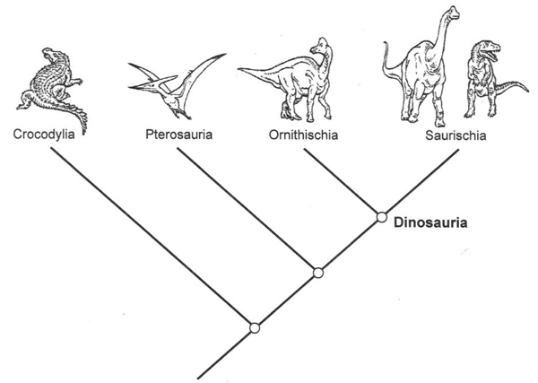Cladogram
Introduction
A family tree that shows how species evolved is called a cladogram. At the top, various taxa (types of organisms) are compared. These taxa could be different species, genera, orders, etc. For example, the dinosaur cladogram on the right compares different orders. The most interesting taxon go on the far right, while their most distant relative (the outgroup) goes on the far left. In the dinosaur cladogram, we are interested in Saurischia, and the outgroup is Crocodylia.
membrane wings
teeth
The branches of a cladogram show evolution. Higher branches represent recent evolutionary changes and lower ones more ancient changes. Branches meet at the common ancestor that gave rise to subsequent taxa. For example, an early species of Dinosauria gave rise to both Ornithischia and Saurischia but not Pterosauria. Common ancestors are not often labeled because no one knows their identity; they are extinct and difficult/impossible to find.
Important characteristics are labeled on a cladogram, showing in which branch they evolved and how long ago. For example, membrane-wings only evolved along the Pterosauria branch while teeth evolved much longer before, along the branch that gave rise to all these creatures. Scientists place these characteristics using logic, then confirm them with fossils.

Procedure
I. Record observations in a table of characteristics
II. Translate the table of characteristics into a Venn diagram of characteristics
III. Translate the Venn diagram into a cladogram
Hints: make rough sketches of Venn diagrams and cladograms on scratch paper
use cut-out species names that you can easily move around
start with the most related pair, then work outwards

1. Guided practice. Fill in the table of characteristics. Finish the Venn diagram by circling the amphibious species. Finish the cladogram by adding species and labeling characteristics.
H. saccophora

H. aumakuawai
1 entrance
H. papaiili
Makes a case
Species | Makes a case | 1 entrance | Amphibious
H. saccophora
H. aumakuawai
H. papaiili
H. aumakuawai

2. Choose only the most important, defining characteristics. Fill in the table of characteristics. Translate the data into a Venn diagram, then a cladogram. Notice any differences from the cladogram above.

Species | Makes a case | Eats lichen | Amphibious
H. saccophora
H. aumakuawai
H. papaiili

3. Adding a few species greatly increases complexity. Make a cladogram of these 5 species. Choose important characteristics. Label characteristics on the cladogram.
You may abbreviate species names.
suggested characteristics
case makes a case
case shape
with pebbles
with sand
with lichen
with algae
with snail shells
has 2 openings
has 1 opening
has hinged door
habitat lives on trees
lives on rocks
lives in streams
island it inhabits
diet eats green plants
eats animals
eats wood
size small (3–5mm)
med (6–12mm)
large (>12mm)
other amphibious
tan wings
gray/black wings

Species
H. saccophora
H. pupumoehewa
H. aumakuawai
H. papaiili
E. trivitella

4. Final cladogram. Make a cladogram of these 7 species. Choose important characteristics. Translate data into a Venn diagram, then a cladogram.

Species
H. saccophora
H. kahamanoa
H. pupumoehewa
H. aumakuawai
H. papaiili
H. lignivora
E. trivitella

Discussion
1. Compare cladogram 1 to cladogram 2 (both should show 3 species). Why are they different?

2. How might different scientists construct different cladograms of the same species? Discuss the roles of observation versus opinion in constructing a cladogram.

3. How did you choose important characteristics?

4. Describe your method for translating data tables into Venn diagrams.

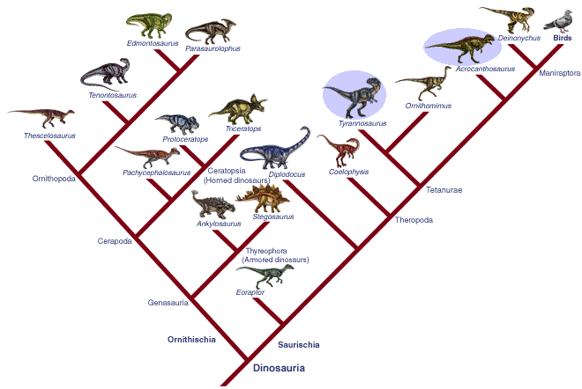

5. List 2 interesting facts shown in the
dinosaur cladogram (right).

6. Which cladogram below is correct? Why?
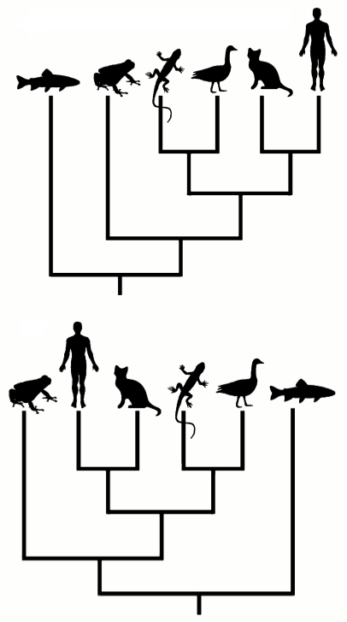

A

Grading | points worth | points earned
Results  carefully observe species  choose characteristics that distinguish species or groups  accurately translate data tables into Venn diagrams  accurately translate Venn diagrams into cladograms | 14
Discussion  thoughtful answers use vocabulary from the class/reading | 6
Total | 20

B

