Chapter 22
Must Knows:
- How Lamarck’s view of the mechanism of evolution differed from Darwin’s
- Several example of evidence for evolution and how they each support how organisms have changed overtime
- The difference between structures that are homologous and those that are analogous, and how this relates to evolution
- The role of adaptations, variations, time, reproductive success, and heritability in evolution.

22.1:The Darwinian revolutions challenged traditional views of a young Earth inhabited by unchanging species
Before Darwin:
Carolus Linnaeus: Grouped similar species into increasingly general categories
______________: branch of biology dedicated for naming and classification
Binomial Nomenclature: two-part naming system that includes the organisms _________ and _________
Georges Cuvier: Opposed the idea of evolution
Paleontology: the study of __________
Strata: superimposed layers of rock compressed from new layers covering old ones
The _______ the strata, the more dissimilar its fossils were to current life-forms.
Catastrophism: the principle that events in the past occurred suddenly and were caused by mechanisms different from those operating in the present
Charles Lydell and James Hutton:
Geologic features could be explained by gradual mechanisms still operating today
Uniformitarianism: mechanisms of change are _________ overtime.
Important: The Earth must be very __________
Jean-Baptiste de Lamarck: Based idea of evolution on two principles
- Use and disuse: parts of the body that are _________ extensively become larger and stronger, while those that are ____________ deteriorate
- Inheritance of acquired characteristics: characteristics acquired during an organism's lifetime could be passed on to the next generation

22.2: Descent with modification by natural selection explains the adaptations of organisms and the unity and diversity of life
Descent with modification by natural selection explains the adaptations of organisms and the unity and diversity of life

Charles Darwin’s voyage on the HMS Beagle from 1831-1836 was the impetus for the development of his theory of evolution by ___________
-His mechanism for evolution was natural selection. Recall Lamarck’s mechanism was the i__________ of acquired characteristics
N________________ is a process in which individuals that have certain inherited traits tend to survive and reproduce at higher rates than other individuals because of those traits. This explains how adaptations arise:
-Adaptations are___________characteristics that enhance organism's’ ability to survive and reproduce in specific environments
Example: Desert foxes = large ears to radiate heat
Arctic foxes = small ears to conserve body heat

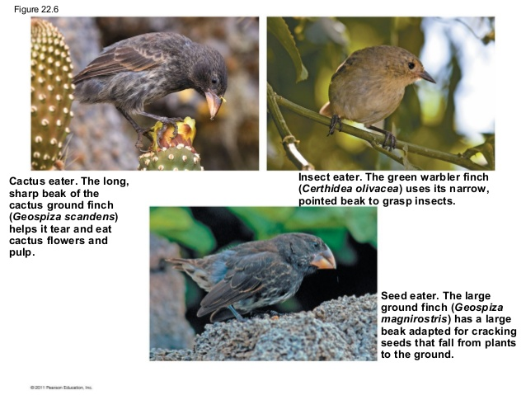

Important points of Natural Selection:
- Individuals in a population ______ in their traits, many of which are heritable
- A population can produce far more offspring that can survive. With more individuals than the environment can support, __________ is inevitable
- Individuals with inherited traits that are better suited to the local environment are more likely to survive and reproduce than individuals less well-suited. Sometimes called “d__________ reproductive success”
- Evolution occurs as the unequal reproductive success of individuals ultimately leading to adaptations to their __________. Over time, natural selection can increase the match between organisms and their environment.

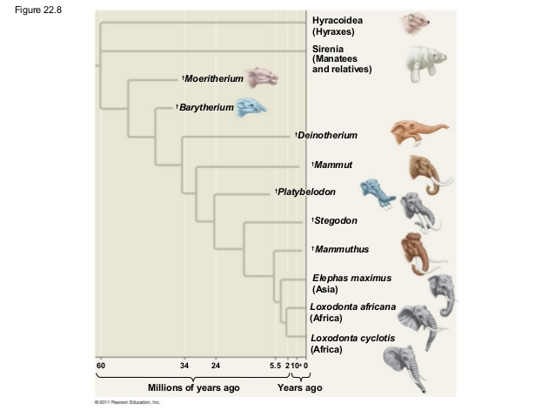

If an environment changes, or if individuals move to a new environment, natural selection may result in adaptation to these new conditions, sometimes giving rise to new species in the process.

Artificial selection is the process by which species are modified by __________.
Example: Selective breeding of milk or meat production and the development of dog breeds
Individuals do not evolve. P_________ evolve.

22.3: Evolution is supported by an overwhelming of scientific evidence
- Direct observation of Evolutionary change
- Insect populations can ___________ become resistant to pesticides such as DDT
- Evolution of drug-resistant viruses and antibiotic- resistant bacteria
- Homology and Convergent Evolution
- Homology: Characteristics in related species can have an underlying similarity even though they have very different functions. Similarity resulting from ___________ is known as homology.
- Homologous Structures are anatomical signs of evolution.
Examples: Forelimbs of mammals that are now used for a variety of purposes, such as flying in bats or swimming in whales, but were present and used in a common ancestor for walking
- Embryonic homologies: Comparison of early stages of animal development reveals many anatomical homologies in embryos that are not visible in ________organisms. Example: All vertebrate embryos have a post-anal tail and pharyngeal pouches.
- Vestigial Organs are structures of marginal, if any, importance to the organism. They are ___________ of structures that served important functions in the organism's ancestors. Example: Remnants of the pelvis and leg bones are found in some snakes.
- Molecular homologies are shared characteristics on the molecular level. Examples: All life forms use the same genetic language of DNA and RNA. _______ _______sequences coding for hemoglobin in primate species show great similarity, thus indicating a common ancestor.
- Convergent Evolution explains why distantly species can resemble one another. Convergent evolution has taken place when two organisms developed similarities as they ________ to similar environmental challenges not because they evolved from a common ancestor. The likenesses that result from convergent evolution are considered analogous rather than homologous. Think of it like this: Similar problems have similar solutions. Examples:
- The torpedo shapes of a penguin, dolphin, and shark are the solution to movement through an aqueous environment.
- Sugar gliders and flying squirrels occupy similar niches in their respective habitats.

- The Fossil Record: Fossils provide evidence for the theory of evolution
- Fossils are remains or traces of organisms from the past. They are found in sedimentary rock. __________ is the study of fossils.
- Fossils show that evolutionary changes have occurred over time and the origin of major new groups of organisms
- _________ theory of evolution through natural selection explains the succession of forms in the fossil record. Transitional fossils have been found that link ancient organisms to modern species, just as Darwin’s theory predicts
- Biogeography: The geographic distribution of species
- Species in a discrete geographic area tend to be more closely related to each other than to a species in distant geographic areas.
Examples: In South America, desert animals are more closely related to local animals in other habitats that they are to the desert animals of Asia. This reflects evolution, not creation.
- Continental Drift and the break-up of Pangaea can be explain the similarity of species on _________that are distant today
- Endemic Species are found at a certain geographic location and nowhere else.
Example: Marine iguanas are endemic to the Galápagos.
Extra Vocabulary:
- Evolutionary Tree - A branching diagram that reflects a hypothesis about evolutionary relationships among groups of organisms
- Analogous - Having characteristics that are similar because of convergent evolution, not homology
- Pangaea - The supercontinent that formed near the end of the Paleozoic era, when plate movements brought all the landmasses of Earth together

