Chapter 11: Gene Expression
Gene Expression: The activation or “ turning on” of a gene that results in protein production
- Genome-entire DNA/genetic material in an individual
- Jacob/Monad – discovery of lac operon and won the Nobel prize

- Gene Expression in prokaryotes (E.coli)
lac operon – how does it work?
In the presence of lactose sugar (disaccharide made of glucose and galatose), E. coli produces enzymes to break down (metabolize) lactose sugar but if lactose is not present, enzyme is not produced.
Link: lac operon: http://classes.midlandstech.edu/carterp/Courses/bio101/chap15/chap15.htm
In the absence of lactose, regulatory gene produces repressor protein that sit on the operator region of the DNA which prohibits RNA polymerase from sitting on the promoter region hence no transcription occurs.

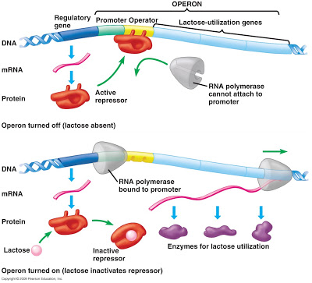

However, in the presence of lactose, repressor protein is removed by its interaction with lactose and transcription can occur to produce enzyme to break down lactose.

- Gene Expression in Eukaryotes
Eukaryotic gene expression is more complex because
- Genes are located in several individual chromosomes
- Multicellular organism made of many specialized cells that make certain proteins only (although they all have a full set of chromosomes)
- No operon found as of now.

Euchromatin – uncoiled form of DNA during mitosis or meiosis. This is when transcription happens. Some parts never uncoil (from histone) so by amount of uncoiled DNA indicates degree of gene expression.
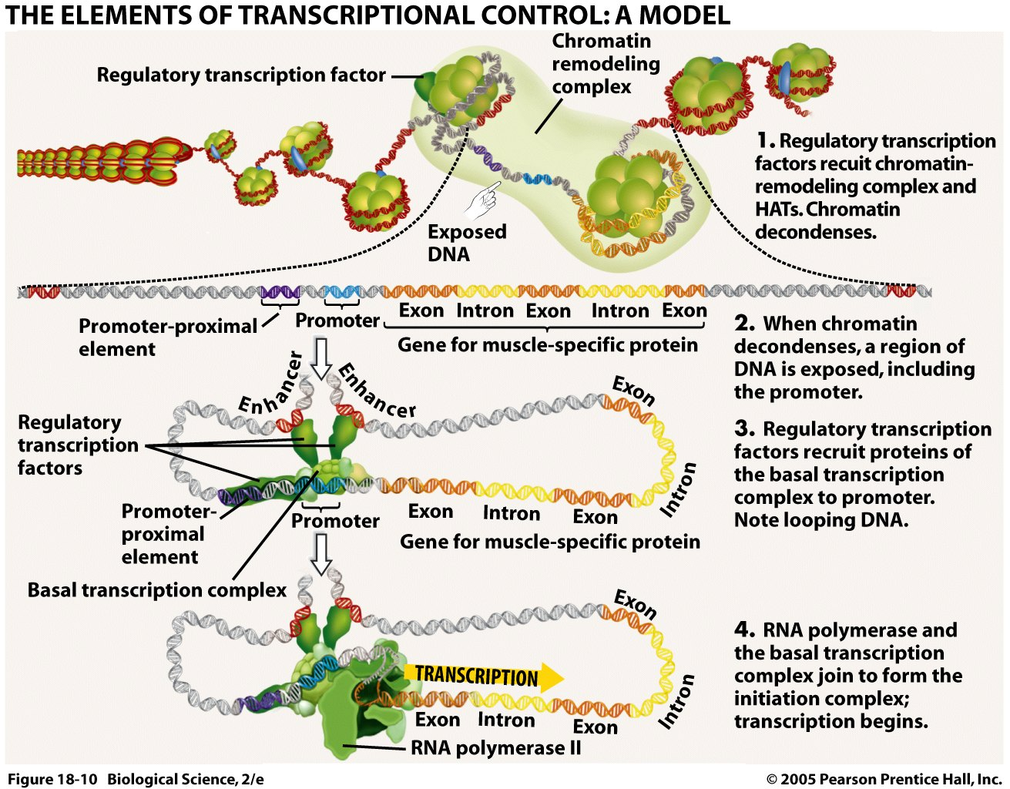

Transcription factors bring enhancers (DNA sequence) near the promoter region which starts the transcription process by activating RNA polymerase.

After transcription, mRNA is further cleaned up in the nucleus by removing introns. Only exons are kept. Enzyme spliceosome used along with ribozyme (RNA enzyme).

- Gene expression in development and cell division.
Homeotic genes are regulatory genes that determine where certain anatomical structures, such as appendages will develop during morphogenesis. See fly which has leg growing out of its head (figure 11-5). It’s important to turn on the right genes in right cells.

- Gene Expression, Cell division, and cancer
Cell division is controlled by proto-oncogenes ensuring proper rate of cell division however, if mutation occurs in these genes, it changes into oncogene, a gene that can caused uncontrolled cell division leading to tumor formation.

Two types of tumor – benign and malignant (destroys health tissue)

Tumor suppressor genes acts as a brake for uncontrolled cell division but if it is mutated too, cancer occurs.

See chart on page 225 (figure 11-7)

Carcinogen – cancer causing agent .
Examples: radiation, chemical in cigarette, UV, X-ray, asbestos

