*Fibers are used in forensic science to create a link between crime and suspect*

* Trace evidence
* Collecting fibers within 24 hours is critical (95% lost)
* Shedding—common form of fiber transfer
* Microscopic Analysis
* IR, florescent, refraction spectroscopy
* Destructive Testing Methods
  + Burn Analysis
  + Chemical Analysis

***Chapter 4: A Study of Fibers and Textiles***  
**By the end of this chapter you will be able to:**

* Identify and describe common weave patterns of textile samples
* Compare and contrast various types of fibers through physical and chemical analysis
* Describe principle characteristics used to identify common fibers (microscopic)
* Apply forensic science techniques to analyze fibers (burn analysis)
* Properly operate Bunsen burner

**Common Weave Patterns**

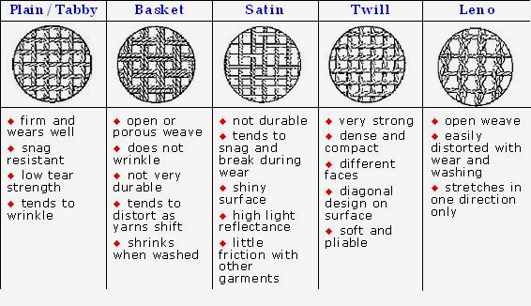

* Yarns—fibers (of any length, thick or thin, loose or tight) twisted or spun together
* Blending fibers meets different needs   
  (e.g., resistance to wrinkling)
* Fibers are woven into fabrics or textiles
  + Threads are arranged side by side (the warp)
  + More threads (the weft) are woven back and forth crosswise through the warp

**Natural Fibers**

Many different **natural** fibers that come from plants and animals are used in the production of fabric.

**Plant fibers** (seed, stem/leaves, fruit):

* Cotton—most common textile   
  plant fiber (picture)
* Coir – coconut covering; is durable
* Linen – flax stem
* Hemp & jute from stems grow in bundles.
* Manila fiber from abaca plant leaves

**Animal fibers (made of proteins):**

* Wool and cashmere from sheep
* Mohair from goats
* Angora from rabbits
* Hair from alpacas, llamas, and camels
* Silk from caterpillar cocoons **Bombyx mori** (longer fiber does not shed easily)

**Mineral Fibers:**

* Fiberglass—a fibrous form of glass; Used to insulate buildings
* Asbestos—a crystalline structure; Used for building material

**Cotton**

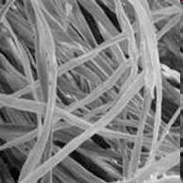

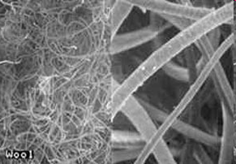

Wool

**Cross-section of a man-made fiber**



**Synthetic Fiber**

More than half of all fibers used in the production of textile materials are synthetic or **man-made**. Nylon, rayon, and polyester are all examples of **synthetic** fibers.

**Regenerated Fibers (derived from cellulose):**

* Rayon
  + Most common in this group
  + Imitates natural fibers, but stronger
* Celenese®
  + Cellulose chemically combined with acetate
  + Found in many carpets
* Polyamide nylon
  + Cellulose combined with three acetate units
  + Breathable and lightweight
  + Used in performance clothing

**Synthetic Polymer Fibers**

-Petroleum base

-Monomers join to form polymers

-Uniform diameters

* Polyester
* “Polar fleece” ([Polyethylene terephthalate](http://en.wikipedia.org/wiki/Polyethylene_terephthalate) (PET))
* First made to mimic wool
* Wrinkle-resistant
* Not easily broken down by light or concentrated acid
* Added to natural fibers for strength
* Nylon

- Easily broken down by light and concentrated acid

- Otherwise similar to polyester

**Comparison of Natural and Synthetic Fibers**

