Case Study Project

Examples:
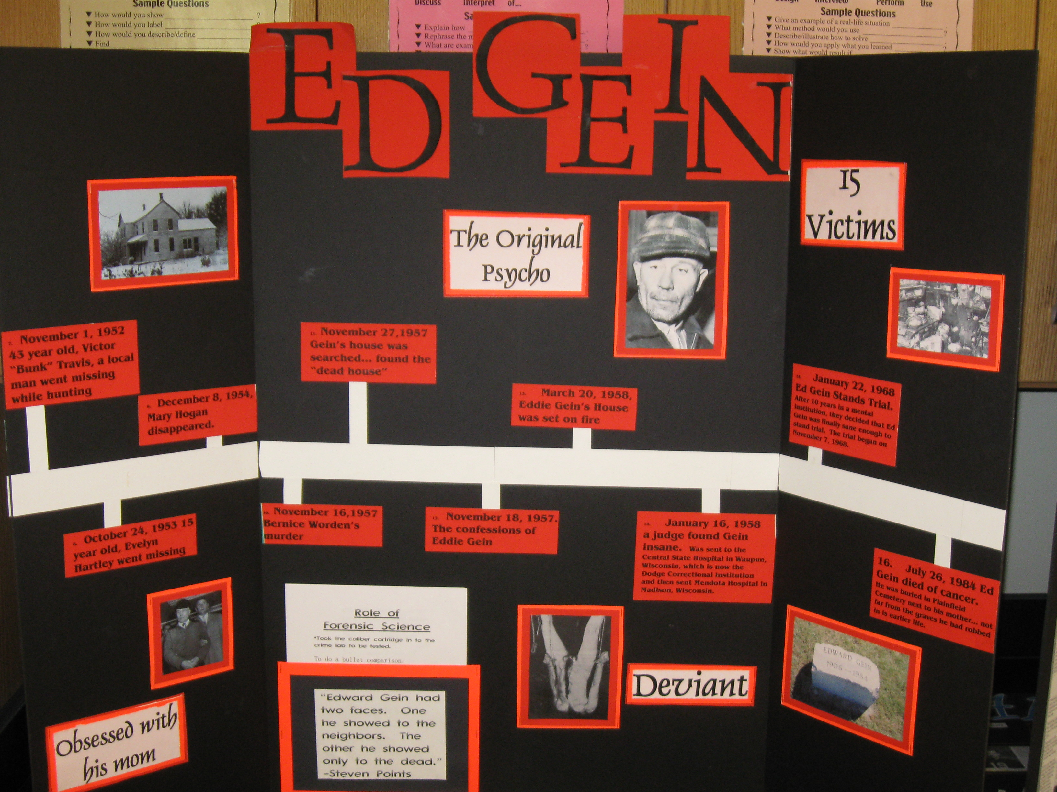

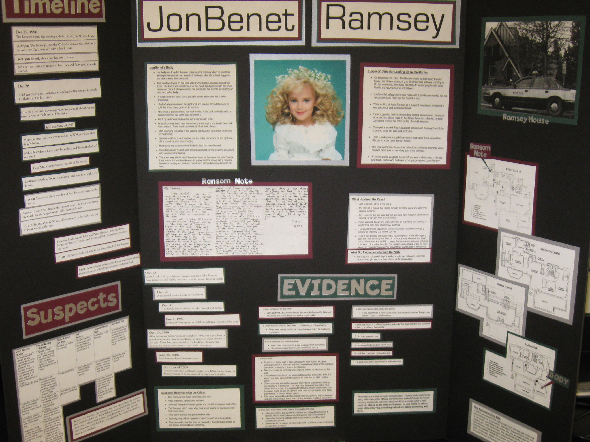
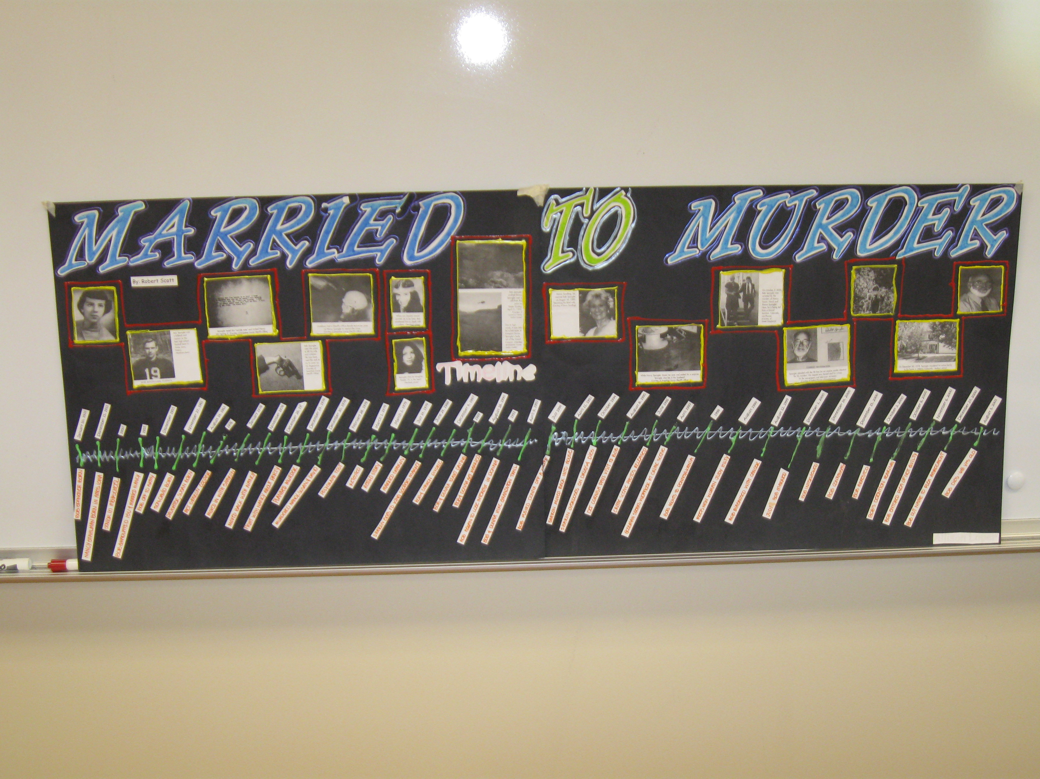

Forensic Case Study Books
There is literally so much out there this list could go on and on and on.

The Lindberg Baby Kidnapping in American History by Judith Edwards
Catch Me If You Can by Frank Abagnale
Portrait Of A Killer: Jack The Ripper Case Closed by Patricia Cornwell
Evil Harvest by Rod Colvin
My Dark Places by James Ellroy
The Ultimate Jack the Ripper Companion by Evans E Skinner
Starkweather by Jeff O’Donnell
Forty Whacks: Lizzie Borden by David Kent
Devils Knot by Mara Leveritt
Stiff by Mary Roach
The Lives and Times of Bonnie and Clyde by E.R. Milner
The Sheppard Murder Case by Paul Holmes
The BTK Murders b Carlton Smith
Helter Skelter by Vincent Bugliosi
The Only Living Witness by Stephen G. Michaud and Hugh Aynesworth
The Confessions of Henry Lee Lucas by Mike Cox
In Cold Blood by Truman Capote
Killer Clown: The John Wayne Gacy Murders by Terry Sullivan
Ed Gein by Bill Cross or Anthony Woods
Deviant: The Shocking True Story of Ed Gein by Harold Schechter
The Jeffrey Dahmer Story: An American Nightmare by Don Davis
JonBenet: Inside the Murder Investigation by Steve Thomas
Ted Bundy: Conversations with a Killer by Stephen G. Michaud
The Professional Serial Killer and the Career of Ted Bundy by Bonnie M Rippo
Starkweather: Inside the Mind of a Teenage Killer by William Allen
Need to Kill by Mark Pettit
The Night Stalker by Philip Carlo
The Ice Man: Confessions of a Mafia Contract Killer by Philip Carlo

Name: ____________________________________ Period: _____________ Date: ______________________________

Case Study Presentation - Your presentation needs to be focused around your visual aid. Do not just read your slides. The visual aid must be a major portion of your presentation. An awesome visual aid will receive 20 points. An awesome visual aid will contain but not limited to: pictures, diagrams, a timeline, etc. Just typing in bullet statements into ppt. will not earn you 20 points.

State your source.
Crime Layout - 1. Describe the suspects behavior leading up to the crime.
(Timeline) Premeditated
Heat of Passion
What events led to the suspect to commit the crime?
A psychological profile 5 pts

2. Details of the crime or crimes.
Layout the events that took place during the crime.
Layout the evidence left at the scene and other
evidence that was pertinent to the crime. 10pts
Focus on
the science Use your knowledge from this class to explain the science
in your behind the forensic evidence. 20 pts
presentation!
What good things did collectors do at the crime scene?
What mistakes did collectors make at the crime scene?
(Preservation of Evidence) 10 pts
3. Events and behavior of suspect after the crime.
How did they make their getaway?
Did they do anything to cover up the crime? 5pts

Finding the How was the suspect found?
suspect - State how the evidence lead them to the suspect.
What successes did they have that lead to apprehending
the suspect?
What things hindered the case and may have given false
lead away from the suspect? 10 pts

The trial - The prosecution - How did the prosecution make their case.
What mistakes did the prosecution make. 5 pts

The defense - Did they plead guilty or innocent?
How did the defense try and dispute the forensic evidence?
What was the defenses overall plan. 5 pts

Other info - How has science (technology) changed since this crime?
How would new technology effected this trial or outcome? 5pts

Your opinion - State your opinion on guilty or innocent. State your opinion on their sentence. What would you have done differently?
Any other interesting info. 5 pts
total = 100 pts

