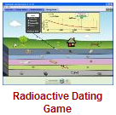**Intro to Half-Life PhET Lab (Radioactive Dating Game)**

**Introduction:** Dead things decay into simpler molecules. Radioactive particles decay. Is it the same kind of decay? What does it mean when a substance is radioactive? In this simulation, you will investigate the concept of half-life.

**Some handy vocabulary for you to define:** *(use your notes, your book, or the internet)*

Neutron _______________________________________________________________________________________________

Isotope _______________________________________________________________________________________________

Radiocarbon Dating______________________________________________________________________________________

Half-Life _______________________________________________________________________________________________

Decay (as used in half-life)_________________________________________________________________________________

Carbon-14…what does the “14” represent? ___________________________________________________________________

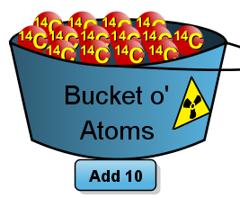**Procedure:** *PhET🡪Play with the Sims 🡪 Chemistry 🡪 Radioactive Dating Game* 

* Take some time and play with the simulation. Those atoms are radioactive! How cool is that?!
* How many **protons** does Carbon-14 have? _____________ (hint…what is its atomic number?)
* How many **neutrons** does Carbon-14 have? _____________ (hint: what is the mass?)
* Add a **Carbon-14** atom to the play area. What happens to that Carbon-14 atom? ________________________________________________________________________________
* Do all Carbon-14’s decay at the same time? ____________________________________________
* Add 50 Carbon-14s. (click  five times.) What happens? _______________________________________________
* and Using 20 Carbon-14s, **draw the pie graph** at the following time periods:

|  |  |  |
| --- | --- | --- |
| 5000 Years | 10000 years | 15000 years |
|  |  |  |

* Redo the above with 100 Carbon-14 atoms and fill in the three boxes below.

|  |  |  |
| --- | --- | --- |
| 5000 Years | 10000 years | 15000 years |
|  |  |  |

* How do the pie graphs of 20 atoms compare to those of 100 atoms? __________________________________________
* Generally, does the size of a radioactive sample affect half-life? __________ Why/Why not? _______________________

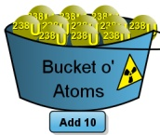**Consider Uranium-238...**

* Carbon-14’s half-life was measured in thousands (**5700**) of years. About how long is Uranian-238’s half-life? _________________________________________________________________________
* How many protons does U-238 have? _____________ How many neutrons? __________________
* Into what atom does Uranium-238 decay? ______________________________________________
* 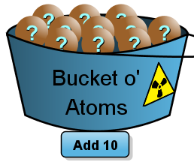Does the size of the sample of Uranium-238 affect its half-life? _______________________________________________

**About that *Unknown* Element….**

* How would you determine the half-life of this unknown element? Write up a little plan here:
* Estimate the half-life of this element. _________ seconds.

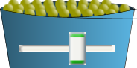 Observe the decay curves ( % remaining vs time) for Carbon-14 and Uranium-238. Sketch the decay curve for those isotopes here:

Uranium-238

Carbon-14

 Determine how the little Geiger counter works in Measurement and Dating Game. Estimate the age of each of the following objects in the list below:

|  |  |  |  |
| --- | --- | --- | --- |
| Item | Estimated Age | Item | Estimated Age |
|  |  |  |  |
|  |  |  |  |
|  |  |  |  |

**Analysis questions**

1. Why can’t we use Carbon-14 to date the rocks? ___________________________________________________________
2. Why couldn’t the fish fossil or dinosaur skull be dated with either C14 or U238? _________________________________

___________________________________________________________________________________________________

1. Could Carbon-14 be used to date a hammer suspected of being used in 3400BC? _________ __________Why/Why not? ___________________________________________________________________________________________________
2. The half-life of the unknown element was about _______ seconds.
3. Starting with 100 Carbon-14 atoms, how many would you expect to have after one half-life? _____ After three? ______
4. Make a small sketch of what a decay curve may look like for an unknown element🡪
5. You happen upon an antiques store and the clerk claims that he has a belt that was once worn by Alexander the Great, around 350 BC. You radiocarbon date it and find the percent of carbon to be 75% remaining. Could the belt be genuine?

How did you arrive at your answer?