Name: _____________________________________ Period: _______

AP Biology Lab 10: Energy Dynamics

Purpose:
What factors govern energy capture, allocation, storage, and transfer between producers and consumers in a terrestrial ecosystem?

Background:
Almost all life on this planet is powered, either directly or indirectly, by sunlight. Energy captured from sunlight drives the production of energy-rich organic compounds during the process of photosynthesis. These organic compounds create biomass. Gross productivity is a measure of the total energy captured. The net amount of energy captured and stored by the producers in a system is the system’s net productivity.

In terrestrial systems, plants play the role of producer. Plants allocate that biomass (energy) to power processes or to be stored. Different plants have different strategies of energy allocation that reflect their role in various ecosystems. For example, annual weedy plants allocate a larger percentage of their annual biomass production to reproductive processes and seeds than do slower-growing perennials. As plants, the producers, are consumed or decomposed, the stored chemical energy powers additional individuals (the consumers) or trophic levels of the biotic community. Biotic systems run on energy much as economic systems run on money. Energy is generally in limited supply in most communities. Energy dynamics in a biotic community is fundamental to understanding ecological interactions.

Learning Objectives:
- To explain community/ecosystem energy dynamics, including energy transfer between the different trophic levels.
- To calculate biomass, net primary productivity (NPP), secondary productivity, and respiration use a model consisting of Brussels sprouts and butterfly larvae.

There are two parts to this lab:
- In part 1, you will estimate the net primary productivity (NPP) of Wisconsin Fast Plants over several weeks.
- In part 2, you will calculate the flow of energy from plants (producers) to butterfly larvae (primary consumers). These calculations will include an estimate of (a) secondary productivity, which would be the amount of biomass added to the larvae and therefore available to the next trophic level, and (b) the amount of energy lost to cellular respiration.

Part I: Estimating Net Primary Productivity (NPP) of Wisconsin Fast Plants

Primary productivity is a rate – energy captured by photosynthetic organisms in a given area per unit of time. Based on the second law of thermodynamics, when energy is converted from one form to another, some energy will be lost as heat. When light energy is converted to chemical energy in photosynthesis or transferred from one organism (a plant or producer) to its consumer (ex: an herbivorous insect), some energy will be lost from heat during each transfer.

In terrestrial ecosystems, productivity (or energy capture) is generally estimated by the change in biomass of plants produced over a specific time period. Measuring biomass or changes in biomass is relatively straightforward: simply mass the organism(s) on an appropriate balance and record the mass over various time intervals. The complicating factor is that a large percentage of the mass of a living organism is water – not the energy-rich organic compounds of biomass. Therefore, to determine the biomass at a particular point accurately, you must dry the organism. Obviously, this creates a problem if you wish to take multiple measurements on the same living organism. Another issue is that different organic compounds store different amounts of energy; in proteins and carbohydrates it is about 4kcal/dry of weight and in fats it is 9kcal/dry of weight.

Define the following terms, and then fill in the diagram below showing energy transfer in plants. Use the word “biomass” where necessary.

- Gross primary productivity: ___________________________________________________________________

__________________________________________________________________________________________

- Net primary productivity: _____________________________________________________________________

__________________________________________________________________________________________

- Secondary productivity: ___________________________________________________________________

__________________________________________________________________________________________

Review the energy transfer in plants by filling in the arrows below:

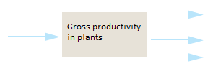

Review the energy transfer in primary consumers (butterflies) by filling in the arrows below:

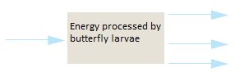

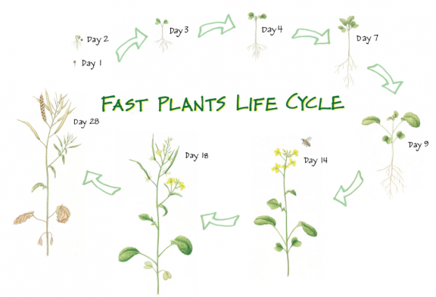
Procedure:
Day 1:
- Plant 40 Wisconsin Fast Plant seeds according to your teacher’s instructions. These seeds will be grown for 7 days under controlled conditions.

Day 7:
- Randomly select 10 plants and remove them with their roots intact from the soil.
- Carefully wash the soil from the roots and blot the roots dry.
- Measure the wet mass of the 10 plants collectively. Record the mass in the data table provided.
- Place the 10 plants in a drying bowl and place them in a drying oven at 200°C for 24 hours.

Day 8:
- Measure the mass of the dry plants. Record the mass in the data table provided.
- Use the following equation to calculate percent biomass:

mass of dry plants
% biomass = -------------------------- x 100
mass of wet plants

**Note how much of the plant’s total mass is actually biomass (organic compounds) and how much is made up of water!**

- Each gram of a Fast Plant’s dry biomass is equivalent to 4.35 kcal of energy. Note: throughout this lab, the energy equivalents of biomass in kcal (plant or animal) were obtained in a laboratory using a calorimeter that measures the amount of energy per gram of organism.

Use the following formula to calculate the amount of energy (in kcal) in the plants:

amount of energy (kcal) = (mass of dried plants (g)) x (4.35 kcal/g)

- Record the amount of energy in 10 plants and in 1 plant in the data table.
- Net primary productivity (NPP) is the amount of energy stored (added) as biomass per day by autotrophs in a ecosystem and is expressed in units of kcal/day.

Use the following formula to calculate NPP per plant per day:

energy per plant (kcal)
NPP = --------------------------------

age of plant (days)

- Record the NPP per plant per day in the data table.

Day 14:
- Repeat steps 2-11.

Day 21:
- Repeat steps 2-11.

Results & Data:

Part I: Estimating Net Primary Productivity (NPP) of Wisconsin Fast Plants

Group Data: NPP of Wisconsin Fast Plants

Age in Days | Wet Mass of 10 Fast Plants (g) | Dry Mass of 10 Fast Plants (g) | Percent Biomass | Energy in  10 Fast Plants(kcal) | Energy in  1 Fast Plant (kcal) | Net Primary Productivity per day per Fast Plant
7

14

21

Class Data: NPP of Wisconsin Fast Plants

Time (Days) | Group 1 | Group 2 | Group 3 | Group 4 | Group 5 | Group 6 | Average NPP
7

14

21

Analysis:
- Graph your group AND the class average NPP vs. time.

- Why does the NPP increase over time (as the plants grow and mature)?

Part II: Estimating Energy Transfer from Producers to Primary Consumers

In this experiment, you will be using a simple two-step food chain using Brussels sprouts as the producers and cabbage butterflies as the primary consumers.

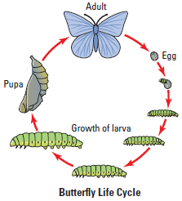

Review the energy transfer in primary consumers (butterflies) by filling in the arrows below:

In order to calculate plant, larvae, and frass energy in kilocalories (kcal), you must multiply by know values measured in kilocalories for these organisms.

Example: to calculate plant energy, you multiply the biomass by 4.35 kcal/g; for the larvae you multiply biomass by 5.5 kcal/g; and for frass you multiply by 4.75 kcal/g.

Can you explain why these values differ depending on which organism (or waste material) you are measuring?

__________________________________________________________________________________________________

__________________________________________________________________________________________________

__________________________________________________________________________________________________

Procedure:

Day 1:
- Obtain Brussels sprouts (which are in the same family (Brassicacae) as Wisconsin Fast Plants) and obtain the wet mass. Record mass in the data table provided.
- Place them in an aerated container with air holes.
- Obtain 5-10 butterfly larvae that are 12 days old and obtain their mass. Record mass in the data table provided.
- Place them in the container with the Brussels sprouts.

Day 4:
- Remove the Brussels sprouts from the container and obtain their mass. Record mass in the data table provided.
- Remove the butterfly larvae (now 15 days old) and obtain their mass. Record mass in the data table provided.
- Place the Brussels sprouts in a drying bowl and place them in a drying oven at 200°C for 24 hours.
- Place the butterfly larvae in a drying bowl and place them in a drying oven at 200°C for 24 hours.
- Place the frass in a drying bowl and place it in a drying oven at 200°C for 24 hours.

Day 5:
- Measure the mass of the dried Brussels sprouts, caterpillar larvae, and frass. Record masses in the data table provided and perform calculations.

Results & Data:

Part II: Estimating Energy Transfer from Producers to Primary Consumers

Tables of Energy/Biomass Flow from Plants to Butterfly Larvae

Table 1: Brussels Sprouts

 | Day 1 | Day 3
Wet mass of Brussels sprouts (g) |  |  | Grams consumed by all larvae =
Plant percent biomass (dry/wet)
Plant energy  (wet mass x percent biomass x 4.35 kcal) |  |  | kcals consumed by all larvae =
 |  |  | kcals consumed per larvae =
Table 2: Butterfly Larvae

 | Day 1 | Day 3
Wet mass of butterfly larvae (g) |  |  | Grams gained =
Wet mass per individual larvae (g) |  |  | Grams gained per larvae =
Larvae percent biomass (dry/wet)
Energy production per individual larvae  (individual wet mass x percent biomass x 5.5 kcal/g) |  |  | kcals gained per larvae =

Table 3: Frass

Day 3
Dry mass of the frass
from all larvae (g)
Frass energy (waste) =
frass mass x 4.75 kcal/g
Energy of the frass
from 1 larva (kcal)

Table 4: Respiration

Respiration (show calculation) | Day 3
(respiration = energy consumed per larvae – energy gained by larvae – energy lost by frass) | (energy lost in respiration)  kcal

Analysis:
- You will be using the percent biomass of both plants and larvae to calculate the energy lost by the plants or gained by the larvae in the following calculations. In part I of the lab the dried biomass was used to calculate net primary productivity. In part II of the lab you are using percent biomass because you cannot directly calculate the biomass for the Brussels sprouts or larvae on day 1. Why?

- Calculate the amount of energy transferred from the producer to the consumer (energy gained per larvae ÷ energy consumed per larvae). Theoretically, this should be 10%. How does your calculation compare? Why might it be different?

