Biology from Hawaii Name
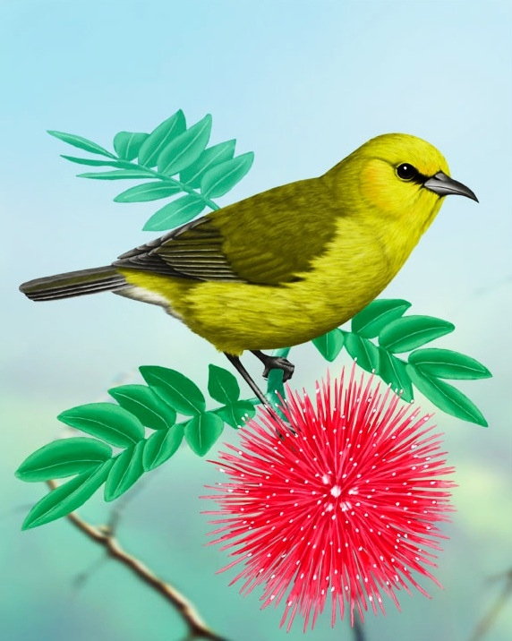2014
‘Amakihi Breeding Lab
Introduction
The Hawaiian Islands have 113 endemic birds species, unique creatures that only exist in Hawaii. These ranged from tiny nectar eaters to gigantic, 200 pound ducks. Today, 80% of these species are either endangered or already extinct! Humans caused this biological tragedy by changing land from nature into farms or towns, by introducing new predator and competitor species such as rats and pigeons, and by introducing new diseases such as avian malaria.

‘Amakihi are little green-and-yellow forest birds. Like other endemic Hawaiian birds, they were hit hard by avian malaria. Mosquitoes transferred the malaria parasite to ‘amakihi birds and they either died or got too sick to reproduce. ‘Amakihi numbers plummeted. The only forests where you could find ‘amakihi were high up on the top of mountains where it was too cold for mosquitoes to breed.

But then, in 2005, large flocks of ‘amakihi appeared with the ability to survive avian malaria! Their children could survive malaria infection, too. These birds are now spreading around the Hawaiian Islands, reclaiming mosquito-ridden forests once off-limits to this species. How did ‘amakihi evolve this new ability?

Procedure
Invent a way to simulate breeding in an ‘amakihi population.
1. Start with these parent birds (P₁)
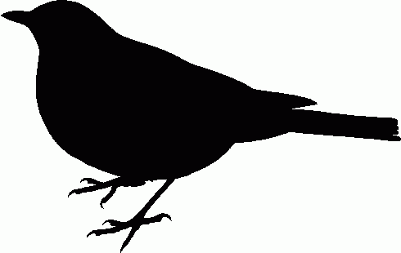
AA Aa aa aa aa

Aa aa aa aa aa

aa aa aa aa aa

aa aa aa aa aa

2. Simulate Random Mating
Randomly choose 2 birds to produce each baby chick.
Randomly pass alleles from parent birds to baby chicks.
Produce 20 chicks through random mating.

3. Breed 5 Generations
Breed P₁ birds to create an F₁ generation. Breed F₁ birds to produce an F₂ generation, etc.
Use your simulation to produce a flock of great-great-grandchildren, 5 generations in the future.
Record all genotypes for each generation.
Procedure (continued)
Describe your simulation like they were the rules for a game.

Results
Record each bird's genotype for every generation; create the appropriate data tables.

Analysis
1. Describe the way you produced random mating. Did every bird (and every allele) have an equal chance to reproduce?

2. Play a different group's game. Compare the randomization between your game and theirs.

3. What happened to the A allele? By generation 5, was A more common than before?
Grading | points worth | points earned
Procedure  simulation produces random mating  each generation produces the next | 4
Results  genotypes appropriately recorded | 3
Analysis  answers refer to data | 3
Total dl | 10

