Name: _________________________

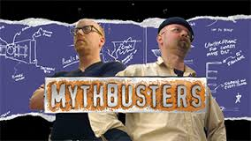

Episode Title: ___________________________

1. **Question/Problem:** What myth or legend are they investigating? Pick one if there are more than one in the clip you are viewing.
2. **Research:** What did they know before they began investigating?
3. **Hypothesis:** What is your hypothesis?
4. **Experiment:** What did they do to investigate the myth/legend? Write out the experimental steps.
5. **Conclusion:** What did they learn from their investigation – confirmed or busted? Why?
6. Identify the variables and constants involved in the investigation.

Independent variable: _______________________

Dependent variable: _________________________

Constant: ________________________

1. Identify the safety measures they used to prevent accidents and/or injuries.
2. Are their results reliable? Explain.