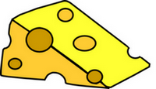
Who Ate the Cheese?!
Objectives: In this simulation you will examine crime scene evidence to determine who is responsible for eating the Queen's special imported Lindbergher Cheese (yes, the stinky cheese). You will model the process of electrophoresis and DNA fingerprinting.

ROYAL GUARD INCIDENT REPORT

Incident Data
Incident Type: | Theft |  | Complaint Status | Pending DNA results
Processed by: | Chief Wiggam |  | Other Officers: | Officer Li Gase

Property
Property Code: | Rare cheese |  | Owner's Name | Queen Elizabeth
Name: | Lindbergher |  | Value: | $12,000

Burglary Data
Method of Entry: Unknown, no evidence of force on doors or windows.
Narrative: The cheese was allegedly stolen from the Queen's sitting room the night before the grande ball. The cheese was listed as a gift from the Manchurian diplomat. Officer Li Gase dusted for fingerprints and found none on the table or doors, the maid claimed that they had been wiped clean earlier. The wheel of cheese was on a platform in the sitting room, and half of it had been eaten. We took pictures of the half eaten cheese and sent it to the lab for further tests. Edna N. Zime, the lab technician said that saliva samples could be taken from the teeth imprints of the cheese that was left behind.

Suspect Data
Suspect Number: 1
Name: Princess Dubbah Elix
Description of Suspicion: The princess was seen entering the sitting room earlier in the evening. She is well known for her love of cheese.
Suspect Number 2
Name: Electra Foresis
Description of Suspicion: Electra was recently involved in a relationship with the Manchurian diplomat that sources say ended badly. Her motive may have been to sabotage the diplomat's gift to the Queen.
Suspect Number 3
Name: Ada Nine
Description of Suspicion: Ada was the maid in charge of cleaning the sitting room. She had access to the cheese.
Suspect Number 4
Name: Gene Tics
Description of Suspicion: Gene is the leader of the local Cheese-Makers Guild, he may not have wished for Queen Elizabeth to have cheese from anywhere but his own guild.

Crime Lab Data
Crime Lab Investigator | R. Renee |  | Lab Technician | Edna N. Zime
List of Evidence Received | Plastic bag with cheese crumbs |  | List of Procedures Used | DNA extraction  Polymerase Chain Reaction  DNA restriction Analysis
Narrative: After receiving the package with the plastic bag marked Crime Scene, the DNA was extracted. Because the sample was so mall, the DNA was amplified using the polymerase chain reaction. We isolated the DNA from the four suspects and compared them to the crime scene DNA using DNA restriction analysis.
Results: See attached DNA Results
Name:______________________________________ Date:______________ Period:_____
DNA Evidence Evaluation: Who Ate the Cheese?
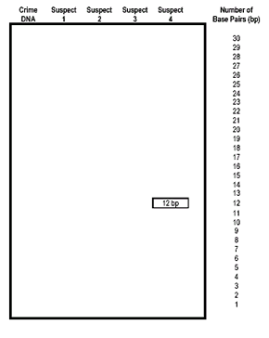
Procedure:
1. Turn your paper strips (DNA sequences) so that the side with the bases is facing you. The restriction enzyme cuts at every point it finds C C G G, always cutting between the C and the G. Label the back of the slips with the suspect number so that you don't get them confused after cutting. Use scissors to cut the DNA sequence at the C C G G points.
2. Count the number of base pairs (bp) in each piece of DNA that you created. Record the base pair number on the back side of the DNA fragment.
3. Make an enlarged chart (gel) like the one shown. Your teacher will give you paper for this. Use a ruler to ensure that the lengths are uniform.
4. Tape your DNA fragments to the chart, using the base pair numbers as a guideline for fragment placement.
5. Compare the crime scene DNA to the suspects and indicate on your chart, which suspect is guilty of eating the cheese.

Analysis:
1. On your chart, label the positive (+) and the negative (-) ends. Circle the suspect's DNA who matches the DNA at the crime scene and write the name of the suspect.
2. For each of the following tasks performed in the activity, describe what they are actually simulating.
Cutting the DNA into fragments:____________________________________________
Taping the DNA onto the large paper: _________________________________________

3. For each word below, describe how it relates to DNA Fingerprinting:
Polymerase Chain Reaction:___________________________________
Gel Electrophoresis: ________________________________
Restriction Enzyme: __________________________________

