Name: __________________________________________

Water Potential Worksheet

Water potential is the potential of water to leave an area. It is waters ability to ‘get up and go’. High water potential represents a high potential to leave. Low water potential represents a low potential to leave. Therefore, water moves from an area with a high water potential to an area with low water potential.

1. Write the formula for water potential.
__________________________________________

2. Write the formula for solute potential.
__________________________________________

3. What does each of the symbols mean?

Symbol | Meaning
i
C
R
T

4. Water moves from an area of ___________________ water potential to an area of ___________________ water potential.

5. Can Ψ_{s} be a positive number? Explain. ______________________________________________________ ___________________________________________________________________________________

6. Pure water has a Ψ = ____________

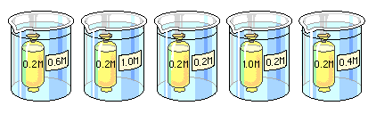
7. Arrange the beakers above in order of the mass of the bags inside them after the experiment has run for 30 minutes. List the bag that loses the most mass first.

8. In beaker B, what is the water potential of the distilled water in the beaker, and of the beet core?

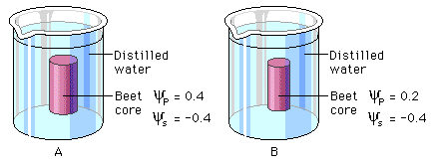

Ψ of water in Beaker B: _____________

Ψ of Beet core: _____________

9. Which of the following statements is true for the diagrams above? ___________
a. The beet core in beaker A is at equilibrium with the surrounding water.
b. The beet core in beaker B will lose water to the surrounding environment.
c. The beet core in beaker B would be more turgid than the beet core in beaker A.
d. The beet core in beaker A is likely to gain so much water that its cells will rupture.
e. The cells in beet core B are likely to undergo plasmolysis.

10. Calculate the Ψs of a .6 molar sucrose solution at 22°C. (sucrose does not ionize so i = 1.0) Show your work.

11. What effect does adding solute to distilled water have on the solute potential of that solution? Why?
____________________________________________________________________________________ ____________________________________________________________________________________

12. Consider what would happen to a red blood cell (RBC) placed in distilled water.

a. Which would have the higher concentration of water molecules? (circle one)

DISTILLED WATER RBC

b. Which would have the higher water potential? (Circle one)

DISTILLED WATER RBC

c. What would happen to the red blood cell? Why?
____________________________________________________________________________________ ____________________________________________________________________________________

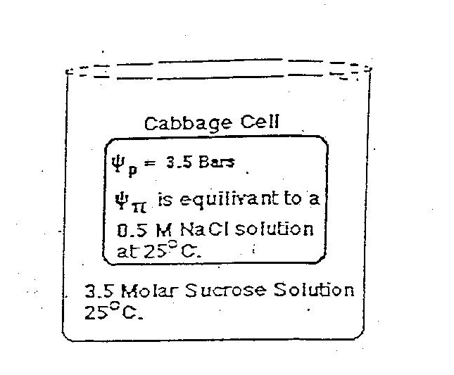
13. In the space below calculate the water potential of the fluid in the beaker. Be sequential, show formulas and work. Note solute potential in the cabbage cell is equivalent to 0.5M NaCl at 25°C.

14. In the space below calculate the water potential of the red cabbage cell that has just been placed in the beaker. Be sequential, show formulas and work.

15. If the membrane of the cabbage cell is permeable only to water will water move from cell to beaker of beaker to cell?
___________________________________________________________________________________

16. Dialysis bags containing a 0.5% starch solution are placed in beakers containing the starch solutions indicated below:

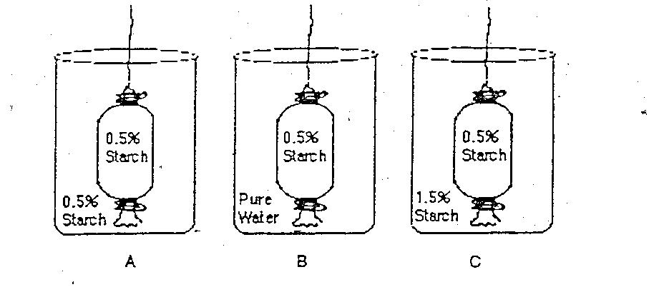
Indicate the letter of the beaker in which the following events occur.

- The dialysis bag remains the same size __________
- The dialysis bags swells. ___________
- Water moves from the dialysis bag into the beaker. ______________
- The solution inside the bag is hypotonic to its surroundings. ___________
- Water potential inside the bag is higher than water potential outside the bag. ___________
- The solution inside the bag is isotonic.to the solution outside the bag. ___________

17. A plant cell, when initially placed in pure water, has an solute potential of -4 bars and a pressure potential of + 2 Bars.
Which way will the water go? ________________________________

18. A protozoan cell is placed in a O.5M sucrose solution at 27°C. Assume the cell has a solute potential of -2 bars. Because the protozoan lacks a cell wall, it cannot generate turgor pressure and will always have a pressure potential of 0 bars.

- When the cell is placed in a sucrose solution, which way will water go? __________
- What will be the appearance of the cell when equilibrium is reached?_____________
- What will be the cells Ψ_{p} value at equilibrium?__________________

19. Given the following scenarios draw an arrow representing the movement of water across these semi-permeable membranes.
a. b. c.

ψ = 1.2 ψ = 3.2 ψ = 0 ψ = 2.3 ψ = -2.3 ψ = 0

20. For the following molarities of sucrose, calculate the water potential of each.
Ψ_{S} = -I C R T. Sucrose’s ionization constant is 1. The pressure constant (R) is 0.0831 liter bars/mole ºK. And the experiments was run at 23 ºC. (Convert to Kelvin by adding Celsius to 273). SHOW WORK BELOW
  - 1.1 Mol/Liter = __________________
  - 0.3 Mol/liter = ___________________
  - 0.0 Mol/Liter = ___________________
  - 7 Mol/Liter = ___________________

21. Santa Claus is trying to repeat these experiments at the North Pole. The temperature is -3 ºC, calculate the new ψ for each problem from #20.
SHOW WORK BELOW
a. Ψ = ___________________
b. Ψ = ___________________
c. Ψ = ___________________
d. Ψ = ___________________

22. Describe the relationship of temperature to water potential.
___________________________________________________________________________________
23. How does sugar or salt curing preserve meat? _________________________________________________ ______________________________________________________________________________________________________________________________________________________________________________________________________________________________________________________________________________
24. Why will your favorite plant likely die if you apply twice the recommended amount of fertilizer?
______________________________________________________________________________________________________________________________________________________________________________________________________________________________________________________________________________

