Name: _____________ Period: Date:

The Structure of Leaves

1. Label the following parts of this diagram: stalk, midrib, blade, smaller vein.

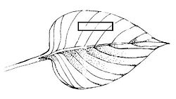

1. Label the following parts of this diagram of a leaf section: air spaces, upper epidermis, lower epidermis, wax layer, guard cell, wax layer, vein, stomate, spongy layer, palisade layer.

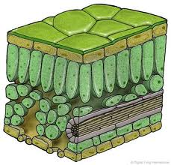

a. what is the function of stomates? _________________________________________________

b. what is the function of vein? __________________________________________________

1. Using these colors, shade in the following parts on the diagram above:

Green-leaf cells that make food Blue-leaf cells that carry water and food

Red-leaf cells that protect Yellow-waterproof layers

1. Below is a picture of Chloroplast.



a. Where does light reaction occur? ________________

b. Where does Calvin Cycle happen? _________________

c. Draw the structures involved in photosynthesis and

write the starting materials and end products of each

process.

1. Write the overall chemical reaction of Photosynthesis

______________________________________________________________________________

1. Overview of Photosynthesis

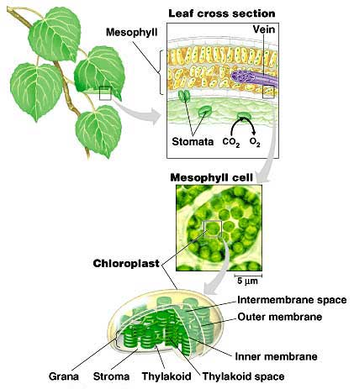

1. Notes on Light reaction and Calvin cycle