Name:___________________ Date: _________________ Period: ____
Pre-Frog Dissection Worksheet
Read pages 804-812 in Biology Textbook to answer the following questions.
Extra Credit: Frogs are amphibians. What are amphibians? _______________________________
- What is Mucous Gland?
- What are the two functions of skin?
- Identify an advantage and a disadvantage to the permeability of amphibian skin.
- How is it possible to measure the health of ecosystem through amphibian’s (frog’s) skin?
- Why do amphibians spend most of their time in moist environments?

- Label the following diagram
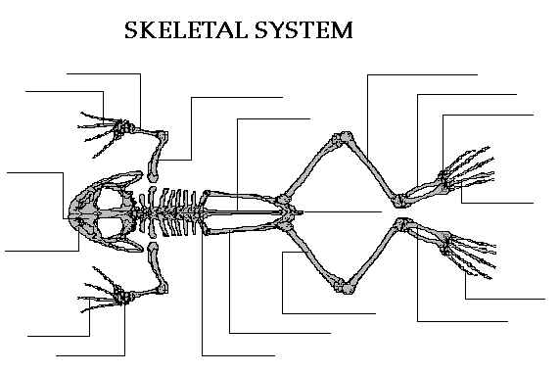
- Human heart has four chambers. How many chambers do frog hearts have? ______
- What are the four main steps of the circulatory system in frogs? Draw a frog heart and explain.
- Define Pulmonary Circulation and Systematic Circulation.
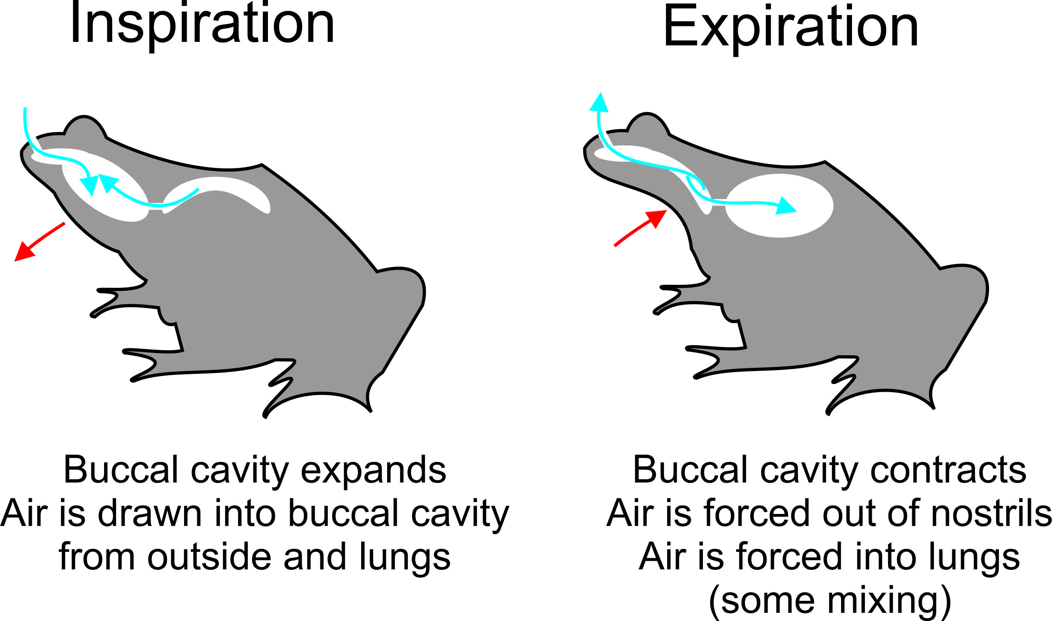
- Label the Respiration Diagram & explain how pulmonary respiration is accomplished.

- What is Cutaneous Respiration?
- Label the Digestive System below & define the following words: Duodenum, Ileum, Mesentery and Vent .
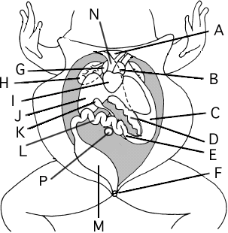
- Amphibians like frogs are carnivorous. What do frogs eat?
- Liver produces bile which is stored in gall bladder. Its main function is ______________.
- What is the role of pancreas?
- What is the function of kidneys?
- What features do the digestive and excretory systems have in common?

- Define Nictitating Membrane, Tympanic Membrane, and Columella.
- How is stimuli received in the brain?
- Sequence the stages of a frog’s life cycle.

- Describe the two strategies that have been found in frogs for protecting eggs and developing the young.

HW: Please complete virtual frog dissection online and be ready for dissection on Monday.

