No Bones About It
Activity 1.
When a body is discovered, it is important to learn as much as possible from the remains. Forensic anthropologists use mathematical formulas to estimate someone’s height from the lengths of certain bones in their body. But where do these formulas come from?

1. Using a metric ruler, measure the length of your femur (thigh bone) in centimeters. This is the large bone that runs from your hip socket to your knee cap. Record this information in the table below.
2. Have a partner measure your actual height in centimeters. Record this information in the table below.
3. Collect the same information (femur length and height) from several of your classmates. Leave the “calculated height” row blank for now.
Table 1: Classroom Measurements
Name

Femur Length(cm)
Height (cm)
Calculated Height (cm)

4. Use the graph paper below to graph the data you’ve collected. Use the Femur Length for the x-axis and Height for the y-axis.

5. Use the graph to answer the following question:
What relationship is there between the length of someone’s femur bone and their height?

Anthropologists performed hundreds of calculations like the one we just did. Their calculations showed that a person’s height can be estimated using the lengths of the long bones of the body - the femur, tibia, and fibula in the leg and the ulna, radius, and humerus of the arm. However, the relationship between the length of these bones and a person’s height is different from men and women, and for people from different races. The table next page lists all the different equations forensic anthropologists use to estimate a person’s height.
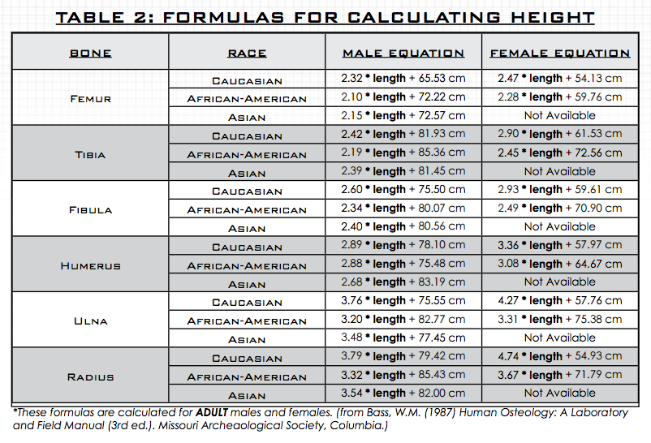
Use the table to fill the “Calculated Height row on Table 1. Are you results close to the actual height? What are some possible sources of error? ____________________________________________________________________________________
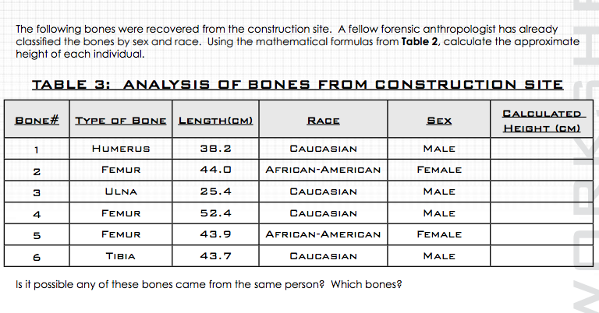
____________________________________________________________________________________________________________________________

What is the minimum number of bodies buried at this site? What is the maximum number of bodies?

____________________________________________________________________________________________________________________________

Do all bones from the same body give exactly same height? If not, why would the heights be different?

____________________________________________________________________________________________________________________________

Another forensic anthropologist on the team estimates the remains have been buried three to four years. A search of the local missing person’s database shows that the following people disappearing during that time.
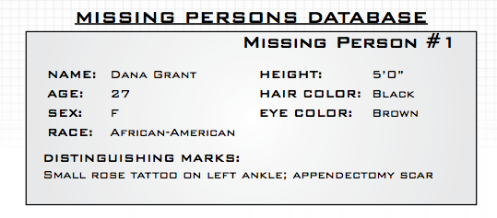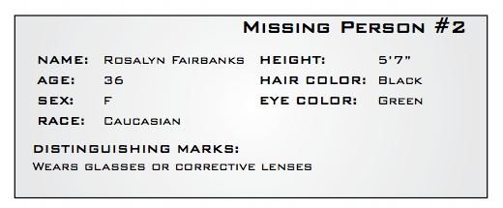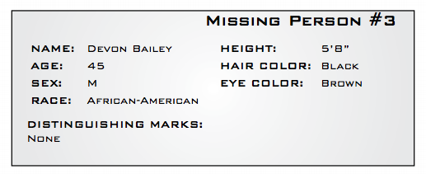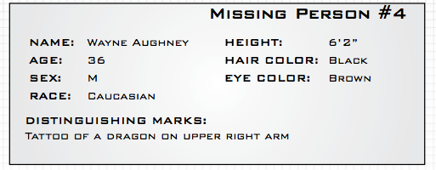
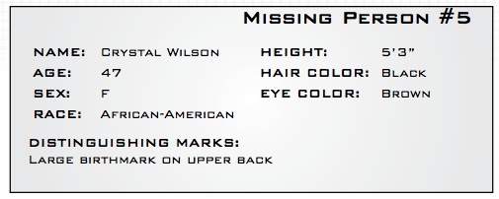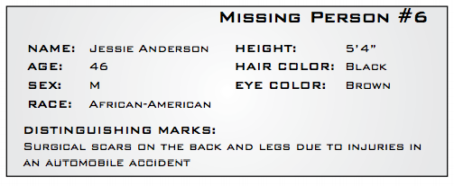

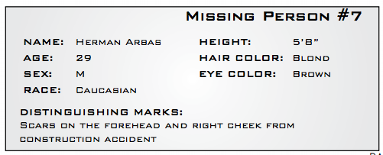
Using the database, can you determine the possible identities of the people buried at the site?

Are you heights exactly what you expected them to be?

What are some possible sources of error in your identification?

What other forensic tests could you do to test your deduction?

