Instructions: This exam contains 48 multiple-choice questions and 2 grid-in questions.
Indicate all of your answers on the answer sheet. Units are not required for grid-in items. Use your time effectively, working as quickly as you can without losing accuracy. Do not spend too much time on any one question. Go on to other questions and come back to the ones you have not answered if you have time. It is not expected that everyone will know the answers to all of the questions. Your total score is based only on the number of questions answered correctly. Points are not deducted for incorrect answers or unanswered questions. Time: 55 minutes. You may use a five function calculator.
Directions: Each of the questions or incomplete statements below is followed by four suggested answers or completions. Select the one that is best in each case and then fill in the corresponding circle on the answer sheet.

1. Ronald Franklin’s X-ray diffraction images taken in the 1950s most directly support which of the following claims about DNA?
- The ratios of base pairs are constant
- The nucleotide sequence determines genetic information
- The two strands of DNA are antiparallel
- The basic molecular structure is a helix
2. In 1944 Avery, MacLeod, and McCarty performed transformation experiments using live, harmless, bacteria and extracts from virulent bacteria treated with various enzymes. Which of the following enzymes were used and why?
- Protease and RNases to rule out protein and RNA as the transforming factors
- Lipase to rule out lipoproteins as a transforming factor
- Kinase to show that transformation is phosphorylation dependent
- ATPase to show that transformation is not dependent of ATP
3. A student in a biology class crossed a male drosophilia melanogaster having a grey body and long wings with a female D. melanogaster having a black body and apterous wings. The following distribution of traits was observed in the offspring.
Phenotype: Number of Offspring
Grady body, long wings; 42
Black body, apterous wings; 41
Gray body, apterous wings; 9
Black body, long wings; 8
Which of the following is supported by the data?
- The alleles for grey body and long wings are dominant
- The alleles for grey body and long wings are recessive
- Genes for the two traits are located on two different chromosomes, and independent assortment occurred
- Genes for the two traits are located close together on the same chromosome, and crossing over occurred between the last two gene loci
4. If chemical signals in the cytoplasm control the progression of a cell to the M phase of the cell cycle, then fusion of a cell in G1 with a cell in the early M phase would most likely result in the
- Replication of chromosomes only in the G1 cell
- Exiting of both cells from the cell cycle and into the G0 phase
- Condensation of chromatin in preparation of nuclear division in both cells
- Transfer of organelles from the G1 phase cell to the cell in the M phase
Cell Number | Amount of DNA in pg
1 | 5.00 x 10²⁶
2 | 2.45 x 10⁸
3 | 8.41 x 10²²
Three Possible Cell Origins
E. coli
Polyploid strawberry
Rattlesnake

- Three cells from three different organisms were obtained. The amount of DNA from each cell was extracted and measured and recorded in the table. The three possible cell origins have been listed in the second table. After reviewing this data, decide which organism provided cell number one.

- E. coli
- Polyploid strawberry
- Rattlesnake
- There is not enough information to determine the cellular origin

- Down syndrome affects a large number of American citizens. Down syndrome appears when an individual has an extra copy of chromosome 21—a condition called Trisomy 21. How could a mutation during meiosis cause this trisomic condition?

- A piece of chromosome 21 got attached to the end of chromosome number 2
- A section of the long arm of chromosome 21 is deleted and the genes in that section were lost
- There was an inversion of the genes on the q arm of chromosome 21
- The chromosome 21s did not separate during anaphase I or anaphase II

- A human experimental subject-Joe Coogan had the amount of methylation present on 5 of his genes measured. The methylation data from Joe are recorded in the graph. Which one of the following statements about gene activity in Joe in an accurate conclusion from this graph?
- Of these five genes, Joe’s NRCA 2 gene has the greatest activity.
- Of these five genes, BRCA 1 gene is the least active.
- Of these 5 genes, Joe’s hemoglobin gene is the least active.
- Of these five genes, Joe’s RAS gene is completely inactive.

- Gene regulation is very important in cells. The gene regulation processes in prokaryotes are different from the gene regulation in eukaryotes, Which one of the following might be a gene regulatory process in a prokaryote?
- Silencing of gene by compaction as heterochromatin
- Alternative splicing on introns by the spliceosome complex
- Inactivation of the genes that make tryptophan when a repressor binds to the operator
- Increasing the rate of gene activated by adding acetyl groups to the histone proteins in the chromatin
In fruit flies, long wings are dominant to vestigial wings and red eyes are dominant to brown eyes. Two flies that are heterozygous for both wing length and eye color were crossed. The phenotypes of the offspring are presented in the table.

Phenotypes of Fruit Flies | Number of Offspring Flies with that Phenotype
Long wings and red eyes | 480
Long wings and brown eyes | 40
Short wings and red eyes | 60
Short wings and brown eyes | 420
- What inheritance pattern is seen with this data?
- The data suggest that these two traits are linked on the same chromosome.
- The data displays simple Mendelian inheritance.
- The two alleles for wing length are codominant.
- The brown eye allele appears to be located on the X chromosome.

- Use the data in the table to calculate the cross-over frequency for these two fruit fly traits.
- 0%
- 5%
- 10%
- 50%

Hormone | Reaction Speed (milliseconds)
Insulin | 2.7
Testosterone | 48.2
T3 | 3.1
Estrogen | 51.4

- A table was given to show the reaction rates of 4 different hormones in a human subject. What information about the hormone structures can be taken from these data?
- Since the reaction rates are slow for both estrogen and testosterone, they are probably steroid hormones.
- Insulin is a steroid hormone made by the adrenal cortex.
- T₃ and estrogen are both protein hormones.
- Faster reaction rates are indicative of steroid hormones.

- Hemophilia is a bleeding disorder that is due to a recessive X-linked allele. If Mary is heterozygous for hemophilia and Bob suffers from hemophilia, what is the probability of their daughters having hemophilia?
- 0%
- 25%
- 50%
- 100%

- There are several enzymes involved with the DNA replication process. Why is DNA ligase involved with the production of the lagging strand of DNA but not the leading strand of DNA?
- DNA ligase unzips the parental DNA double helix.
- DNA ligase adds nucleotides to an exposed 3’ side.
- DNA ligase holds the separated single strands of DNA apart.
- DNA ligase connects the Okazaki fragments together.

- The graph above shows the number of acetyl groups attacked to the histones of four different genes that are present in the poppy plant. Analyze this data to conclude which gene has the highest activity level.
- Pattern formation gene
- Meristem identity gene
- Flowering gene
- Polarity gene

15. A dog is following the scent of a jackrabbit. Which of the following accurately describes how the dog’s brain integrates information for smell?
A) Chemoreceptors in the brain send impulses for smell in the nasal cavity.
B) Chemoreceptor cells in the nasal cavity sends impulses to the appropriate area of the brain.
C) Chemoreceptors on epithelial cells of the tongue send hormones to the appropriate area of the brain.
D) Receptors originating in the nose send action potentials to the motor regions of the brain.

16. Thrips are insects that feed on rose pollen. Scientists noted that the thrips population increased in the spring and decreased dramatically during the summer. The researchers hypothesized that food abundance was the limiting factor for the population. Which of the following types of data would be most useful for the scientists to collect at regular intervals on a designated test plot of rose plants?
A) Amount of sunlight (hours/day)
B) Mean temperature (oC)
C) Density of rose pollen produced (g/m2)
D) Amount of pollen produced by each flower (g/flower)

17. If ATP breakdown (hydrolysis) is inhibited, which of the following types of movement across cell membranes is also inhibited?
A) Movement of oxygen into a cell
B) Movement of water through aquaporins
C) Passage of a solute against its concentration gradient
D) Facilitated diffusion of a permeable substance

18.
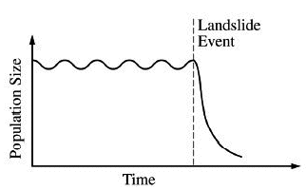
Undersea landslides can disrupt marine habitats by burying organisms that live on the ocean floor. The graph above shows the size of a population of a certain organism that lives on the ocean floor. The population was affected by a recent landslide at the time indicated on the graph. Which of the following best predicts how the population will be affected by the landslide?
A) The surviving organisms will evolve into a new species.
B) The reduced population will likely have allelic frequencies that are different from the initial population.
C) The population will adapt to deeper waters to avoid future landslides.
D) The reduced population will have a greater number of different genes than the initial population.

19. Which of the following questions is most relevant to understanding the Calvin cycle?
A) How does chlorophyll capture light?
B) How is ATP used in the formation of 3-carbon carbonhydrates?
C) How is NADP+ reduced to NADPH?
D) How is ATP produced in chemiosmosis?

20.
The equation above shows one of the reversible reactions that occur in blood. After exercise, an athlete’s blood pH has dropped below the normal level. How will normal blood pH be restored?
A) An increase in O2 concentration in the plasma will lead to an increase in H+ concentration.
B) An increase in temperature will lead to an increase in H+ concentration.
C) An increase in sweating will lead to a decrease in OH – and H+ concentration
D) An increase in breathing rate will lead to a decrease in blood CO2 and H+ concentration.

21. A researcher is investigating the relationship between the existing species diversity in a community and the ability of an introduced nonnative species to destabilize the community. Which of the following graphs is most consistent with the claim that communities with high diversity are more resistant to change than are communities with low diversity?
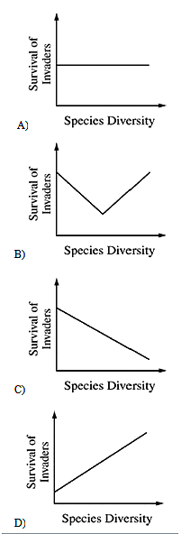

Questions 22–25
The figures below show the changes in populations of two species of flour beetles, Tribolium confusum (Figure I) and Tribolium castaneum (Figure II), in cultures without parasites (o) and in cultures infected with a parasite ( •). Each data point represents the mean population size from ten culture dishes of equal size and food content.
22. Under which of the following conditions is the observed number of beetles per culture dish the greatest?
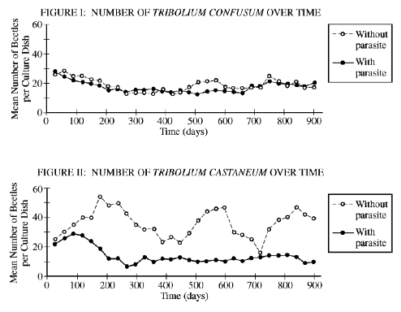
A) T. confusum with parasite at 500 days
B) T. confusum without parasite at 300 days
C) T. castaneum with parasite at 100 days
D) T. castaneum with parasite at 600 days

23. The data over the duration of the experiment provide the strongest support for which of the following conclusions regarding the effect of the parasite on Tribolium populations?
A) T. confusum is adversely affected by the parasite, while T. castaneum is not.
B) T. castaneum is adversely affected by the parasite, while T. confusum is not.
C) Both T. confusum and T. castaneum are adversely affected by the parasite.
D) Both T. confusum and T. castaneum show increased fitness in the presence of the parasite.

24. In Figure I, the difference between the two curves can best be attributed to which of the following?
A) The difference between controlled laboratory conditions and the natural environment
B) The effect of the host on its parasite
C) The influence of competition for limited resources
D) The natural variation among populations

25. If the experiment was continued for an additional 500 days, the population density of T. castaneum with the parasite would most likely stabilize at a value closest to which of the following?
A) 5 beetles/culture dish
B) 10 beetles/culture dish
C) 20 beetles/culture dish
D) 25 beetles/culture dish

26. The vertebrate forelimb initially develops in the embryo as a solid mass of tissue. As development progresses, the solid mass near the end of the forelimb is remodeled into individual digits. Which of the following best explains the role of apoptosis in remodeling of the forelimb?
A) Apoptosis replaces old cells with new ones that are less likely to contain mutations.
B) Apoptosis involves the regulated activation of proteins in specific cells of the developing forelimb that leads to the death of those cells.
C) Apoptosis involves the destruction of extra cells in the developing forelimb, which provides nutrients for phagocytic cells.
D) Apoptosis in the developing forelimb triggers the differentiation of cells whose fate was not already determined.

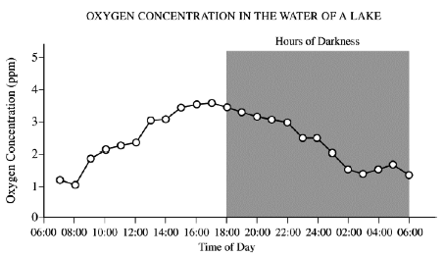
27. What most likely causes the trends in oxygen concentration shown in the graph above?
A) The water becomes colder at night and thus holds more oxygen.
B) Respiration in most organisms increases at night.
C) More organisms are respiring at night than during the day.
D) Photosynthesis produces more oxygen than is consumed by respiration during the day.

Data regarding the presence (+) or absence (-) of five derived traits in several different species are shown in the table below.
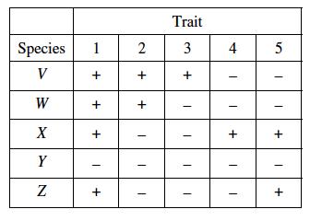
28. Which of the following cladograms provides the simplest and most accurate representation of the data in the table?
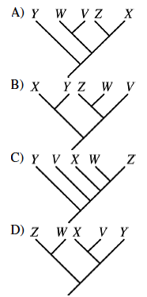

29. A common laboratory investigation involves putting a solution of starch and glucose into a dialysis bag and suspending the bag in a beaker of water, as shown in the figure below.
The investigation is aimed at understanding how molecular size affects movement through a membrane. Which of the following best represents the amount of starch, water, and glucose in the dialysis bag over the course of the investigation?
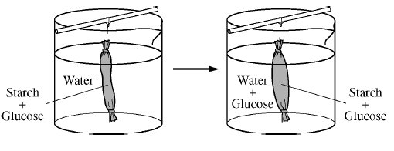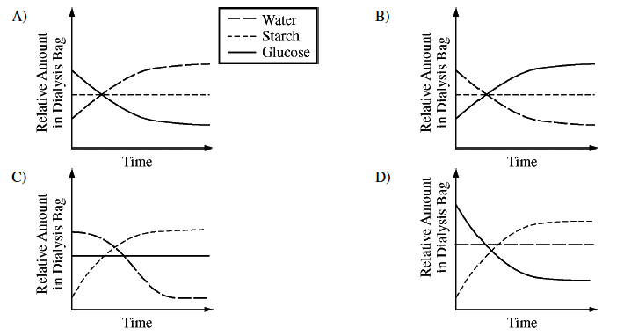

Questions 30–32
Rhagoletis pomonella is a parasitic fly native to North America that infests fruit trees. The female fly lays her eggs in the fruit. The larvae hatch and burrow through the developing fruit. The next year, the adult flies emerge.
Prior to the European colonization of North America, the major host of Rhagoletis was a native species of hawthorn, Crataegus marshallii. The domestic apple tree, Malus domestica, is not native to North America, but was imported by European settlers in the late 1700s and early 1800s.
When apple trees were first imported into North America, there was no evidence that Rhagoletis could use them as hosts. Apples set fruit earlier in the season and develop faster, where hawthorns set later and develop more slowly.

Recent analysis of Rhagoletis populations has shown that two distinct populations of flies have evolved from the original ancestral population of flies that were parasitic on hawthorns. One population infests only apple trees, and he other infests only hawthorns. The life cycles of both fly populations are coordinated with those of their host trees.

The flies of each population apparently can distinguish and select mates with similar host preferences and reject
mates from the population specific to the other host tree. There between the two groups
is very little hybridization (only about 5 percent)

30. The divergence between the two populations of Rhagoletis must have occurred very rapidly because
A) the apple tree was imported into North America with European settlement approximately 200 years ago
B) flies were imported into North America with European settlement approximately 200 years ago
C) long-distance rail transport of fruit increased only after the American Civil War (1861 –1865)
D) heavy use of gunpowder during the American Civil War (1861 –1865) led to increased mutation rates in many natural populations of plants and animals

31. Initially, which of the following isolating mechanisms is likely to have been the most important in preventing gene flow between the two populations of Rhagoletis?
A) Gamete incompatibility
B) Temporal isolation
C) Mechanical isolation
D) Reduced hybrid viability

32. Matings between individuals from the two populations of Rhagoletis produce hybrid flies that appear to be healthy and have normal life spans. The eggs laid by these hybrid flies, however, hatch less often than those of flies from either of the two populations. What isolating mechanism seems to be important in this hybrid population?
A) Prezygotic isolation
B) Mechanical isolation
C) Reduced hybrid fertility
D) Habitat isolation

33. Scientists have found that the existing populations of a certain species of amphibian are small in number, lacking in genetic diversity, and separated from each other by wide areas of dry land. Which of the following human actions is most likely to improve the long-term survival of
the amphibians?

A) Cloning the largest individuals to counteract the effects of aggressive predation
B) Reducing the population size by one-fifth to decrease competition for limited resources
C) Constructing a dam and irrigation system to control flooding
D) Building ponds in the areas of dry land to promote interbreeding between the separated populations

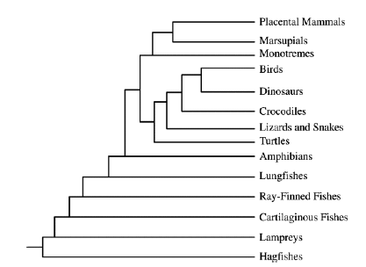
34. To determine the evolutionary history and relationships among organisms, scientists gather evidence from a wide variety of sources including paleontology, embryology, morphology, behavior, and molecular biology. A phylogenetic tree of vertebrates is shown. Which of the following statements is most consistent with the phylogenetic tree shown?
A) Birds and turtles evolved their own means of gas exchange independently of the other vertebrates.
B) Mammals are most closely related to birds because they share a direct common ancestor.
C) The common ancestor of reptiles, birds, and mammals produced amniotic eggs.
D) Crocodiles are direct descendents of ray-finned fishes since they live in the same
environment.

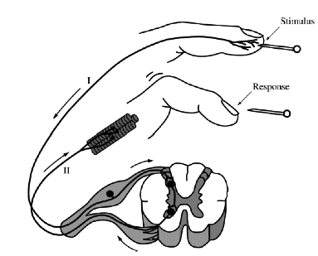
35. The diagram above depicts the response to a pinprick (stimulus) on the tip of a human finger. The arrows show the direction of impulse transmission along the labeled axons. If axon II was damaged before the pinprick, which of the following is most likely?
A) The person will not feel the pinprick.
B) The person can no longer feel pain.
C) The person’s finger will not withdraw reflexively.
D) The person cannot transmit nerve impulses to the brain.

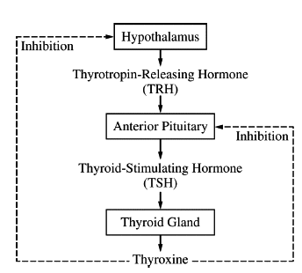
36. The diagram above illustrates feedback control as exerted by the hormone thyroxine. Following surgical removal of the thyroid gland, the level of TSH in the blood will increase. Which of the following best explains this increase?
A) Residual blood thyroxine, from prior to thyroid gland removal, will bind to cells in the anterior pituitary, signaling more TSH secretion.
B) Thyroxine will remain bound to thyroxine receptors on various body cells, and these body cells will secrete additional hormones that stimulate the anterior pituitary to secrete TSH.
C) Thyroxine that was stored in the anterior pituitary prior to thyroid gland removal will signal more TSH secretion.
D) A decrease in thyroxine levels means a loss of inhibition to the hypothalamus and anterior pituitary, leading to increased TSH secretion.

37.
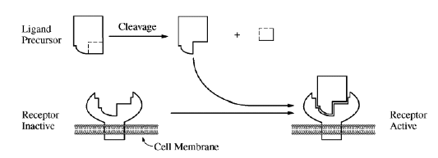
The figure above shows a model of a ligand precursor being cleaved to produce an active ligand that binds to a specific receptor. Which of the following is most likely to reduce the binding of the active ligand to its receptor?
A) A change in the cytoskeletal attachment of transmembrane proteins
B) The presence of a large amount of the precursor form of the ligand
C) An increase in the ratio of the number of unsaturated to the number of saturated fatty acid tails of the membrane lipids
D) A mutation in the receptor gene that causes a substitution of a charged amino acid for a
nonpolar amino acid in the ligand binding site of the receptor

Questions 38-41
A biologist spent many years researching the rate of evolutionary change in the finch populations of a group of islands. It was determined that the average beak size (both length and mass) of finches in a certain population increased dramatically during an intense drought between 1981 and 1987. During the drought, there was a reduction in the number of plants producing thin-walled seeds.
- Which of the following procedures was most likely followed to determine the change in beak size?
  - A) A few finches were trapped in 1981 and again in 1987, and their beak sizes were compared.
  - B) The beak size in fifteen finches was measured in 1987, and the beak size in the original finches was determined by estimation.
  - C) The beak size in a large number of finches was measured every year from 1981 to 1987.
  - D) Finches were captured and bred in 1981, and the beak size of the offspring was measured

39. Which of the following statements might best explain the increase in average beak size in the finch population during the drought?
  - A) Finches with bigger beaks are better able to crack thick-walled seeds and produce more surviving offspring.
  - B) Finches with bigger beaks can attack and kill finches with smaller beaks.
  - C) Finches with bigger beaks possess more powerful flight muscles and are able to find more food.
  - D) Finches that crack large seeds develop larger beaks over time.

40. Which of the following best describes the mechanism behind the change in beak size in the finch population?
- The formation of two new finch species from a single parent species
- A change in gene frequencies in the finch population due to selective pressure from the environmental change
- A new allele appearing in the finch population as a result of mutation
- The achievement of dynamic equilibrium in the finch population as a result of homeostasis

41. The biologist discovered that from 1988 to 1993, the average beak size declined to pre-1981 levels. The reversal in beak size from 1988 to 1993 was most likely related to which of the following events?
A) A loss of food supply for the finches
B) The end of the drought
C) An increase in drought conditions
D) An increase in predators consuming finches

42. Which of the following statements most directly supports the claim that different species of organisms use different metabolic strategies to meet their energy requirements for growth, reproduction, and homeostasis?
A) During cold periods pond-dwelling animals can increase the number of unsaturated fatty acids in their cell membranes while some plants make antifreeze proteins to prevent ice crystal formation in tissues
B) Bacteria lack introns while many eukaryotic genes contain many of these intervening sequences.
C) Carnivores have more teeth that are specialized for ripping food while herbivores have more teeth that are specialized for grinding food.
D) Plants generally use starch molecules for storage while animals use glycogen and fats for storage.

- In mice, the homozygous mice are black and white. The heterozygous mice are gray. What pattern of inheritance is expressed in fur color of mice?
- Complete dominance and recessiveness
- Codominance
- Incomplete dominance
- Pleiotropy

44. Photosynthetic activity can be measured using chloroplasts suspended in a buffered solution containing DCPIP, a dye that can accept electrons from the electron transport chain of photosynthesis. Transfer of electrons to DCPIP decreases the relative absorbance of a specific wavelength of light (605 nm) by a solution that contains the dye. A buffered solution containing chloroplasts and DCPIP was divided equally among six identical samples. The samples were placed at various distances from a lamp, and then all samples were exposed to white light from the lamp for 60 minutes at room temperature. Sample 3 was wrapped in foil to prevent any light from reaching the solution. At 20-minute intervals, the photosynthetic activity in each sample was determined by measuring the relative absorbance of 605 nm light. The results of the experiment are provided below.
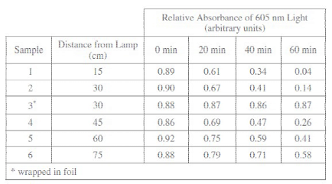
44. Which of the following provides the best indication that light is required for the activation of electron transfer reactions in chloroplasts?
A) Calculating the rate of change of the absorbance for sample 1
B) Comparing the observed results for sample 2 and sample 3
C) Repeating the entire experimental procedure at night
D) Including multiple trials for all the samples

45. Which of the following can be reasonably concluded from the experimental results?.
A) Chloroplasts must be suspended in a buffer solution to function properly.
B) The optimal temperature for activation of electron transfer is 25o C.
C) DCPIP inhibits biochemical reactions in suspended chloroplasts.
D) Light from a lamp can substitute for sunlight in stimulating chloroplast processes

46. If an additional sample containing the chloroplast/DCPIP solution was placed at a distance of 90 cm from the lamp, which of the following predictions would be most consistent with the experimental results?
A) The concentration of DCPIP in the solution will increase exponentially.
B) The absorbance at 60 minutes will be roughly equal to 1.4.
C) The change in absorbance over time in the solution will be less than that of the other samples.
D) The temperature of the solution will exceed 75o C.

47. Which of the following descriptions of photosynthesis best explains the results of the experiment?

A) Availability of electrons for transfer to DCPIP depends on light energy.
B) Movement of DCPIP across chloroplast membranes occurs in less than 60 minutes.
C) Chlorophyll molecules degrade rapidly in the presence of DCPIP.
D) DCPIP can only be used to measure photosynthetic activity at low light levels.

48. Which of the following scientific questions could be investigated using a similar experimental setup?
A) How much carbon dioxide is required by a plant cell to produce one molecule of glucose?
B) What wavelength of light best activates electron transfer reactions in chloroplasts?
C) Which molecule in chloroplasts accepts activated electrons from DCPIP during photosynthesis?
D) Are the same genes that are expressed in chloroplasts also expressed in mitochondria?

Grid-In Questions
1. A certain species of plant has four unlinked genetic loci, W, X, Y, and Z. Each genetic locus has one dominant allele and one recessive allele. For a plant with the genotype WwXxYyZz, what is the probability that the plant will produce a gamete with a haploid genotype of Wxyz ? Give your answer as a fraction or as a value between 0 and 1, to four decimal places.
2. In pea plants, yellow peas are dominant to green peas. Smooth peas are dominant to wrinkled peas. Two plants the heterozygous for both traits are crossed. If there are a total of 5000 offspring pea plants, what number would be expected to have green, wrinkled peas?

