Step 1. Question1 – What would happen if the population size decreases from1000 to 100? (bottleneck effect)
Step 2 Variable - population size
Step 3 Hypothesis – If the population size decrease, then there will no H-W equilibrium where the allele frequency will shift to one either A1 or A2 (p or q) because small size violates one of the five conditions for H-W equilibrium.
_{Step 4 Result}
Normal (fitness all 1, no mutation, no migration, 200 generations, all allele frequency begin w/ p=0.5, q=0.5)
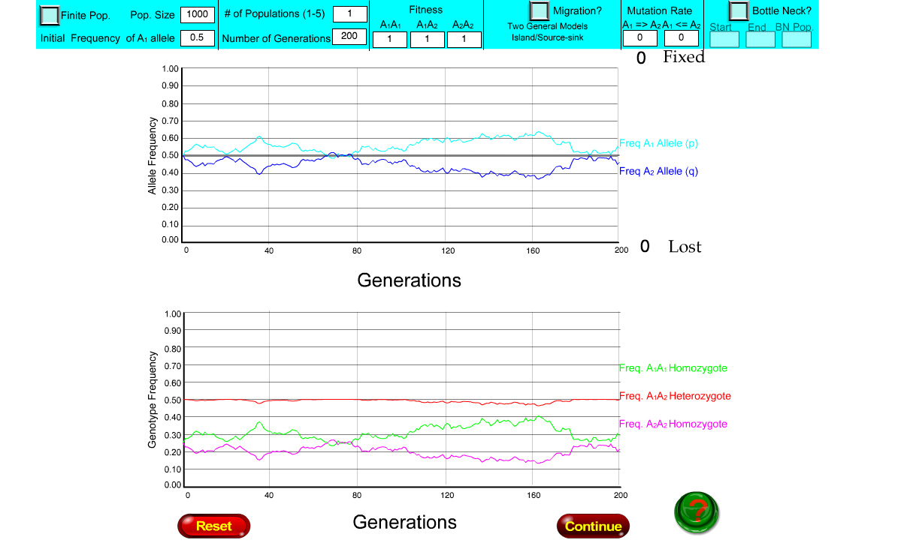
Parameters – all kept at norm except for population size
Result after 200 generations (2trials)
Allele frequency Genotype Frequency
A1(p)= 1 A2(q) = 0 AA = 0 Aa= 0 aa=1
