Name: ______________________________________

Pre-lab Homework

1. Today's lab requires you to understand a bit of vocabulary. Briefly draw or explain the following
terms.

• Chromosome:

• Gene:

• Allele:

• Haploid (1n):

• Diploid (2n):

• Gamete (1n):

• Zygote (2n):

:

1

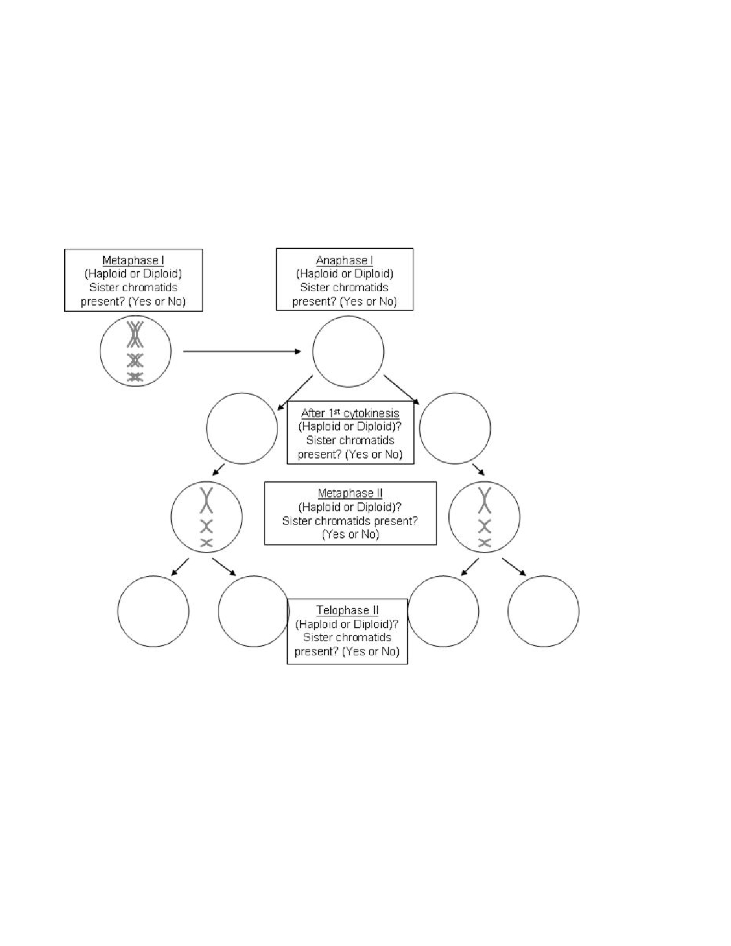
1. A. Draw chromosomes: For each of the following phases of meiosis, draw out the chromosomes
from an organism that has 3 different types of chromosomes (n=3). The chromosomes need to be
drawn so that you can see if they are duplicated (made up of 2 sister chromatids) or not, and the three types should be represented by three different lengths of chromosomes.
Hint: if it has three types of chromosomes, it has 6 chromosomes in a diploid cell (2n=6). The cells in Metaphase I and Metaphase II has been drawn for you.

1. B. Circle the correct answers in the boxes: for each stage listed, indicate if the cell is haploid or diploid and whether chromosomes are made up of sister chromatids or not.

2. In humans, both mitosis and meiosis start with one diploid cell. How are the cells ultimately
produced by the processes different? (in number of cells, in numbers of chromosomes and in genetic
diversity)

2

Meiosis

LAB SYNOPSIS:
• Meiosis will be modeled using pop-beads.

• The genetic diversity of gametes will be modeled using pop-beads
o Crossing Over and Independent Assortment.
• The genetic diversity of offspring via random fertilization will be modeled using pop-beads.

OBJECTIVES: After successfully completing this lab, a student will be able to:
• List the main phase of meiosis, including the major events of each phase.
• Explain events that lead to genetic variation of gametes.

Part I: Meiosis

Exercise 1A: Modeling Interphase Prior to Meiosis with Pop Beads

3

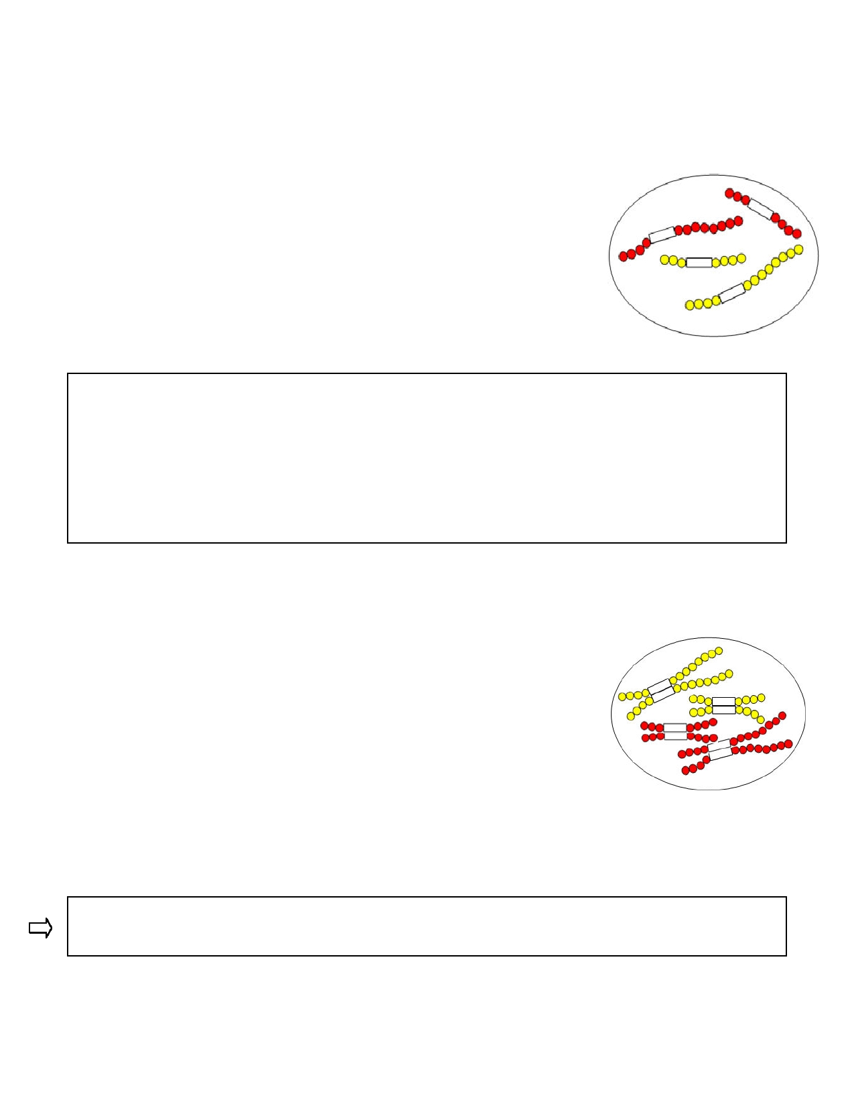
Procedure: constructing chromosomes using pop beads. Since you will be exchanging chromosomes with
other groups to model fertilization, make sure you construct your chromosomes exactly as in fig. 2
1. Using figure 2 as a guide, construct chromosomes for a pretend cell containing 4 chromosomes
(2 red chromosomes originally inherited from its mother and 2 yellow chromosomes from its father). This is a diploid cell.

Diploid cell- A cell containing 2 sets of chromosomes. One set from mom, one set from dad.
Diploid cells contain homologous pairs of chromosomes.

Homologous chromosomes- are similar in size, the order of genes and
centromere position (represented here by the white magnetic links).
Homologous chromosomes are not however identical because one was inherited from mom and the other from dad.
Figure 2. Pop bead chromosomes

Sets and Pairs
For figure 2 understand;
Which set of chromosomes were inherited from the father?

Which set of chromosomes were inherited from the mother?

Which chromosomes are homologous pairs?

Confirm your understanding of this before continuing.

Interphase-
Just like mitosis, germ cells undergo the 3 parts of interphase; Gap 1, Synthesis phase & Gap 2.

• Gap 1 (G1)- Phase in which the cell grows and functions normally.

• Synthesis phase (S-phase)- Phase in which the cell duplicates its DNA. During the S-phase of interphase each chromosome goes through the process
of DNA replication. Following DNA replication, each chromosome is composed of 2 identical sister chromatids attached at the centromere.

Procedure
2. Although in real cells you cannot see individual chromosomes, to
demonstrate the results of the S-phase, construct exact copies of each of your chromosomes and link them via their magnets.

Figure 3. After DNA Replication

Note: Following the S-phase, you still have 4 chromosomes, but each chromosome is made up of two sister chromatids. Fig. 3.

Label each of the following in figure 3. Chromosome, Sister Chromatid, Centromere & Homologues.

• Gap 2 (G2)- Phase in which the cell resumes its growth in preparation for meiosis.

4

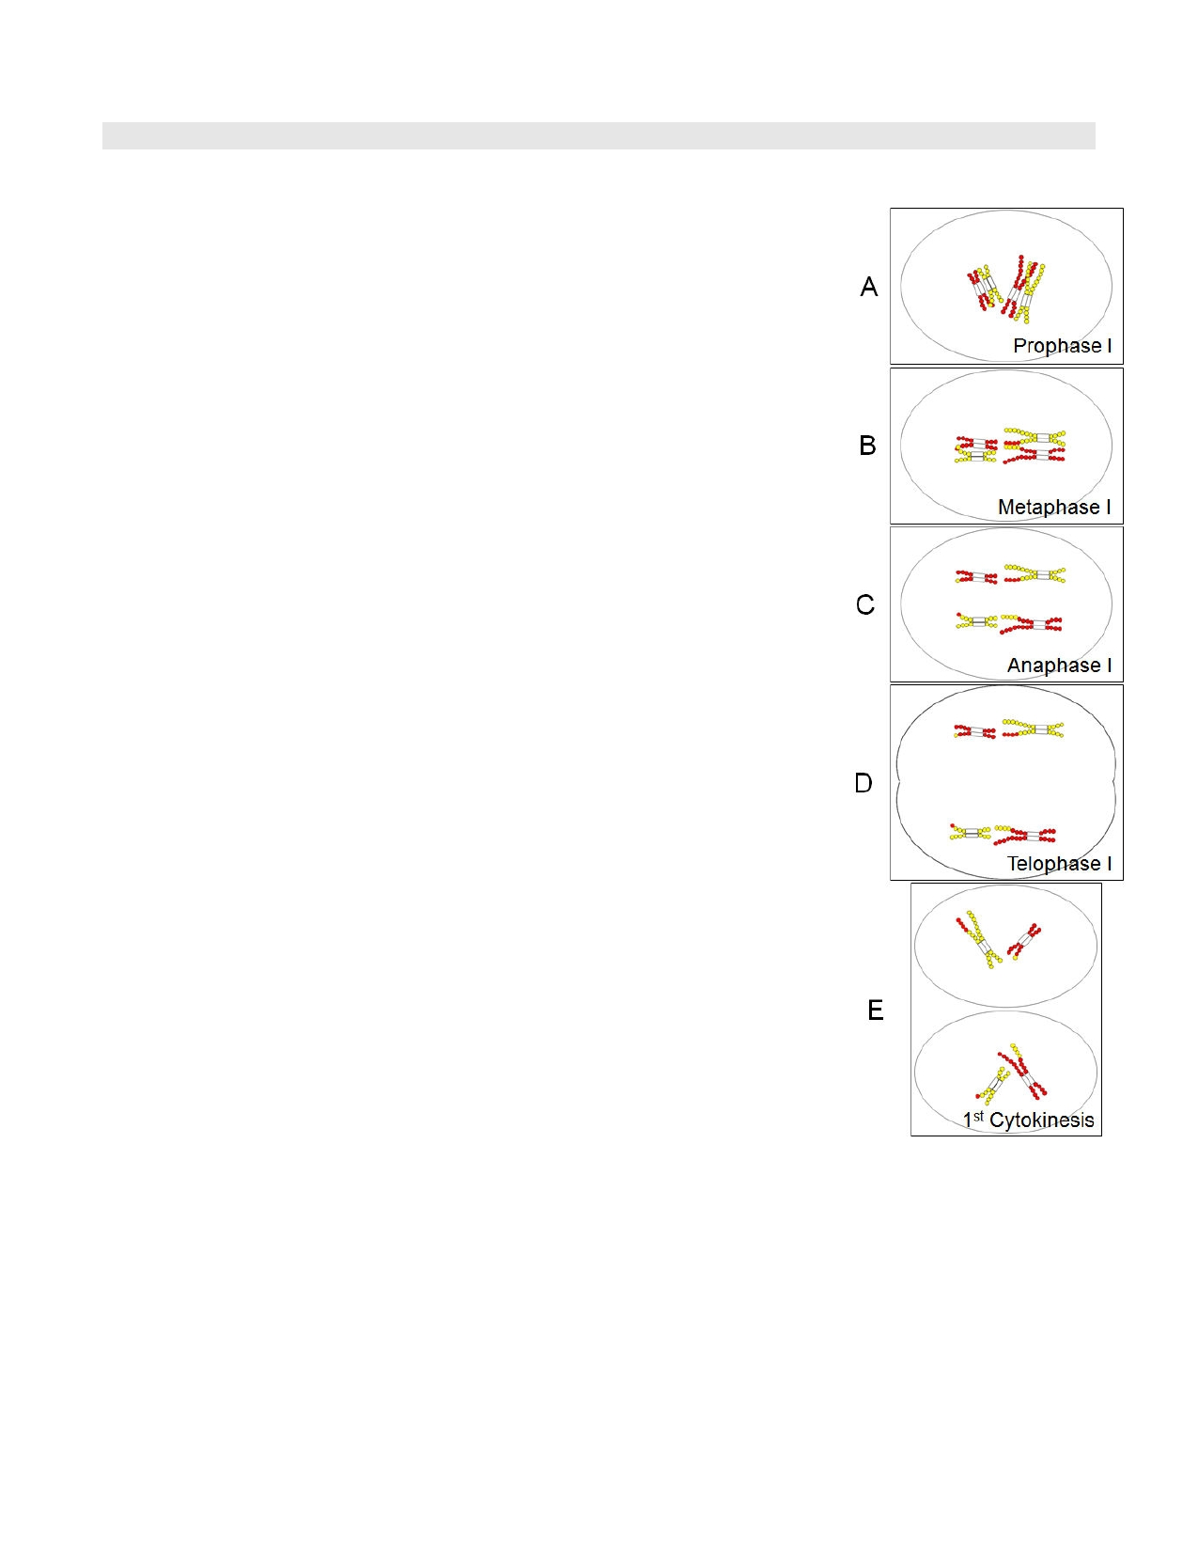

Exercise 1B: Meiosis I and Crossing-Over. Modeling Using Pop-Beads
*Meiosis I (The Reduction Phase) Phase of the meiosis that separates the homologous pairs. (Recall in
mitosis, we separated sister chromatids). One diploid cell will form two haploid cells.
Prophase I- chromosomes become visible under the light microscope.
Also during prophase I, the nucleolus disappears and the nuclear envelope
breaks down. Microtubules extend from centrioles at either pole of the cell forming the spindle apparatus.
3. Use figure 4 to guide you through the process. Fig. 4A represents
prophase. Your moving of the chromosomes with your hands is equivalent to the work the spindle microtubules are doing.

∗ Prophase I cont.- Synapsis and Crossing-over. (this does not happen
during mitosis)
∗ Synapsis- homologous chromosomes pair up
∗ Crossing-over- The process in which genetic material is exchanged
between two homologous chromosomes.
Exercise 3 below covers the process of crossing-over in detail. You may choose to wait to cross over till then.

∗ Metaphase I- homologous pairs line up in the middle of the cell
(along the metaphase plate).
4. Line chromosomes up double-file so homologous chromosomes are
facing either side of the cell (Fig. 4B).
* Independent Assortment- homologous pairs line up and assort
chromosomes originally inherited from mom vs. from dad randomly. (See
below)

∗ Anaphase I- homologous chromosomes separate and begin to move to
either side of the cell.
5. Separate homologs and pull them to either side of the cell (Fig. 4C).

∗ Telophase I- homologous chromosomes are pulled all the way to ether
side of the cell.
6. Pull chromosomes further away from one another (Fig. 4D).

Cytokinesis I- This is the process of cell division, dividing one cell into two Figure 4. Meiosis I
new daughter cells. Following cytokinesis the nuclear envelope reforms around
the chromosomes, the chromosomes de-condense and the nucleolus reforms.
7. Pull chromosomes yet further away from each other. Note: each "new cell" does not have
identical chromosomes to each other (Fig. 4E).
Haploid cells- Cells containing 1 set of chromosomes.
Haploid cells do not contain homologous pairs of chromosomes. Pairs separated during meiosis I.
Note from figure 4E. Following meiosis I, homologous chromosomes have been separated, but each of the
two chromosome is still made up of 2 sister chromatids. Meiosis II is the process of separating the sister chromatids. Meiosis II is very similar to mitosis.
5

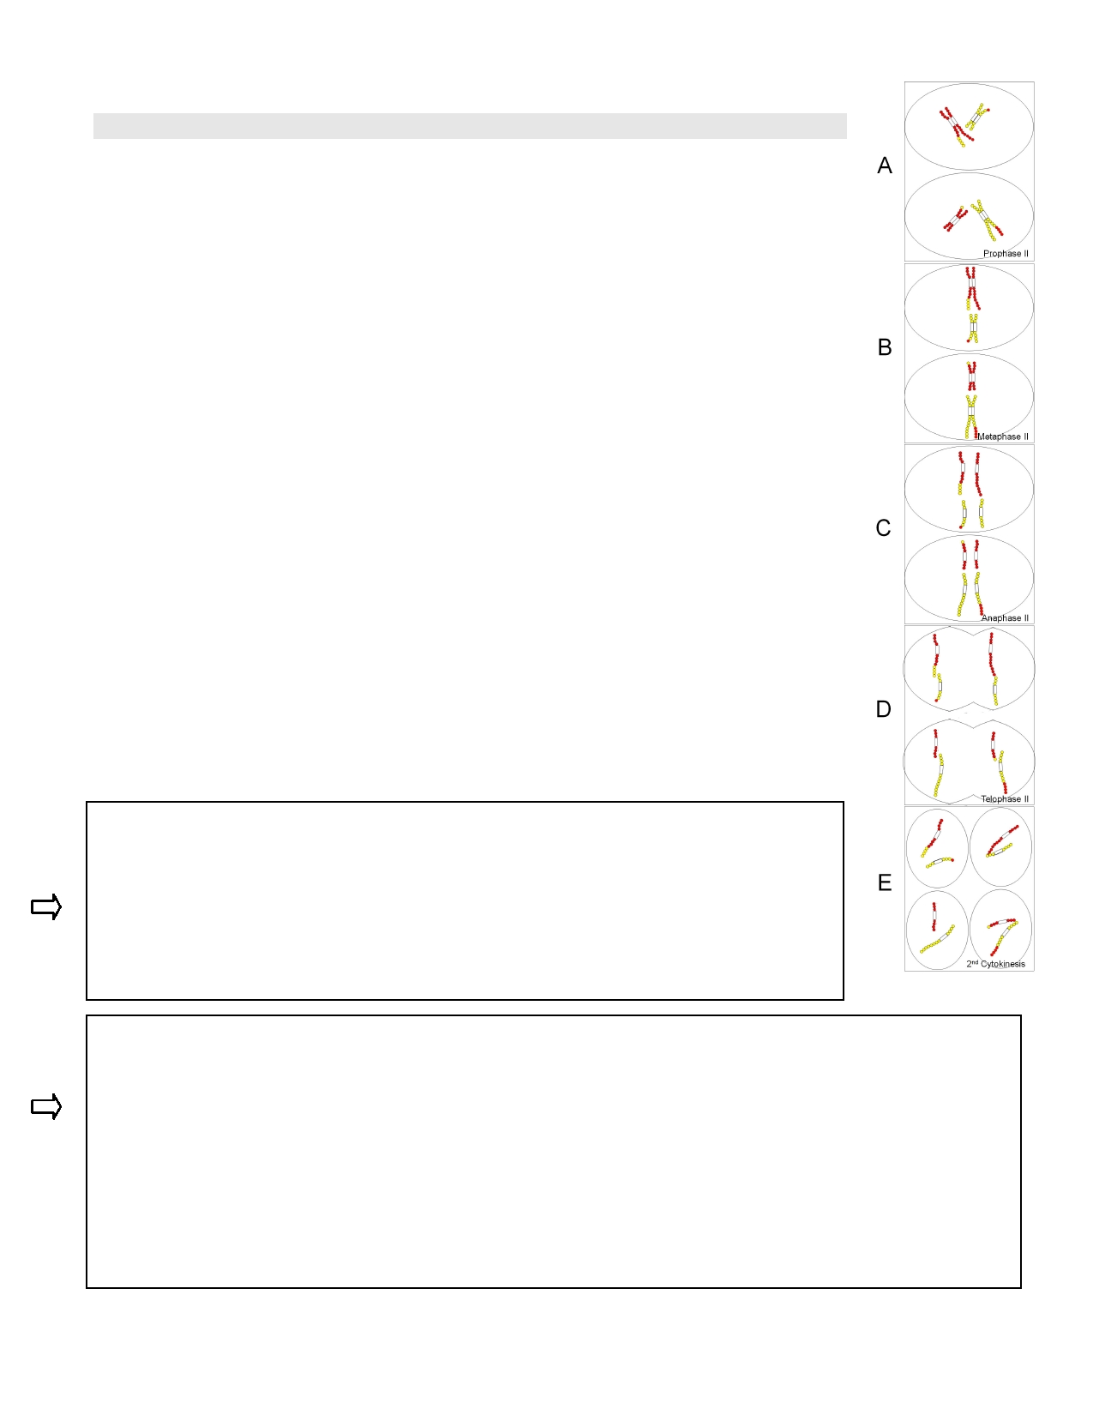

Exercise 1C: Meiosis II. Modeling Using Pop-Beads

Meiosis II- Phase of the meiosis that separates the sister chromatids. (Recall in
mitosis, we also separated sister chromatids). Two haploid cells will form four haploid cells.

• Prophase II- chromosomes become visible under the light microscope. (Fig. 5A)
• Metaphase II- chromosomes line up single-file in the middle of the cell (along the
metaphase plate). (Fig. 5B)
• Anaphase II- sister chromatids separate and begin to move to either side of the
cell. (Fig. 5C)
• Telophase II- sister chromatids, now considered individual chromosomes, are
pulled all the way to ether side of the cell. (Fig. 5D)
Cytokinesis II- This is the process of cell division, dividing each cell into a total of 4
new daughter cells. Following cytokinesis the nuclear envelope reforms around the chromosomes, the chromosomes de-condense and the nucleolus reforms. (Fig. 5E)

Note: Following cytokinesis II each cell is genetically different from each other.

Practice the phases of the cell cycle again without the aid of the figures.
--------------------------------
Gametogenesis- Differentiation and development of the 4 cells resulting from meiosis into the gametes (either sperm or egg).

If this were a human germ cell;

How many total chromosomes are their prior to the meiotic cell cycle? _______

How many sets of chromosomes would there be prior to meiosis I ? _______

How many chromosomes would there be in each set prior to meiosis I ? _______

How many sets of chromosomes would there be in each cell after meiosis I ? _______

How many chromosomes would there be in each set after meiosis I ? _______
-----
Would chromosomes be composed of sister chromatids before meiosis II? _____

Would chromosomes be composed of sister chromatids after meiosis II? _____

How many chromosomes would be in each of the 4 cells after meiosis II? _______

6

Figure 5. Meiosis II

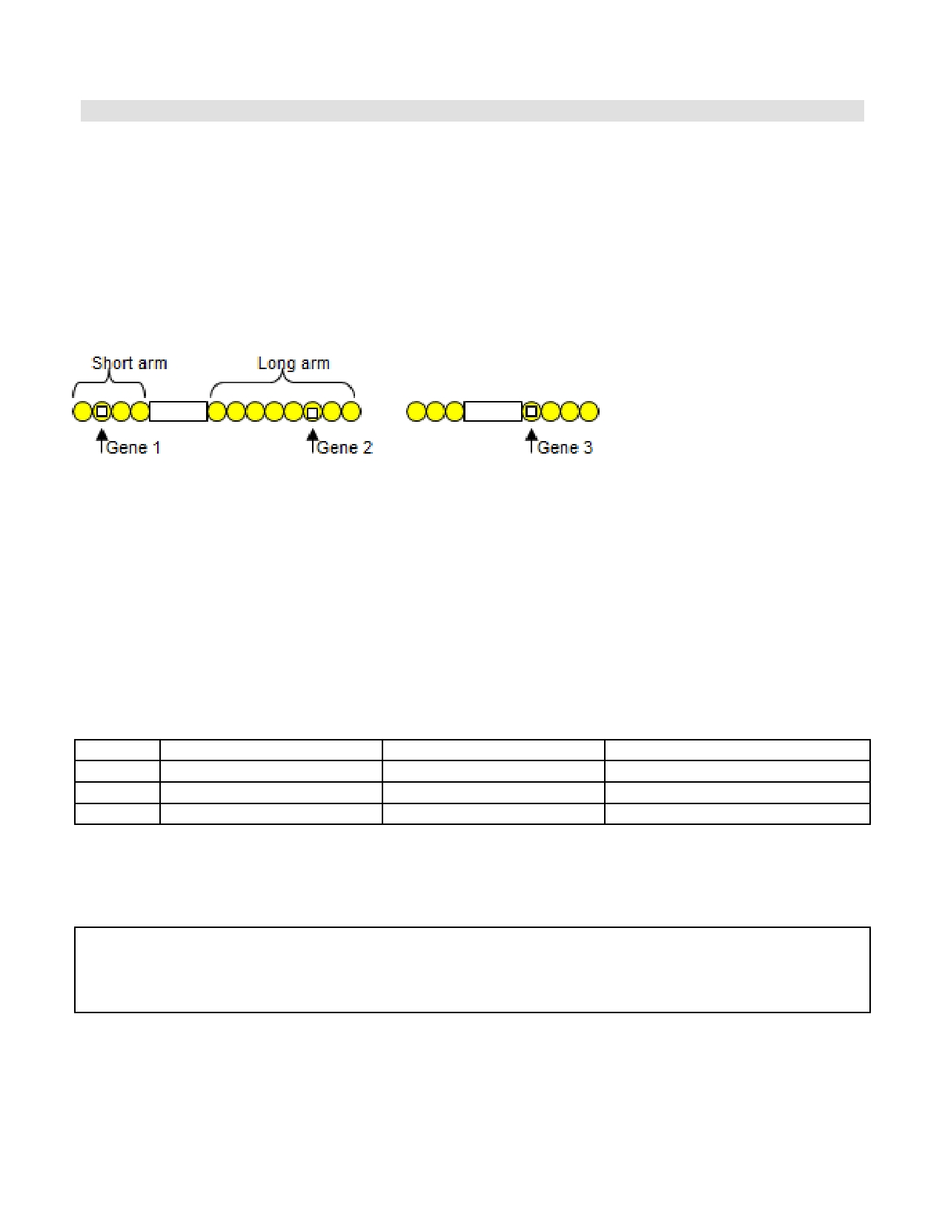

Exercise 2: Genetic Diversity of Gametes

There are two events that lead to the genetic diversity seen in the final 4 haploid cells at the end of
meiosis; crossing over and independent assortment. In the following exercise, we will use pieces of tape to track genes as they go through the process of meiosis.

Procedure:

1. Using labeling tape, identify 3 genes on your "dad's" yellow chromosomes precisely as follows: Genes are represented by individual beads on the pop-beads. You will also need to label mom's red chromosomes
(not shown in figure)

Figure 6. Dad's Yellow Chromosomes

Step 1: Assigning Alleles
• Gene 1 codes for β-hemoglobin (part of the protein that carries oxygen in your red blood cells). Normal β-hemoglobin can be represented by s while the sickle cell anemia trait will be represented by S
• Gene 2 codes for hair color.
Black hair will be represented by B while red hair will be represented by b
• Gene 3 codes for being able to roll your tongue.
Being able to roll your tongue will be represented by R and not being able to roll your tongue will be
represented by r

You need to determine what form of genes 1, 2 & 3 are found in dad's yellow chromosomes and in
mom's red chromosomes. Do this randomly. For each gene, roll the die, if it comes up even (2,4 or 6), write
the uppercase letter form of the gene (S, B or R). If it comes up odd (1,3 or 5) write the lowercase form of the gene (s, b or r).. Indicate your results in the table below.
Gene Dad's yellow chromosomes Mom's red chromosomes Alleles differ or are identical?
1
23

Allele- Different forms of the same gene at a specific position on both homologous chromosomes.
Note in the table which of the alleles for genes 1,2 or 3 differ between mom's and dad's chromosomes, and which alleles are identical.

2. Using the data from the table, label with tape dad's 2 yellow and mom's 2 red chromosomes. Remember
you are modeling the whole process of meiosis, so you will need to duplicate this procedure starting with
DNA replication during the S-Phase. After you should have 4 chromosomes each made up of two identical sister chromatids (yes you will need to put tape on those as well). See fig. 3 above.

3. You are ready to model the process of meiosis in separating genes. You will need to model two events: crossing over during prophase I and the independent assortment of chromosomes during metaphase I.

a. Crossing over: To model crossing over, which is the process that results from the breaking and
swapping of DNA strands between homologous chromosomes, you will need to pair your chromosomes
7

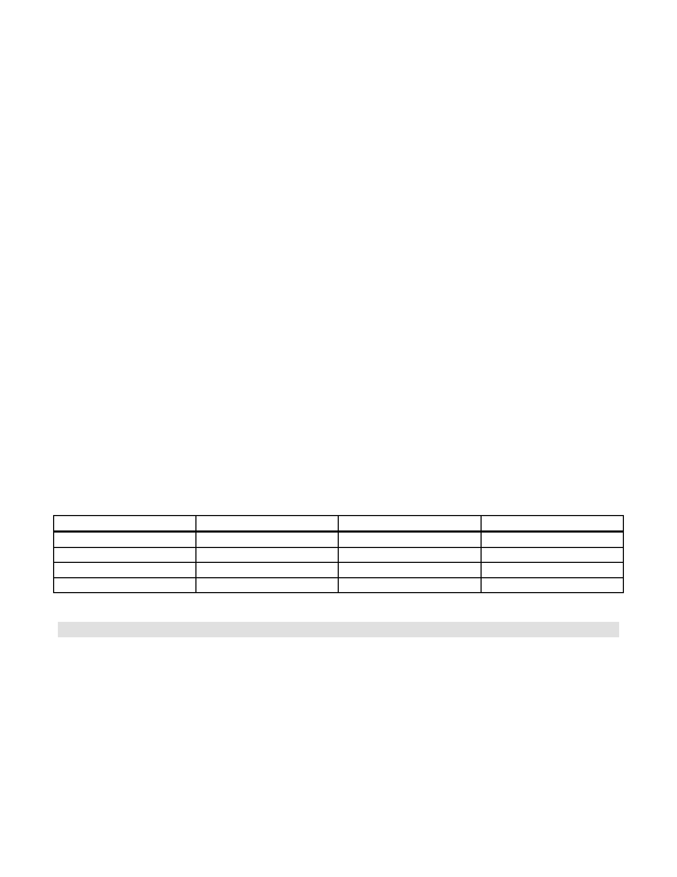
Prophase I
Metaphase I
up. Pairing up of chromosomes happens during prophase I: Place your long red chromosome next to the
long yellow and the short red next to the short yellow (fig. 4A). With your two long chromosomes lined up next to each other, start at end of the long arm. Crossing over is somewhat random, so roll the die; if it is a 6 then break apart the joints on both the red and yellow chromatids that are right next to each other
and swap the chromosome tips. If the die rolls a number other than 6 then do not swap the beads at this
joint. Either way, after finishing this first joint, move down to the joint between the second and third
beads and roll the die again. If the roll is a 6 then cross-over at this joint and then keep moving on
through all the other joints. Every time you roll a 6, you should break open the joint and cross over.
After you have finished with the long chromosome go through the short chromosome, checking for cross over at each of its joints.

b. Independent Assortment: After checking for crossing over on both the chromosomes, it is time to
set up the chromosomes for metaphase I. Notice that the process of crossing over forces the two chromosomes of the same type to be next to each other. These chromosomes, called homologous
chromosomes, now will line up for Metaphase I in pairs. To determine which chromosome goes on each
side, we will once again allow chance to dictate. To set up the long chromosomes, roll the die; if the
number is a 1, 2, or 3 then the chromosome with the most red beads will be on the left. If the number is a
4, 5, or 6 then the chromosome with the most yellow will be on the left. Now repeat this for the short
chromosome (1, 2, 3 = red on left; 4, 5, 6 = yellow on left).

4. Now go through the rest of meiosis until you have produced 4 haploid cells (fig. 4&5). These cells will develop into gametes. Each gamete needs to find another gamete to fuse with so that they can make a new
diploid cell called a zygote! Notice that the gametes are haploid (only one of each type of chromosome), and that each gamete is "genetically" different from the other gametes.

Recall: Before meiosis the one diploid cell had 2 copies of each gene. See your table above.
Note: After meiosis, due to the separation of homologous pairs, the resulting 4 haploid cells only have 1
copy of each gene. And, that due to crossing over and independent assortment, these genes have been randomly segregated.

Record the results for the four cells following meiosis: Recall these 4 cells will develop into gametes.
Gene 1 Gene 2 Gene 3
Gamete #1
Gamete #2 Gamete #3 Gamete #4

Exercise 4: Random Fertilization

Crossing over and independent assortment result in diversity of the gametes produced. Random
fertilization results in an additional degree of variation in the resulting offspring that any two individuals can p roduc e .
As you will see in the video shown during today's lab, picking mates is often anything but random; for now though, we will randomly select gametes to fuse together to produce a zygote. This process is clearly more complicated than we will be modeling today but we are really just looking for the genetics of what is going on.

Procedure:

8

1. Pick a random sperm: Group your 4 separate gametes in front of you. Now roll the die twice, add the
numbers together and starting from the left, count through the gametes one at a time until you reach the number you rolled. Give this sperm to another lab group. You will also need to obtain another group's random sperm.

2. Fertilize a random egg: Use the die again to randomly determine which of your remaining 3 gametes to
fertilize. Record the set of alleles found in your new offspring in the table below and then collect the
information from each of the other groups. If there is a group that cannot find a "mate", you many need to select another one of your gametes to give to them. If this happens, just randomly chose one of your remaining gametes to use for fertilization.

*Fertilization reestablishes the diploid (2n) condition.

Record your fertilization results and those from other groups below.

Group
*E xa m p l e
#1 (your group's egg)
#2 #3 #4 #5 #6
Alleles for gene 1
SS
Alleles for gene 2
bb
Alleles for gene 3

What will be the result of the genes inherited by the Example above? SS, bb, & Rr. Will it have sickle
cell anemia or not? Will it have black hair or red hair? Will it be able to roll its tongue or not?

