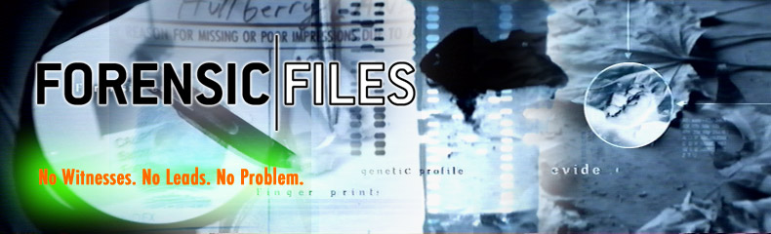

VIDEO QUESTIONS

Please do not write on this paper. Write the answers on your notebooks.

Episode name: ___________________________________________________

Read over the following questions. Then watch the video. Take note of the answers BUT watch or you will miss something. You will have time at the end to answer the questions completely with a partner.

1. What evidence is collected that convicted the suspect?
2. Who were the victims? Was there more than one victim? What was the motive for the crime? (If this is serial murders, are there similarities with the all victims? If so what are they? If not why not?)
3. Who is/are the suspect/s? What is their description?
4. What areas of Forensics were used to analyze the evidence? Explain.
5. Describe any problems in solving the case.
6. How was the suspect proven guilty?
7. Did the convicted suspect really the perpetrator? If he was falsely accused, how was he exonerated?