Do You Understand Evolutionary Trees? (Part One)
By T. Ryan Gregory | February 10th 2008
A single figure graces the pages of Charles Darwin's groundbreaking work On the Origin of Species, first published in 1859. The figure in question depicts a tree-like sequence of branchings through time as hypothetical lineages diverge and new species arise. To be sure, the metaphor of a tree was important in Darwin's thinking about the history of life. He wrote in the Origin,
As buds give rise by growth to fresh buds, and these, if vigorous, branch out and overtop on all sides many a feebler branch, so by generation I believe it has been with the great Tree of Life, which fills with its dead and broken branches the crust of the earth, and covers the surface with its ever-branching and beautiful ramifications.
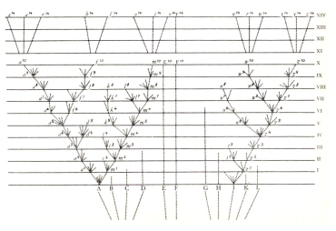
The tree diagram in On the Origin of Species
Evolutionary biology has changed considerably over the past 150 years, but the concept of a tree of life remains central. An entire field, phylogenetics (Gr. phyle, tribe + genesis, birth), has arisen whose focus is on hypothesizing evolutionary relationships as reflected by branching tree diagrams. The resulting phylogenetic trees, as Baum et al. (2005) recently noted, "are the most direct representation of the principle of common ancestry—the very core of evolutionary theory—and thus they must find a more prominent place in the general public’s understanding of evolution.”
Unfortunately, when it comes to interpreting evolutionary trees and the relationships that they represent, misconceptions are widespread. This post marks the first in a series on evolutionary trees and the information that they do and do not convey, presented in honor of Darwin Day 2008. These are adapted from a forthcoming article in Evolution: Education and Outreach that is now available free of charge in preprint form.
Let us begin with a simple tree depicting hypothesized (and well supported) relationships among major groups of vertebrate animals. In this figure, time extends from bottom to top, with the base of the tree representing a time in the distant past and the "tips" (called "terminal nodes") occupied by contemporary species. Each point at which two branches converge (called "internal nodes") reflects a common ancestor shared by two lineages. Thus, the lineage represented by cats and the one of which humans represent the terminal node are joined by a common ancestor some time in the past (i.e., an extinct ancestral mammal). Lizards and birds also share a common ancestor (i.e., an extinct ancestral reptile), and this lineage joins with the mammalian lineage at an even deeper node representing an ancestor that was shared by all of these amniote lineages. The amniote lineage shares an ancestor with the lineage represented by frogs at a still deeper node, and at the base of this tree (i.e., the deepest internal node, or the "root") is an ancestor shared by all of these vertebrate lineages.
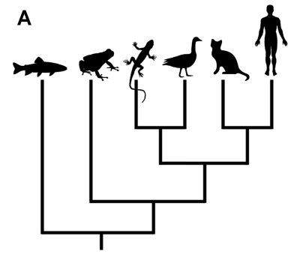

The question is this. In your reading of this tree, which group is the most closely related to fishes: frogs, lizards, birds, cats, or humans?
As Baum et al. (2005) noted, the intuitive response provided by most people is frogs. After all, frogs are closest to fishes on this tree, aren't they?
Consider next the following tree:
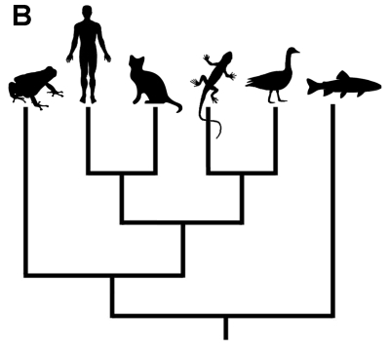
In your view, does this tree depict different relationships? Does it imply that frogs and humans are closer relatives than are humans and reptiles? Is it less accurate than the first diagram?
As counterintuitive as it may feel, there is absolutely no difference in the information presented in the two figures. What matters is the order of branching, and in both cases humans share the most recent ancestor with cats, then this mammal lineage shares a more distant ancestor with the lineage represented by reptiles and birds. These lineages share a common ancestor with the lineage represented by frogs, and then the lineage that now includes all of these tetrapods shares an ancestor with the lineage of which a bony fish is given as a modern representative. Because they are all descended from the same common ancestor (an ancestral tetrapod), frogs, humans, lizards, and birds are all equally related to fishes.
Think of it this way: you and your sibling are linked through a common ancestor (your parent), and you are both equally related to your cousins (to whom you are all linked through a shared grandparent).

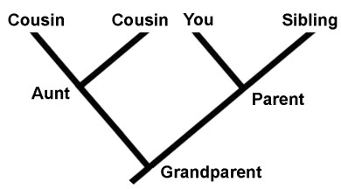

An evolutionary tree is similar in a sense to a baby's mobile: each node can rotate freely without changing the way that they are joined to one another. As such, the order of the terminal nodes is meaningless. One cannot read across the tips.
The relationships depicted in a tree are historical, whereas the terminal nodes represent contemporaneous groups. Whenever you encounter an evolutionary tree, practice rotating a few internal nodes mentally. This is a simple exercise, but it is a powerful method for avoiding a number of common misunderstandings of evolutionary trees.

Do You Understand Evolutionary Trees? (Part Two)
By T. Ryan Gregory | March 11th 2008 01
In the first installment of this series, we encountered the common misconception that the order of the terminal nodes ("tips") on an evolutionary tree reflects the actual relatedness among the species represented. Simply rotating some internal nodes without affecting the branching order ("topology") of the tree -- and thus, making no change to the relationships among species -- showed that that the order of tips on a tree is actually arbitrary. What matters is the way that the species are connected through their common ancestors.
This time, we will deal with misconceptions about the change that actually occurs along the branches in between nodes, especially between an internal node and a terminal node.
Here again is a tree showing relationships among major groups of vertebrates.

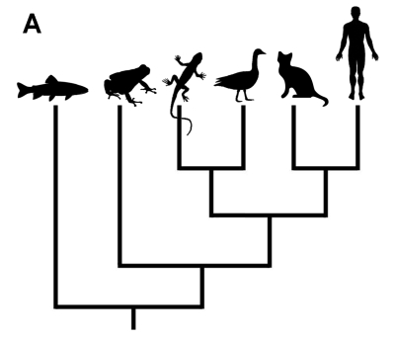

In this case, each terminal node represents a living species and all internal nodes reflect extinct ancestors. Looking at the tree above, there may be a tendency to assume that very little change has occurred in the lineage leading to modern bony fishes, whereas it is clear that a great deal of change has happened in the lineage leading to mammals. But is this an accurate interpretation? Does the long straight line with no branching depicted in the fish lineage mean that no change has occurred in fishes since the split between their lineage and our own? Isn't the outermost branch ("outgroup", or less appropriately "basal lineage") the most "primitive"?
Before answering those questions, consider this tree. It shows hypothesized relationships among the major echinoderm lineages, which includes sea lillies, brittle stars and sea stars, and sea cucumbers and sea urchins. The outgroup in this case is humans.

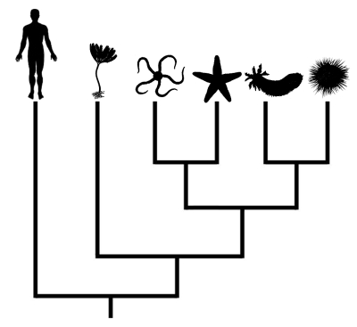

Looking at this tree, would you assume that no change has occurred on the branch leading to humans from the common ancestor of vertebrates and echinoderms? Can you conclude that humans are more "primitive" than sea cucumbers?
There are several reasons that trees like the first one above can be confusing. First, it is an "unbalanced" tree, which means that more diversity is depicted on one side of each internal node, even if this does not reflect reality. As a matter of fact, bony fishes make up about half of all vertebrate species, whereas in the tree above they are represented by only one terminal node as compared to five nodes representing the non-fish vertebrates. Second, there is a tendency to draw conclusions based on the order of terminal nodes, and humans or some other species of interest are usually placed at the far right of the tree (or at the top, depending on the orientation) when, as we saw last time, the order of tips is arbitrary as every node can be rotated. Third, there is an assumption that a long branch means that no change has occurred, a misinterpretation that becomes evident when humans are placed as the "basal lineage" on a tree.
So, not only is it inaccurate to read the order of terminal nodes, it is also not valid to assume that a branch without internal nodes means that no change has happened in that lineage -- more likely, it simply is not depicted as a result of incomplete sampling.
Assuming that no change has occurred even on short branches can also create misunderstandings about evolutionary relationships. For example, consider the following tree, which reflects relationships among several primates.

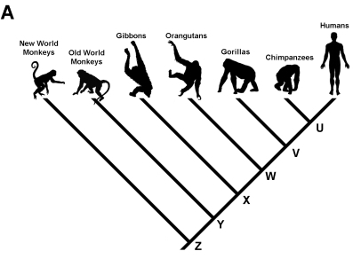

This diagram indicates that humans and chimpanzees are each others' closest living relatives, these two having shared an ancestor (at node U) more recently than either has with any of the other living primates shown in the tree (there are actually two species of chimpanzees, the common chimpanzee Pan troglodytes, and the bonobo, Pan paniscus). The species that is represented by node U was neither a human nor a chimpanzee. In fact, a great deal of change has occurred along the lineage from node U to modern humans, and involved several more ancestors that are not shown on the tree. There was also change along the lineage of which modern chimpanzees are the present representatives. In short, humans are not descended from chimpanzees any more than chimpanzees are descended from humans. Chimpanzees and humans are cousins, and neither is the grandparent of the other.
One often hears the question asked, at least among those who do not understand evolutionary concepts, "If humans are descended from apes, then why are there still apes?". The answer is simple: humans are not descended from other modern apes, rather humans and the other apes are all descended from common ancestors that are extinct. This is possible because new species often arise through a process in which an ancestral species diverges into two or more descendant lineages (a process known as "cladogenesis") rather than simply transforming into a new species (a process called "anagenesis"). Thus, humans and other apes can all exist in the same way that Canada, Australia, and New Zealand can all exist.

