A. Ancheta
Name: _____________________________ Date: ______________________ Period: _____
DNA extraction lab
Prelab Questions:
- Draw the basic cell structures of a plant and an animal.

- How are the plant and animal alike or/and different? Make a table (see below) to compare and contrast.
 | Plant | Animal
Cell wall | Present | Absent
Cell membrane
Nucleus
Genomic DNA
(Chromosomal)
mitochondria

- What are the four basic steps in DNA extraction? (refer to the background information).
____________________________________________________________________
____________________________________________________________________
____________________________________________________________________
____________________________________________________________________

Purpose:
  - To compare and contrast the DNA extraction methods.
- To be able to extract DNA from banana and human cheek cell, and to compare their DNA.

Safety: __________________________________________

DNA Extraction Lab Background Information
DNA (deoxyribonucleic acid) is an immensely long molecule. It is found in every cell with a nucleus, whether it is a plant, fungal, protist, or animal cell. DNA is also found in all bacterial cells and some viruses. In humans, a cell that may be only about one millimeter long will contain about 2 meters of DNA divided among the 46 chromosomes. In order to pack all this DNA into a cell, it is tightly wound around tiny proteins called histones. The 2 meters of DNA contain about 6 billion base pairs. In the cell, DNA appears like a tangled mass of thread. There are techniques that allow you to extract the DNA from cells so that you can see it and work with it. It is a brittle molecule; it can bend just so much before it breaks. This is why it must be handled gently. Even though DNA appears like an unpromising whitish goop, it is the molecule of life; containing the genetic code that directs all the functions of the cell.
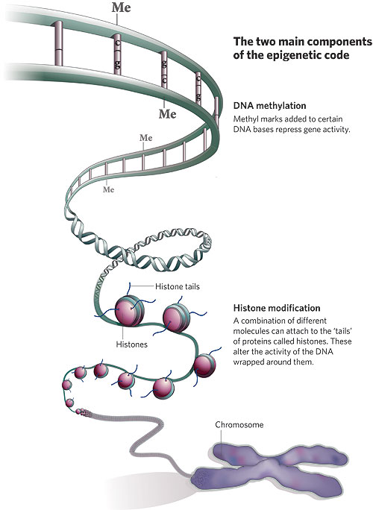
To extract the DNA from cells, these are the basic steps:
A. Obtain a large number of nucleated cells, the more cells, the more DNA.
B. Lyse (break open) the cell membranes. This is done using some kind of surfactant or detergent. This works because the cell membrane is made up of lipids (fats) and detergents will emulsify or break apart fats. Often shaking is advised to increase the rate of cell lysing. An odd ball, Halobacterium normally lives in a high-salt environment, so adding distilled water causes the cells to rupture due to osmosis.
C. Destroy the proteins that are present in the cells and bind to the DNA. This is done using some kind of proteolytic (protein-digesting) enzyme and/or heating the solution about 60°C is needed to destroy the proteins, but temperatures of over 80°C will denature the DNA.
D. Precipitate the DNA. Up to this point the DNA is dissolved in an aqueous solution; DNA is soluble in water but is insoluble in alcohol. This is done by slowly, carefully layering ethanol (ethyl alcohol) on top of the DNA-containing aqueous solution. The DNA appears as a whitish mass floating at the interface of the alcohol and aqueous solutions.
E. Work with the DNA. At this point you can do several things
- Spool the DNA onto a glass stirring rod. Place an ethanol cleaned stirring rod into the solution and twirl the rod to spool the DNA. DON’T mix the two layers.
- Extract the DNA from the interface using a pipet.
- Dry the DNA on the filter paper which later can then be dissolved in distilled water with a small amount of sodium chloride (4%) or in TE buffer. This will yield slightly acidic solution that can be verified using pH paper or a pH meter. Test the DNA with a DNA in a tube containing 3mL of 4% NaCI solution or TE buffer. Add 3 mL of diphenylamine solution to this tube and mix. Place the tube in a boiling water bath for 10 minutes. Diphenylamine reacts with the deoxyribose sugar of DNA to produce a blue color. A DNA positive control and distilled water negative control should be tested along with your DNA sample.

Method #1: The DNA o f Plant (Strawberry)
Procedure:
- Cut banana into chunks. Place fruit into mortar and smash well with pestle, then pour into 100 mL beaker.
- Pour soap/salt solution into beaker just enough to cover fruit. Stir gently to mix.
- Place beaker with fruit into 50-60 C hot water bath for 10minutes. Be sure the water temp stays within range of 50-60 C. You can prepare the hot water in 1000 mL beaker using the microwave oven. Mash fruit against the side of beaker every few minutes while in hot water bath.
- While waiting, use graduated cylinder to measure and mark 5 & 10 mL on test tube.
- Transfer the beaker from the hot water bath to ice water bath, and leave in ice water bath for 3 minutes. Continue to mash fruit every few minutes.
- While beaker is in ice water bath, set up filtering apparatus.
- After 5 minutes in the ice bath, pour the cold mixture into the funnel and let the liquid filter for 5 minutes or longer, until 5mL liquid have filtered through into test tube (from step 4). Gently swirl the filtrate in the test tube (DNA may be on bottom).
- Add 5 mL of alcohol to the same test tube by trickling it down the side of the tube at a 45° angle.
- Observe the test tube for a few minutes until DNA becomes visible between the two layers. DNA looks like white mucus. This “white mucus” consists of millions of DNA strands clumped together.
- Place the test tube with collected DNA in the refrigerator.

Method #2: The DNA of Animal (human cheek cell)
Procedure:
- Obtain 15 ml tube containing 3 ml water from your instructor. Label the tube with your initials. Gently chew the insides of your cheeks for 30 seconds. It is NOT helpful to draw blood! Take the water from the 15 ml tube into your mouth, and swish the water around vigorously for 30 seconds. Carefully expel the liquid back into the 15 ml tube.
- Obtain the tube of lysis buffer and add 2 ml of lysis buffer to your tube. Place the cap on the tube, and gently invert the tube 5 times (don’t shake your tube!). Observe your tube — do you notice any changes? If you do, write them down.
- Obtain the tube of protease (prot) at your workstation. Add 5 drops of protease to your tube. Place the cap on your tube, and gently invert it a few times.
- Place your tube in a test tube rack or beaker in the water bath and incubate at 50°C for 10 minutes. Remove your tubes from the water bath.
- Obtain the tube of cold alcohol from the refrigerator. Holding your tube at a 45° angle, fill your tube with cold alcohol, by adding approximately 3 mls to your tube. It will take repeated additions to add 3ml of the cold alcohol using the disposable plastic transfer pipet.
- Place your cap on your tube, and let it sit undisturbed for 5 minutes. Write down anything you observe happening in the tube.
- With a disposable plastic transfer pipet, carefully transfer the precipitated DNA along with approximately 750 μl of the alcohol solution into a small vial provided. Use glue gun to seal.

Data: qualitative data - Drawing and description of your DNA .

Conclusion: Start by restating the purpose, “The purpose of this lab was to ________________” then write briefly compare and contrast the two methods. Finally write your observation of DNA .

