Chapter 26: Phylogeny and the Tree of Life
You Must Know
● The taxonomic categories and how they indicate relatedness.
● How systematics is used to develop phylogenetic trees.
● How to construct a phylogenetic tree that represents processes of biological evolution.
● The three domains of life, including their similarities and their differences
● The significance of widely conserved processes across the three domains.
26.1 Phylogenies Show Evolutionary Relationships
Phylogeny: the evolutionary history of a species or group of related species.
Systematics: a discipline focused on classifying organisms and determining their evolutionary relationships.
Taxonomy: ​is the scientific discipline of how organisms are named and classified.
Binomial Nomenclature
● A binomial consists of two components, instituted in the 18th century by Carolus Linnaeus ​ ​ ​ ​.
● The first part is the name of the genus ​to which the species belongs.
● The second part, called the specific epithet​​, is unique for each species within the genus.
Hierarchical Classification
● The hierarchical classification of organisms consists of the following levels: species, genus, family, orders, classes, phyla, kingdoms, domains.
● Each categorization at any level is called a taxon​ .
● Systematics use branching diagrams called ​phylogenetic trees to depict hypotheses about evolutionary relationships. The branches reflect the hierarchical classification of groups nested within more inclusive groups.
● Common names for organisms ­such as monkeys, finch, and lilac ­convey meaning in the casual usage, but they can also cause confusion. Each of these names, for example, refers to more than one species. Moreover, some common names do not accurately reflect the kind of organism they signify. Consider three “fishes”: jellyfish, crayfish, and silverfish.

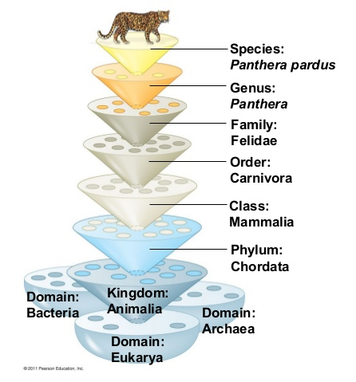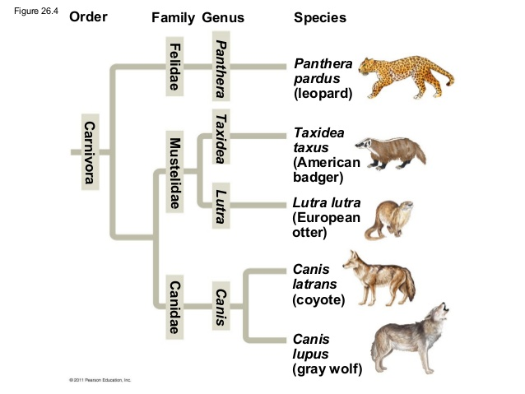

How to read phylogenetic tree: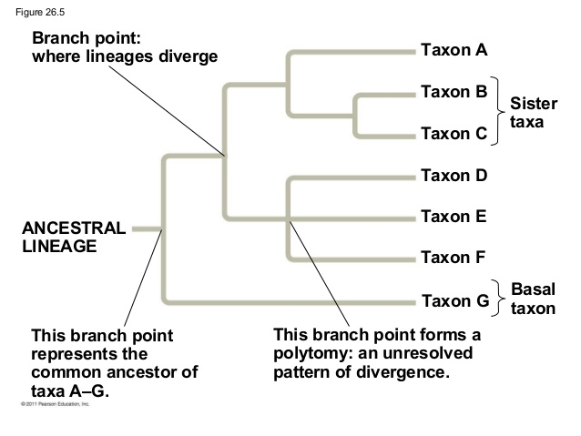

26.2: Phylogenies are inferred from morphological and molecular data
Morphological and Molecular Homologies
Example of morphological homology:
● Genes or other DNA sequences are homologous if they are descended from sequences carried by a common ancestor.
● Organisms that share very similar morphologies or DNA sequences are likely to be more closely related than organisms with vastly different structures or sequences.
● In some cases, the morphological divergence between related species can be great and their genetic divergence small (or vice versa).
Homology or. Analogy
Analogy: similarity due to convergent evolution
● Convergent evolution occurs when similar environmental pressures and natural selection produce similar adaptations in organisms from different evolutionary lineages.
● Analogous structures that arise independently are called homoplasies.
● The more elements that are similar in two complex structures, the more likely it is that they evolved from a common ancestor.
● Molecular systematics uses DNA and other molecular data to determine evolutionary relationships.
● The more ______ the DNA sequences of the two organisms, the more ________ related they are evolutionarily.
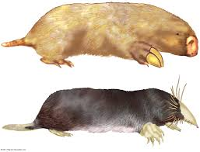
26.3 Shared characters are used to construct phylogenetic trees
Cladistics: common ancestry is the primary criterion used to classify organisms
Clades: groups that includes an ancestral species and all of its descendants
● ________________​­ shows patterns of shared characteristics among taxa and forms the basis of a phylogenetic tree
● The ​__________​within a tree is a group of species that includes an ancestral species and all its descendants. Clades are monophyletic.
● Shared derived characters are used to construct cladograms.
● E.g­ hair is shared derived character of mammals
● A shared ancestral character ​is one that originated in an ancestor of the taxon.
● E.g­ all mammals have backbones but a backbone does not distinguish a mammal from another vertebrae

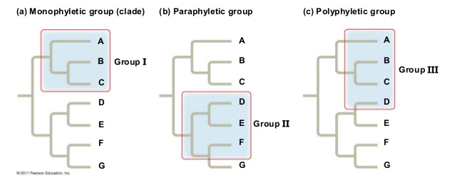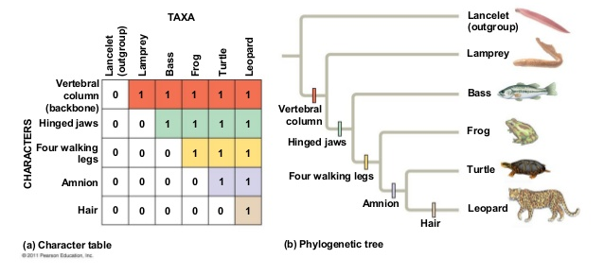
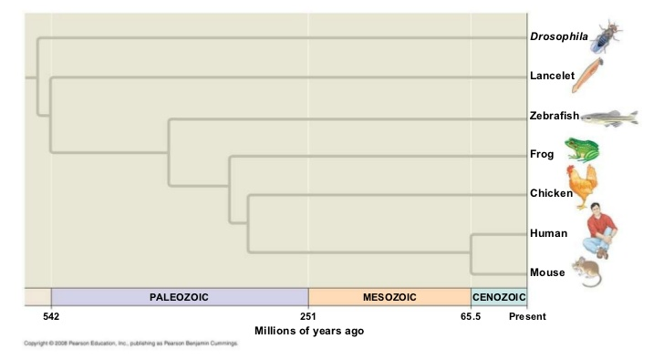
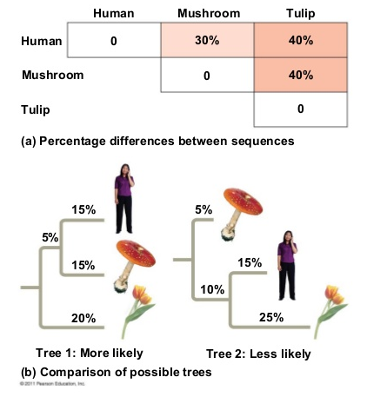
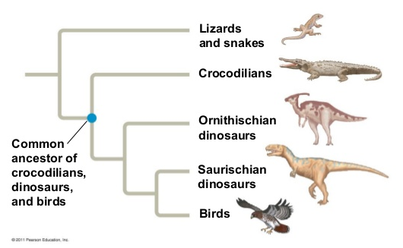

Monophyletic: ​group​­ signifies that it consists of an ancestral species and all of its descendants
Paraphyletic: group​­ consists of an ancestral species and some, but not all, of its descendants
Polyphyletic: group​­ includes taxa with different ancestors
Maximum Parsimony: the simplest explanation that is consistent with the facts should be investigated first
Maximum Likelihood: given certain probability rules about how DNA sequences change over time, a tree can be found that reflects the most likely sequence of evolutionary events
26.4: An organism’s evolutionary history is documented in its genome
● The rate of evolution of ________ sequences varies from one part of the _____________ to another
● Comparing the different sequences helps us to investigate relationships between groups of organisms that ____________ a long time ago
●DNA ​that codes for ribosomal RNA changes relatively slowly, which is why it is useful for investigating relationships between taxa that diverged hundreds of millions of years ago
● DNA that codes for mitochondrial DNA (mtDNA) evolves rapidly, so it is useful for recent evolutionary events Gene Duplications and Gene Families
●Gene ​duplication plays an important role in evolution because it ____________ the number of genes in the genome, providing _______ opportunities for further evolutionary changes.
● There are two types of homologous genes:
○ Orthologous genes - those found in different species, and their divergence traces back to the speciation events that produced the species
○Paralogous ​genes - homology results from gene duplication; multiple copies of these genes have diverged from one another within a species
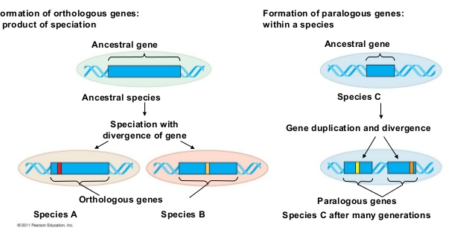
26.5 Molecular Clocks Help Track Evolutionary Time
Molecular Clock: a yardstick for measuring the absolute time of evolutionary change based on the observation that some genes and other regions of genomes appear to evolve at constant rates.
● To measure the molecular clock of a gene that has a reliable average rate of evolution, we graph the number of genetic differences
● The same gene may evolve at different rates in different groups of organisms.
Neutral Theory:­ much evolutionary change in genes and proteins has no effect on fitness and therefore is not influenced by natural selection.
Problems with Molecular Clocks
● Many irregularities are likely to be the result of natural selection in which certain DNA changes are favored over others
● Researchers attempt to extend molecular clocks beyond the time span documented by the fossil record.
● Making uncertain estimations
Solution: calibrate molecular clocks with many genes rather than just one or a few genes
Chapter 26.6: New Information Continues to revise our understanding of the tree of life
● What does the three­ domain system consists of?
Bacteria, Eukarya, and Archaea
● The domains Bacteria and Archaea contain _________ organisms, and Eukarya contains __________ organisms.
Characteristics Bacteria Archaea Eukarya

Characteristics | Bacteria | Archaea | Eukarya
Nuclear Envelope
Membrane Enclosed Organelles
Introns
Histone proteins associated with DNA
Circular chromosomes

● List three ways Bacteria and Archaea are similar.
● How is Archaea are more closely related to Eukarya than Bacteria?
Horizontal Gene Transfer: process in which genes are transferred from one genome to another through mechanisms such as exchange of transposible elements and plasmids, viral infection, and perhaps fusions of organisms

