Chapter 25: The History of Life on Earth

Must Knows:
- A scientific hypothesis about the origin of life on Earth
- The age of the Earth and when prokaryotic and eukaryotic life emerged
- Characteristics of the early planet and its atmosphere
- How Miller and Urey tested the Oparin-Haldane hypothesis and what they learned
- Methods used to date fossils and rocks and how fossil evidence contributes to our understanding of changes in life on Earth
- Evidence for endosymbiosis
- How continental drift can explain the current distribution of species (biogeography)
- How extinction events open habitats that may result in adaptive radiation

25.1 - Condition of early Earth made the origin of life possible

- The current hypothesis about how life arose consists of four main stages 1) Abiotic synthesis of small organic molecules, such as amino acids and nitrogenous
bases
2) The joining of these small molecules into macromolecules, such as proteins and
nucleic acids
3) The packaging of these molecules into protocells, membrane-enclosed droplets,
whose internal chemistry differed from that of the external environment
4) The origin of self-replicating molecules that made inheritance possible

- Earth was formed about 4.6 billion years ago, and life on earth emerged about 3.8 billion years ago. For the first three-quarters of Earth’s history, all of its living organisms were microscopic and primarily unicellular.

- Oparin and Haldane hypothesized that the early atmosphere, thick with water vapor, nitrogen, carbon dioxide, methane, ammonia, hydrogen, and hydrogen sulfide, provided with energy from lightning and UV radiation, could have formed organic compounds, a primitive “soup” from which life arose.

- Miller and Urey tested this hypothesis by creating laboratory conditions comparable to those that scientists at the time thought existed on early Earth. His apparatus yielded a variety of organic compounds.

- Miller-Urey type experiments demonstrate that the abiotic synthesis of organic molecules is possible under various assumptions about the composition of the early atmosphere.

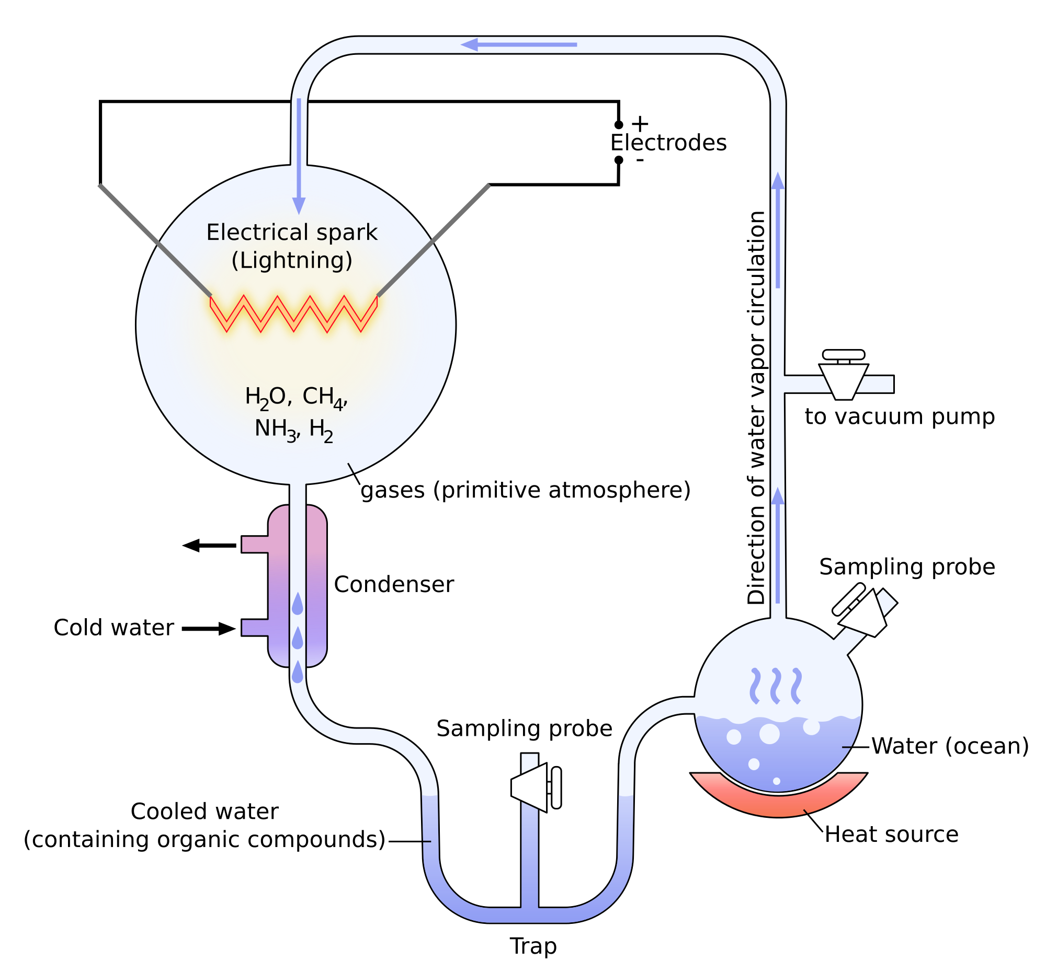

25.2 - The fossil record documents the history of life

- The fossil record is the sequence in which fossils appear in the layers of sedimentary rock that constitute Earth’s surface.

- Rocks and fossils are dated several ways:
- Relative dating uses the order of rock strata to determine the relative age of fossils. The oldest fossils are deposited in the lower strata.
- Radiometric dating uses the decay of radioactive isotopes to determine the age of the rocks or fossils. It is based on the rate of decay, or the parent isotope to decay.

25.3 - Key events in Life’s history

- The earliest living organisms were prokaryotes
- About 2.7 billion years ago, oxygen began to accumulate in Earth’s atmosphere as a result of photosynthesis. The rise of oxygen doomed many prokaryotic groups, but others evolved in the new oxygen-rich environment, including the evolution of groups capable of cellular respiration.

- Eukaryotes appeared about 2.1 billion years ago
- The endosymbiosis proposes that mitochondria and chloroplasts were formerly small prokaryotes that began living within larger cells.
- Evidence for endosymbiosis hypothesis:
- Both organelles have enzymes and transport systems homologous to those found in the plasma membranes of living prokaryotes
- Both replicate by a splitting process similar to prokaryotes
- Both contain a single, circular DNA molecule, not associated with histone proteins
- Both have their own ribosomes, which can translate their DNA into proteins
- Multicellular eukaryotes evolved about 1.2 billion years ago
- The colonization of land occurred about 500 million years ago, when plants, fungi, and animals began to appear on Earth.

25.4 - The rise and fall of groups of organisms reflect differences in speciation and extinction rates

- Continental drift is the movement of Earth's continents on great plates that float on the hot, underlying mantle. The San Andreas Fault marks where two plates are sliding past each other. Where plates have collided, mountains are uplifted.
- Continental drift can help explain the disjunct geographic distribution of certain species, such as fossil freshwater reptile found in both Brazil in South America and Ghana in west Africa, today widely separated by the ocean.
- Continental drift can explain why no either in mammals are indigenous to Australia.
- Mass extinctions, loss of large numbers of species in a short period, have resulted from global environmental changes that have caused the rate of extinction to increase dramatically.

- By removing large numbers of species, a mass extinction can drastically alter a complex ecological community. Evolutionary lineages can disappear.

Ex: The dinosaurs were lost in a mass extinction 65 million years ago. Mass extinctions cause many ecological niches I be vacated. After mass extinctions those niches can be filled by the evolution of new species in an adaptive radiation.

- Mass extinction open niches that new species may occupy. For example, the rise of mammals occurred following the loss of dinosaurs. This is an example of adaptive radiation.

- Adaptive radiation are periods of evolutionary change in which groups of organisms form many new species whose adaptations allow them to fill different ecological niches.
- Adaptive radiations occur after each of the five major extinctions
- Also occurs after major evolutionary innovations, such as seeds in plants or feathers in birds.

Example: The Galapagos finch species are the result of an adaptive radiation due to the creation of new niches when volcanic action formed new land.

25.5 Major changes in body form can result from changes in the sequences and regulation of developmental genes

- Evo-devo is a field of study in which evolutionary biology and developmental biology converge. (Evo from evolution, Devo from development). This field is illuminating how slight genetic divergences can be magnified into major morphological differences between species.

- Exaptations: Structures that evolve in one context but become co-opted for another function.
- Heterochrony is an evolutionary change in the rate or timing of developmental events. Changing relative rates of growth even slightly can change the adult form of organisms substantially, thus contributing to the potential for evolutionary change.

Example: The increased rate of growth in bat finger bones provide the underlying support for bat wings, whereas the decreased rate of growth in leg and pelvic bones in whales led to the loss of hind limbs.

- Homeotic genes are master regulatory genes that determine the location and organization of body parts. Homeotic genes affect where a pair of wings will develop or how a flower's parts are arranged.

- Hox genes are one class of Homeotic genes. Changes in Hox genes and in the genes that regulate them can have a profound effect on morphology, thus contributing to the potential for evolutionary change.
Example: The variable expression of a Hox gene in a snake limb bud and a chicken leg bud, resulting in no legs in the snake and a skeletal extension in the chicken.

