Ancheta
2012 Name ____ Date Period _____
Cellular Respiration
1. Overall Equation:

2. Graphical representation;

+
+
+

3. First step, Glycolysis (break down of sugar), occurs in the _________________________.
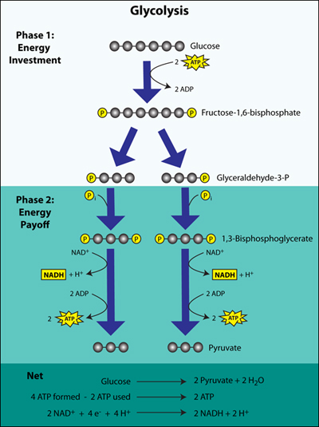
a. In glycolyis, 6 carbon sugar breaks down to 3 carbon __________ .

b. In glycolysis, net of ___ ATP are gained.

c. How does aerobic respiration differ from anaerobic respiration?

d. In the absence of oxygen, does glycolysis still occur? __________

e. What is the main purpose of glycolysis?

Aerobic Respiration Anaerobic Respiration (= fermentation)
Label the steps in the diagram of aerobic respiration below. Then answer the questions regarding this metabolic process. Draw in the missing arrows to show each chemical reaction.
1. Why do muscles get tired after lifting weights?
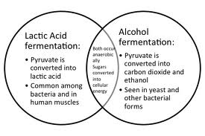
2. How is wine made?

3. How is Vinegar made?

4. What is the main purpose of the following?
a) Krebs Cycle

b) Electron Transport System

5.) What role does the mitochondrion play in the cell respiration?

6) Define the following
a) NADH:
Used for:

b) FADH2:
Used for:

Website for Kreb Cycle animation: http://www.science.smith.edu/departments/Biology/Bio231/krebs.html

