Biology from Hawaii Name
2014
The Carbon Cycle
Introduction
1
H
Hydrogen
1.00794
6
C
Carbon
12.011
7
N
Nitrogen
14.0067
8
O
Oxygen
15.9994
The animals of Manana Island obtain their food by eating plants or each other. By following lines on a food web, scientists can predict how changes in one species will affect others species. But food actually carries 2 necessary ingredients for living things: energy and raw materials.
Energy is power that makes cell parts move. It gets used up and then you need more. Living things respire carbohydrates and fats for energy, change them to waste (CO₂ and water), then dispose of the waste. A food web traces the path of energy in an ecosystem.
Raw materials construct the physical structures of cells. Organisms need raw materials to add more cells (growth) or replace old cells (maintenance). Carbohydrates, fats, protein, and nucleic acids are the classes of molecules used for raw materials. These molecules, in turn, are constructed from the elements carbon, nitrogen, oxygen, hydrogen, and phosphorous. A biogeochemical cycle traces the path of raw materials in an ecosystem; there is one cycle for each element.
The plants of Manana Island don't eat, yet are absolutely alive. They obtain their energy and raw materials from 2 different sources. Energy comes from the sun, they use photosynthesis to store this energy in carbohydrates. Raw materials come from small molecules in the non-living parts of an environment (water, for example). Plants are producers because they use non-living things to construct carbohydrates, fats, protein, and nucleic acids that other organisms desperately need.

Procedure
1. Complete a food web of Manana Island by drawing arrows on the provided diagram. Please draw food web arrows using RED.
2. Complete a carbon cycle of Manana Island by drawing arrows that trace the path of carbon. Please draw carbon cycle arrows using BLACK.
3. Label all the arrows that represent photosynthesis and cellular respiration.

Grading | points worth | points earned
Results  energy transfer drawn in RED, carbon transfer drawn in BLACK  arrows are neat and distinguishable  photosynthesis and cellular respiration clearly labeled | 4
Discussion  creative answers use ingenuity and outside research  human-burned materials and their sources added to the diagram | 6
Total | 10

Results
Earth's atmosphere the sun

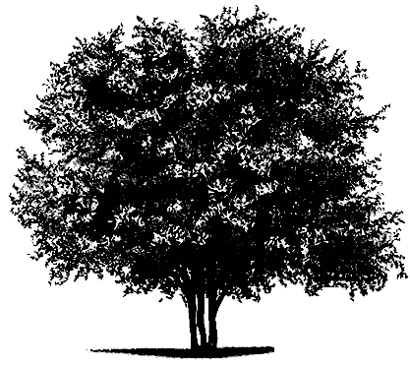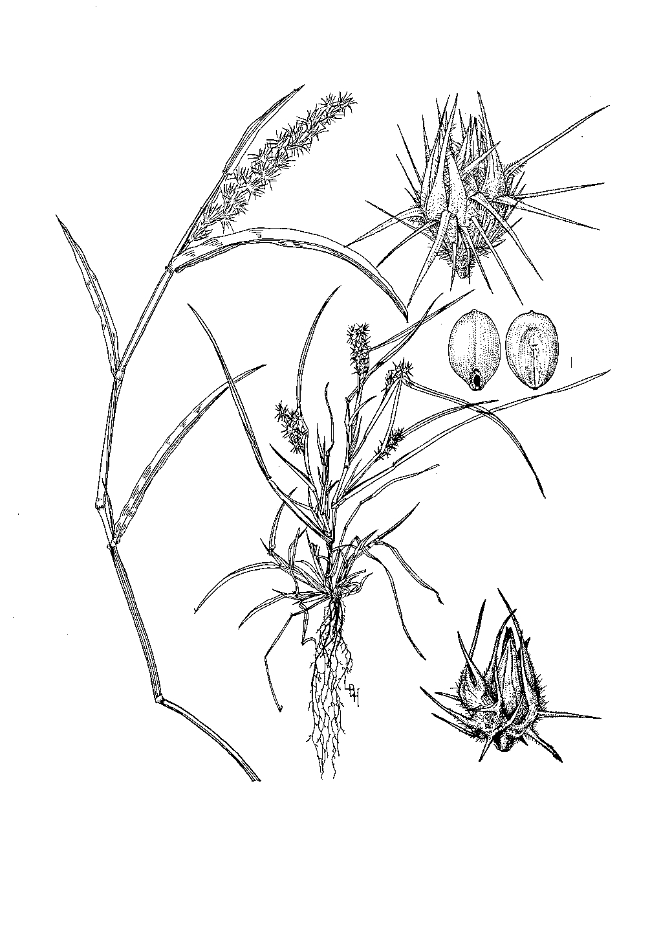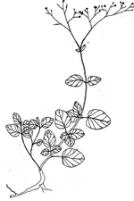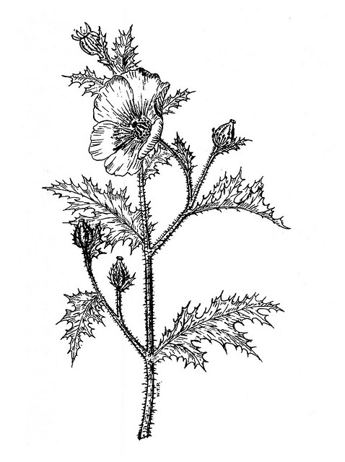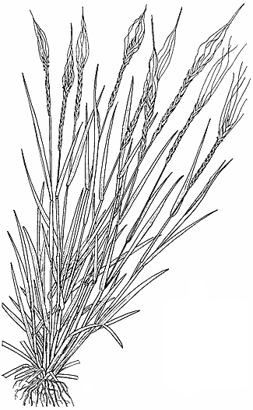
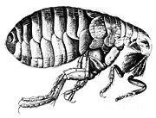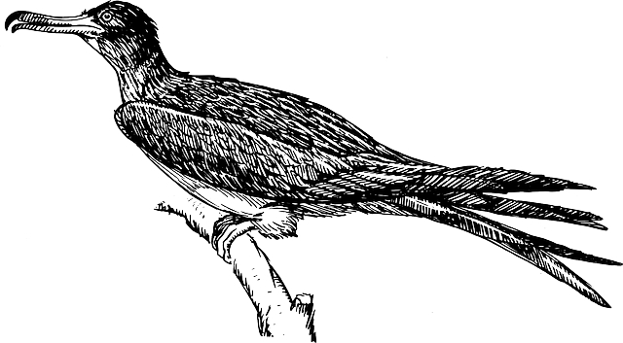

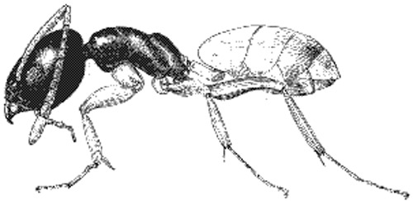

2° consumers
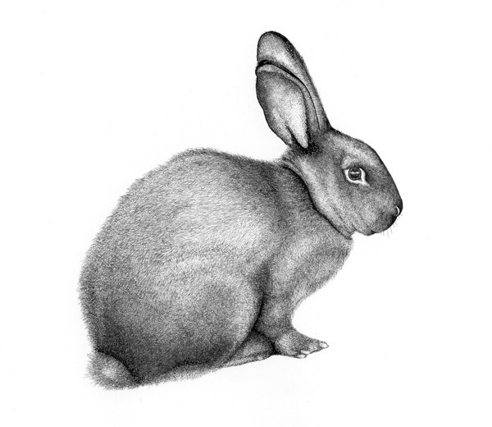

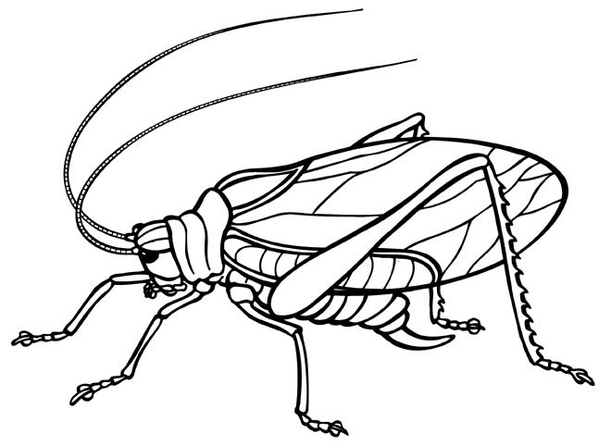

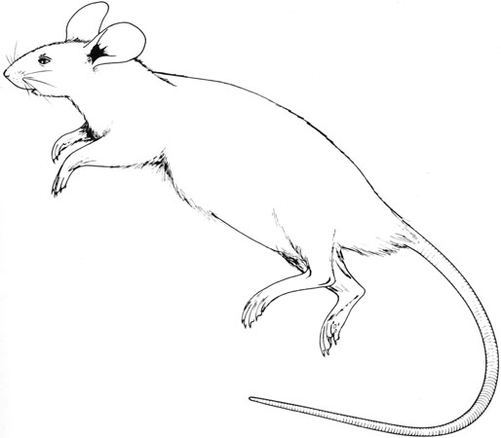

decomposers 1° consumers producers

Discussion
1. Why is it important that carbon travels in a loop?

2. Burning anything releases CO₂ into the atmosphere. Brainstorm a few things that humans burn for electricity, then add them to your carbon cycle diagram above.

3. Where do humans obtain the materials we burn for electricity? Add the source of human-burned materials to your carbon cycle diagram above.

4. By now, how much CO₂ have humans added to the atmosphere?

5. Describe the importance of plants in the carbon cycle.

