Chemistry
A. Review of Definition
      - Matter
- Atom: Smallest particle that cannot be broken down by ordinary means. All matters (living and nonliving) are made up of atoms.
- Element: Made up of one kind of atom.
Example: Hydrogen is made up of hydrogen atoms.
- Molecule: Made up of one or more atoms combined.
Example: water (H₂O) is made up of 2 hydrogen atoms and 1 oxygen atom

B. Periodic Table of Elements
- Periodic Table Trends - Highlight the metalloids B, Si, Ge, As, Se, Sb, Te, At
- Metal - Any element left of the ladder
- Nonmetal - Any element right of the ladder.

C. Chemical composition of the Human Body
Oxygen 64%
Carbon 18%
Hydrogen 10%
Nitrogen 3%
Phosphorus 1%
Sulfur 0.75%
How about the air we breathe? What is the most abundant gas in the atmosphere?

D. Atomic numbers and Masses
An atom is made up of
-proton(+), electron (-), neutron (0)
Atomic Number = Number of Proton
Atomic Mass = # of Proton + # of Neutron

E. Isotope - same element with different number of neutrons example: Hydrogen and Deuterium

F. Rutherford and Bohr Model of atoms

G. Type of Bonding
i. Ionic Bonding (Ionic Compound)
Transfer of electrons
Metal (+) + Nonmetal (-)
Example: NaCl, CaCl₂, LiBr
- metal always written first.
- To name ionic compounds, name the metal then add – ide to non-metal.
(
ii. Covalent Bonding (molecule)
Sharing of electrons
Nonmetal + Nonmetal
Polarity due to electronegativity
Example: CO, CO₂, H₂O
Use Prefixes and add -ide
One – Mono, Two – Di, Three – Tri, Four - Tetra

H. Properties of Water
Hydrogen Bonding (Polarity of water)
1. High Heat of Vaporization
2. Adhesion
3. Cohesion
4. High Heat Capacity
5. Capillary Action

I. Mixture
- homogeneous vs. heterogenous (penny lab)
- solution: unsaturated, saturated, and super-saturated (lollipop lab)

J. Activation Energy
K. Enzyme - protein that acts as a catalyst by reducing activation energy.

Catalyst- A substance that increases the rate of a chemical reaction without itself undergoing any permanent chemical change.

L. Factors that affect Reaction Rate
Temperature, pH, concentration, surface area

Biochemistry
Define organic compounds
Monomer – simple carbon compounds &
Polymer – monomers bonded together

Macromolecules
- Carbohydrates
  - Monosaccharides – Benedict Solution Test (blue to brownish red ppt)
- Example: blood sugar (glucose) fructose, galactose, maltose C₆H₁₂O₆
Insulin: a protein (hormone) that stimulates the cells to take up glucose.
Type I diabetes: immune system attack pancreas that makes insulin (fatal)
Type II diabetes: pancreas cannot keep up with the demands for insulin
sugar is not readily taken up by the cells so you are tired.
  - Disaccharide
- Example: table sugar (glucose and fructose), lactose in milk (glucose and galactose)
- Bond formed by condensation reaction(or dehydration synthesis) = loss of water
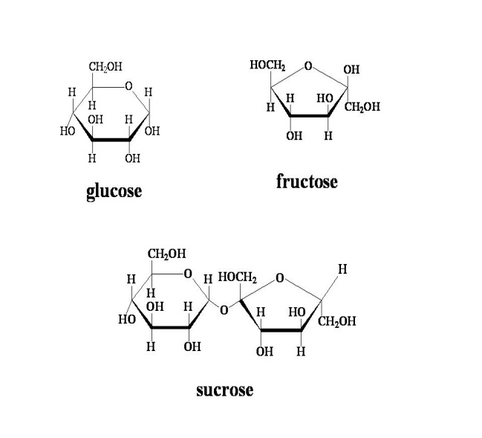
  - Polysaccharides
Break down of complex molecule is done by hydrolysis reaction ( addition of water)
- Example:
a. Glycogen (chain of glucose used for quick release of energy) – carb load night before a long race or competition
b starch and cellulose (plant store carbs this way) Starch is in form of a lot like glycogen but branched and cellulose is what makes up wood.
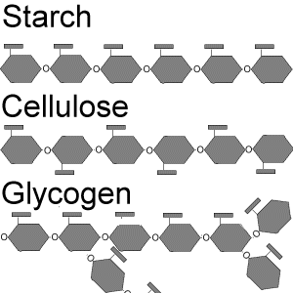

- Proteins – Biuret solution
  - Dipeptides and polypeptides (=protein)
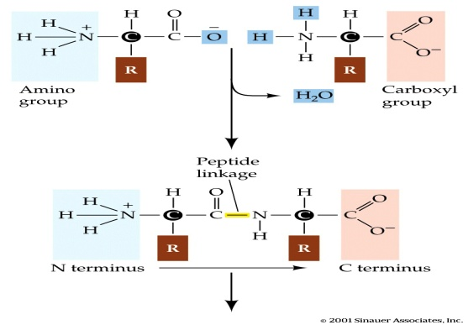
  - function is determined by shape of protein
    - storage, structure, signal, contractile, defensive, enzyme, transport, transcription regulatory.
    - enzymes speed up chemical reactions by lowering activation energy
- lock in key model (substrate bind to the enzyme and breaks down by hydrolysis)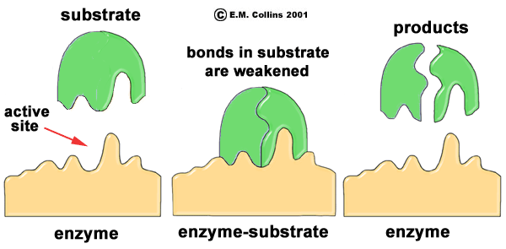
- induced fit model
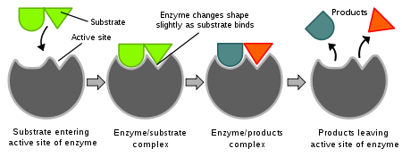
- Lipids (fats and oil) – Sudan IV solution
  - Fatty acid and glycerol are building blocks of lipids (do not dissolve in water)
- long term energy storage (larger number of C & H bonds than carbs)
  - Triglycerides: 3 fatty acids and 1 glycerol (vegetable oil and animal fat)
  - Phospholipid: 2 fatty acids and 1 glycerol (cell membrane)
  - Steroid: not fatty acid but four fused carbon rings
- Example: cholesterol
  - Wax : 1 long fatty acid chaing + alcohol
  - Saturated vs. Unsaturated fats
-saturated solid (animal) and unsaturated liquid (plant)
- single bonds (bad) vs. double bonds (good)

D. Nucleic Acid – methylene blue
a. DNA – Deoxyribonucleic Acid (genetic information)
b. RNA – Ribonucleic Acid (carries out gene info to cell)
nucleotides (nitrogenous base, sugar, phosphate) are basic unit that make up DNA
A, T, G, C and discovered by Watson & Crick

