Chapter 25
The History Of Life On Earth
Must know:
- A scientific hypothesis about the origin of life on Earth
- The age of Earth and when prokaryotic and eukaryotic life emerged
- Characteristics of the early planet and it's atmosphere.
- How Miller and Urey tested the Oparin-Haldane hypothesis and what they learned.
- Methods used to date fossils and rocks and how fossil evidence contributes to our understanding of changes in life on Earth.
- Evidence for endosymbiosis.
- How continental drift can explain the current distribution of species (biogeography).
- How extinction events open habitats that may result in adaptive radiation.

Overview
Over 500 million years ago, the oceans around Antarctica was warm and had forests with large invertebrates. Similar stories are found all over the world about past organisms.

These changes revealed by fossils shows macroevolution, the broad pattern of evolution above species level.

25.1 Conditions on early earth made the origin of life possible
Scientific hypothesis about the origin of life- chemical and physical processes on early Earth,
aided by the emerging force of natural selection, could have produced very simple cells
through 4 main stages.

The four main stages:
- Abiotic (nonliving) synthesis of small organic molecules, such as amino acids and nitrogenous basis.
- The joining of these small molecules into macromolecules, such as proteins and nucleic acids.
- The packaging of these molecules into protocells, membrane- enclosed droplets, whose internal chemistry differed from that of the external environment.
- The origin of self-replacing molecules that made inheritance possible

* Earth was formed 4.6 billion years ago, and life on Earth emerged about 3.8 billion years ago. For the first three-quarters of Earth’s history, all of its living organisms were microscopic.
* Hypothetical early conditions of Earth have been simulated in laboratories, and organic molecules have been produced.
- Oparin and Haldane hypothesis of the early atmosphere:
thick with water vapor, nitrogen, carbon dioxide, methane, ammonia, hydrogen, and
hydrogen sulfide + energy from lightning and UV radiation = organic compounds, a
primitive “soup” from which life arose.
- Miller and Urey tested this hypothesis and produced a variety of amino acids.
- Miller-Urey-Type experiments: abiotic synthesis of organic molecules is possible under various assumptions about the composition of the early atmosphere.
- Miller conducted an experiment simulating volcanic disruption and also conducted an experiment with Urey using an apparatus.
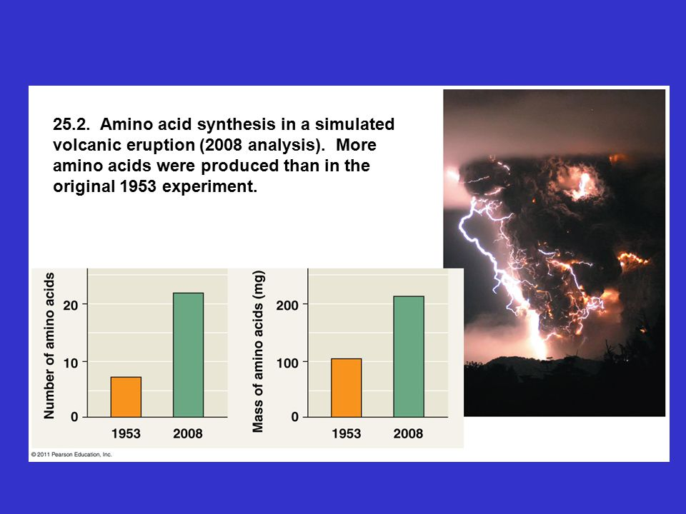
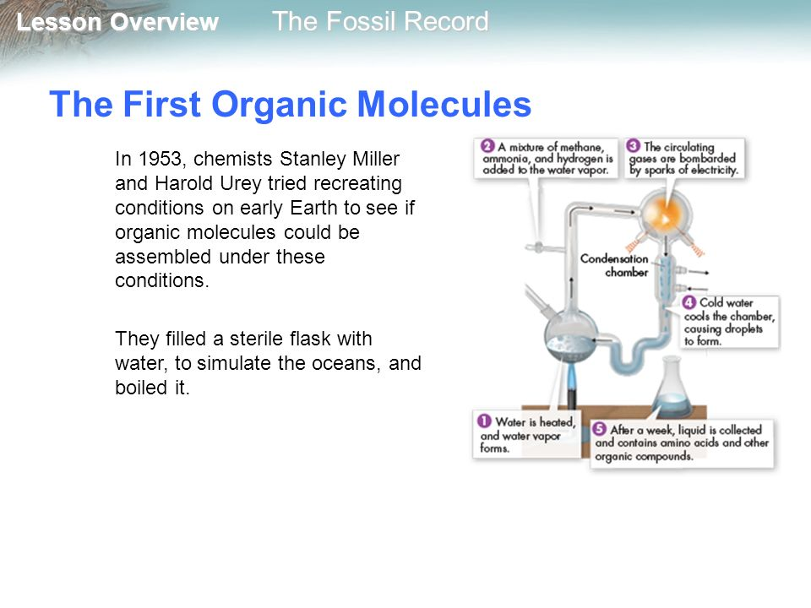

* It is hypothesized that self-replicating RNA (not DNA) was the first genetic material. RNA, which plays a central role in protein synthesis, can also carry out number of enzyme- like catalytic functions. These RNA catalysts are called ribozymes.

25.2 (Leah)
- The fossil record
  - Based primarily on sequence in which fossils have accumulated in sedimentary rock layers called strata.
  - Shows that there have been great changes such as the rise and fall in different groups of organisms on Earth at different points in time.
  - Strata does not give the actual, absolute age of the fossils.
- Radiometric dating
  - Based on the decay of radioactive isotopes
  - (Refer to graph) In this process, a radioactive “parent” isotope decays to a “daughter” isotope at a fixed rate. The rate of decay is expressed by half-life which is the time required for 50% of the parent isotope to decay.
- An indirect method used to date sedimentary rocks is to date layers above and below.
- Mammals belong to the group of animals called tetrapods.The evolution of unique mammalian features can be traced through gradual changes over time. Tetrapods include, reptiles, birds, amphibians, mammals and other now extinct groups (dinosaurs).

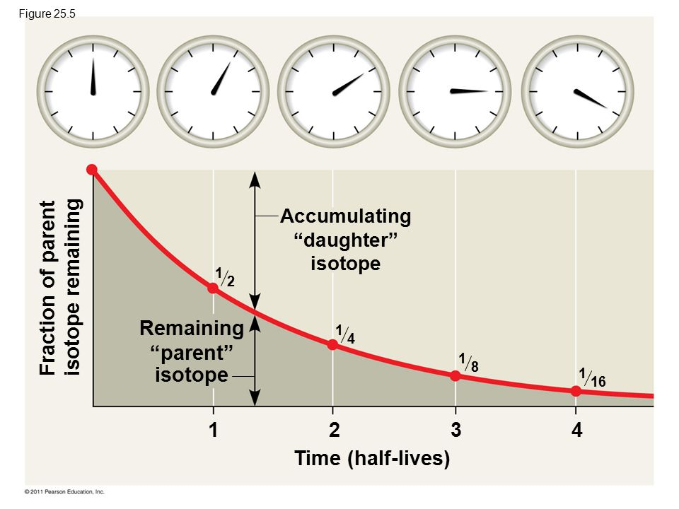
25.3
Key events in life’s history include the origins of single-celled and multicelled organisms and the colonization of land
- The study of fossils have helped geologists to establish geologic record of earth’s history
  - Earliest direct evidence was 3.5 billion years ago. The evidence came from fossilized stromatolites
    - Stromatolites are layered rocks that form when certain prokaryotes bind thin films of sediment together.
- Cyanobacteria was the cause of the early rise in oxygen.
- The evolution of eukaryotic cells containing chloroplasts may have increased oxygen levels. This is also known as the “Oxygen Revolution”.

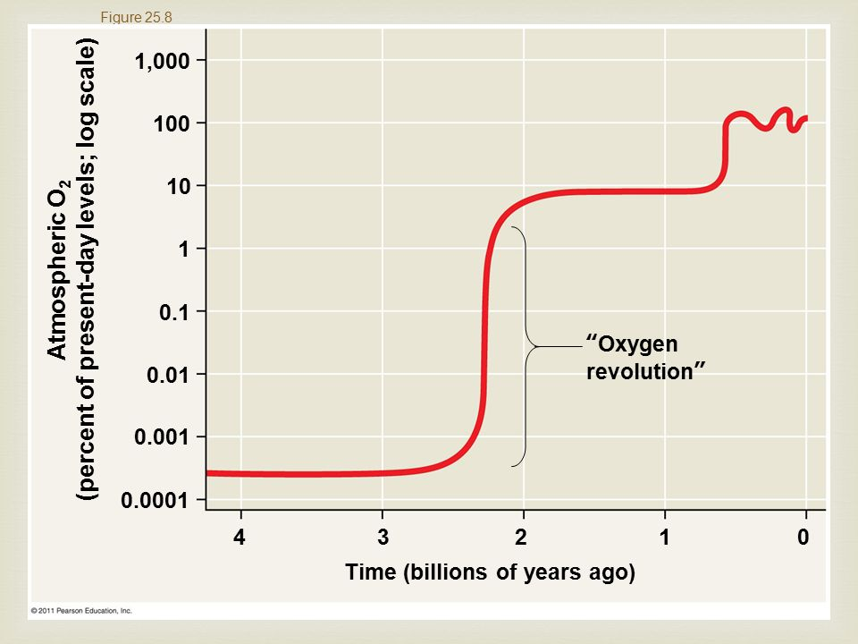

25.4 (Shaina)
The rise and fall of groups of organisms reflect differences in speciation and extinction rates.

Plate tectonics: The theory that the continents are part of great plates of Earth’s crust that float on the hot, underlying portion of the mantle. Movements in the mantle cause the continents to move slowly over time.
Pangea: The supercontinent that formed near the end of the Paleozoic era, when plate movements brought all the landmasses of Earth together.
Mass extinction: The elimination of a large number of species throughout Earth, the result of the global environmental changes.
Adaptive radiation: Period of revolutionary change in which groups of organisms from many new species whose adaptations allow them to fill different ecological roles in their communities.

Plate tectonics
- Movements in the mantle cause the plates to move over time in a process called continental drift.
- Plates can move away from each other, slide past each other, and collide.
  - Ex:
    - North American and Eurasian plates are drifting apart about 2 cm per year.
    - San Andreas Fault is part of a border where two plates slide past each other.
    - 45 million years ago, the Indian plate and the Eurasian plate collided, creating the Himalayan Mountains.
Consequences of Continental Drift
- Continental drift alters the habitats in which organisms live.
  - The creation of Pangea had a tremendous impact on the physical environment and climate, which drove some species to extinction and provided new opportunities for groups of organisms that survived.
- When a continent shifts its location, climate changes.
  - Organisms can adapt, move to a new location, or become extinct when climate change occurs.
- Continental drift promotes allopatric speciation, where lineages of plants and animals diverged from those on other continents.
- Continental drift can explain the geographic distribution of extinct organisms and the current distributions of organisms.
Mass Extinctions
The “Big Five” Mass Extinction Events
- The Permian Mass Extinction
  - Defines the boundary between Paleozoic and Mesozoic eras;
  - Claimed about 96% of marine animal species and drastically altered life in the ocean
  - Wiped out 8 out of 27 orders of insects
  - 1.6 million${km}^{2}$was covered with a layer of lava hundreds to thousands of meters deep.
  - Ocean anoxia, which is a
Is a Sixth Mass Extinction Under Way?
Consequences of Mass Extinction
Adaptive Radiations
Worldwide Adaptive Radiations
Regional Adaptive Radiations

25.5 Major changes in body form can result from changes in the sequences and regulation of development genes.
Effects of Developmental Genes
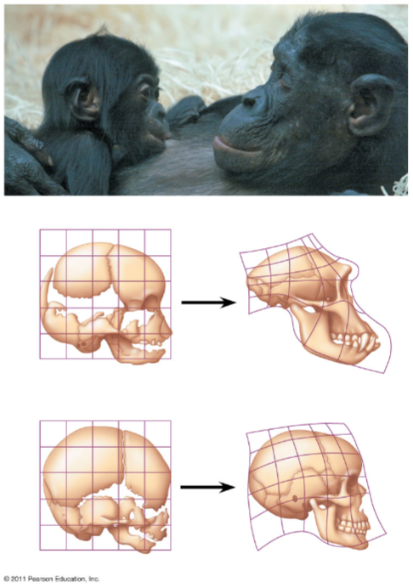
- Changes in Rate and Timing
Heterochrony (from the Greek hetero, different, and chronos, time)
- It is an evolutionary change in the rate or timing of developmental events.
- Examples:
  - An organism’s shape depends in part on the relative growth rates of different body parts during development
  - Different growth rates makes the difference between human and chimpanzee skulls
  - Finger bones yielded the skeletal structure of wings in bats
  - Slowed growth of leg and pelvic bones led to the reduction and eventual loss of hind limbs in whales
- Paedomorphosis (paedos= of a child; morphosis= formation): the sexually mature stage of a species may retain body features that were juvenile structures in an ancestral species.
  - The sexually mature species may retain body features that were juvenile structures in an ancestral species

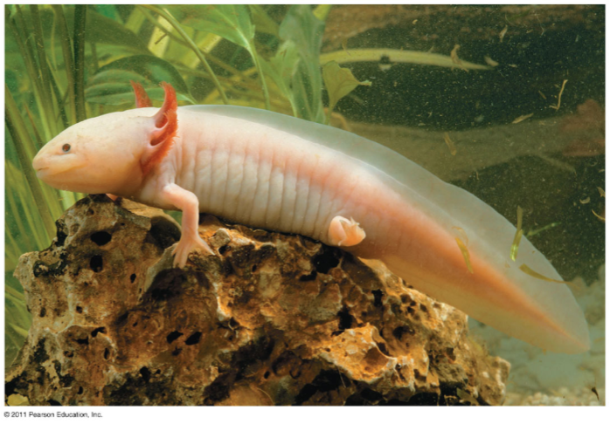
Example:
Most salamander species have aquatic larvae that undergo metamorphosis in becoming adults. But some species grow to adult size and become sexually mature while retaining gills and other larval features.

- Changes in Spatial Pattern
- Substantial evolutionary changes can also result from alterations in genes that control the placement and spatial organization of body parts.
- Example:
  - Homeotic genes: determine such basic features as where a pair of wings and a pair of legs will develop on a bird or how a plant’s flower are arranged.
    - Hox genes are a class of homeotic genes that provide positional information during development
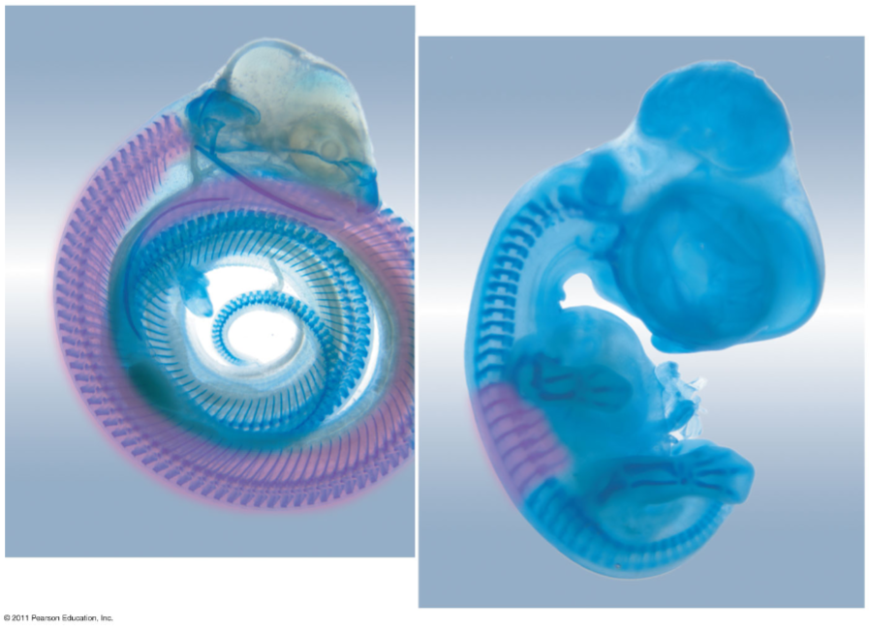
    - IF Hox genes are expressed in the wrong location, body parts can produced in the wrong location

- The Evolution of Development
- The tremendous increase in diversity during the Cambrian explosion is a puzzle
- Developmental genes may play an especially important role
- Changes in developmental genes can result in new morphological forms
- Changes in Genes
- New morphological forms likely come from gene duplication events that produce new developmental genes
- Example: Origin of the insect body plan
  - Ubx gene in insects suppresses leg, but not crustaceans. This gene is expressed in an insect’s abdomen but in the main trunk of body in crustaceans.
  - Genetically engineers fly embryos injected with the Ubx gene from insects or Crustaceans. (Transition from a crustacean Ubx gene to an insect Ubx gene.
- Changes in Gene Regulation
- A change in the nucleotide sequence or regulation of developmental genes can result in morphological changes that harm the organism.
- Regulation changes can be limited to a single cell type.
- Example:
  - Threespine stickleback fish in lakes have fewer spines than their marine relatives. The gene sequence remains the same, but the regulation of gene expression is different in the two group of fish

25.6
Evolution is not goal oriented
Evolutionary Novelties:
Francois Jacob’s - view of evolution harkens back to Darwin’s concept of descent with modification.
- As new species form, novel and complex structure can arise as gradual modifications of ancestral structures. In some cases complex structures have evolved in increments from simpler versions that performed the same basic function.
- Evolutionary novelties can also arise when structures that originally played one role gradually acquire a different one.
Exaptations- structures that evolved in one context but become co-opted for another function.
- Note that the concept of exaptation does not imply that a structure somehow evolves in anticipation of future use.

