Biology from Hawaii Name
2014
Explaining ‘Amakihi Evolution
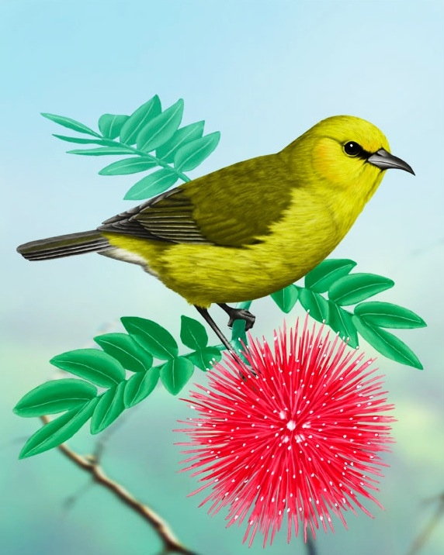Introduction
‘Amakihi are little yellow and green forest birds that recently evolved a genetic way to survive when they catch avian malaria. This species is endemic to the Hawaiian Islands.

In the past, avian malaria killed many ‘amakihi in the lowland forests. Birds catch avian malaria when an infected mosquito bites them. ‘Amakihi were still abundant in the high elevation forests where temperatures are too cold for mosquitoes. Today, there are still populations of ‘amakihi in high elevation forests, and most of those birds cannot survive avian malaria.

Today, populations of ‘amakihi live in mosquito-infested lowland forests, too. These lowland populations are full of birds that can survive avian malaria, something new for this native Hawaiian species.

Procedure
By now, your lab group should have an accurate simulation of a reproducing ‘amakihi population. During the next few classes, modify your simulation to show how natural selection, migration, and genetic drift can cause a population to change.

Part 1: Natural selection
start with your basic simulation
A allele (autosomal dominant) allows birds to survive avian malaria
★ new rule: each generation, avian malaria kills 50% of aa birds before reproducing
produce 20 chicks each generation

Part 2: Migration
start with your basic simulation
★ new rule: each generation, 10 aa birds join your population just before reproducing
produce 20 chicks each generation

Part 3: Genetic drift
start with your basic simulation
Grading | points worth | points earned
Results  record all genotypes  calculate frequency of A allele for each generation  graph frequency of A allele | 12
Analysis  compare simulation to reality | 8
Total | 20

★ new rule: populations only contain 5 birds and produce 5 chicks each generation
pay close attention to random changes
small population P₁:
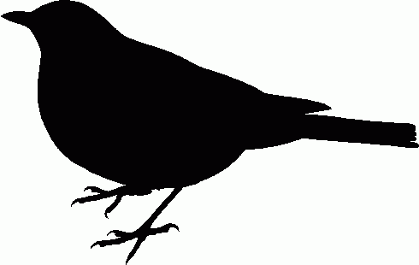
Aa aa aa

aa aa

Results
Record each bird's genotype for every generation; create the appropriate data tables.
Calculate the frequency of the A allele for every generation.
Graph the frequency of the A allele over 5 generations. Produce a different line for each simulation: basic simulation, natural selection, migration, genetic drift. Make a key.

Analysis
1. The high elevation forests of Hawai‘i are mosquito free. Which version of your game (basic simulation, natural selection, migration, genetic drift) simulates reproduction in a mosquito-free habitat? What effect would a mosquito-free habitat have on the frequency of the A allele?

2. The lowland forests of Hawai‘i are infested with mosquitoes that transmit avian malaria. Which version of your game (basic simulation, natural selection, migration, genetic drift) simulates reproduction in a malaria-infested habitat? What effect would a malaria-infested habitat have on the popularity of the A allele?

3. The high elevation forests of Hawai‘i are full of aa ‘amakihi that sometimes migrate down to the lowlands. What effect would this migration have on the frequency of the A allele in lowland ‘amakihi populations?

4. Most species of native Hawaiian birds did not evolve the ability to survive avian malaria. Many lowland species were already very rare when malaria hit, their populations kept small by invasive predators and habitat destruction. How could small populations lead to extinction of the A allele?

5. What actions should humans take for the benefit of native Hawaiian birds? Suggest your own solution to this biological tragedy.

