Biology from Hawaii Name
2014
Allele Frequency
Introduction
If you want to describe the alleles of a large population, it would be unfeasible to list everyone's genotype. It's much easier to use percentages: of all the alleles in a population, what percent are the allele you're studying? This percentage is called the allele frequency.
Here's an example: how common is the brown eye allele (B) among Palestinians? There are 10,500,000 Palestinian people worldwide; listing each one's genotype would fill a 7,500 page book. In that book, you would write 16,567,000 B alleles
and 4,433,000 b alleles
for a total of 21,000,000 alleles (2 alleles per person)
= 0.789 or 78.9%
To calculate the allele frequency, take the number of B alleles 16,567,000
divided by the total number of alleles 21,000,000
Procedure
1. There are 7,000,000 Mayan people; in total they carry: 13,006,000 B alleles
994,000 b alleles
What is the frequency of the B allele in this population?

2. Calculate the frequency of A allele in the 2 populations of birds below. Show your work.
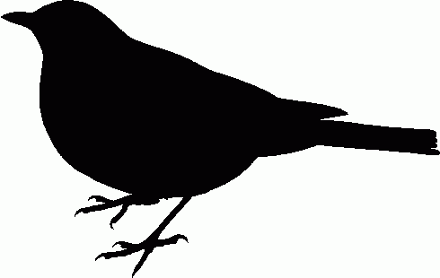
AA Aa Aa
Aa aa
AA Aa

aa aa aa AA Aa

aa aa
aa AA

aa aa aa

a. Frequency of A allele = b. Frequency of A allele =

Biology from Hawaii Name
2014
Improved ‘Amakihi Breeding Simulation

Introduction
In science, an important first step is to have a good idea—a hypothesis. The next step is conduct an experiment to see if the hypothesis could be true. You already did these two things: you hypothesized a way to simulate random mating, then tested your hypothesis by collecting data. By playing another group's simulation, you saw how different scientists hypothesize answers to the same problem. Perhaps you even drew some conclusion about how accurately you simulated random mating.
Now it's time to modify your simulation. Good scientists use what they learn from an experiment to make their hypotheses more accurate. But any new, more accurate hypothesis must also be tested by experiment!

Procedure
1. Alter the rules of your simulation to improve at least one of the following: • randomness
• speed
Write your improved rules here. • fun

Grading | points worth | points earned
Allele Frequency  correctly answer questions | 2
Procedure  improvements provide more accurate results | 2
Results  data logically organized in a table, allele frequencies calculated every generation | 7
Total | 10

2. Practice your improved simulation for 5 generations
a. record the genotypes of all birds in every generation
b. calculate the frequency of A allele in every generation

Results
1. Record the genotypes of all birds in every generation. Create the appropriate data tables.
2. Calculate the frequency of A allele in every generation. Write the A allele frequency on your data tables.

