Name __________________ Period: ____ Date: ______________ Group: ___
Activity 8-6: Point of Origin
Directions: Complete the steps listed in you textbook for the activity, and complete the exercises below.
Problem 1:
Make the calculations for each of the following problems and label the right triangle for each blood-spatter drop. Include angle of impact, distance to area of convergence (d), and height (h) above the ground. Refer to Blood-spatter Sketch 1. From these drops of blood, determine the point of origin of the blood. To determine the point of origin, you will need to:
1. Determine the direction in which the blood was traveling.
2. Draw lines of convergence.
3. Draw a small circle around the intersection of the lines of convergence to indicate the area of convergence.
4. Measure the distance in millimeters from the area of convergence to the front edge of the blood spatter using a metric ruler.
5. Using the scale of 1 mm = 0.2 feet, determine the actual distance.
6. Using blood droplet 1, determine the angle of impact:
a. Measure the width and the length of the blood droplet.
b. Divide the width/length ratio for the blood droplet.
c. Using a calculator and the inverse sine function, determine the angle of impact for that blood droplet.

7. Using the Law of Tangents, determine the point of origin or the height of the source of blood for droplet 1.

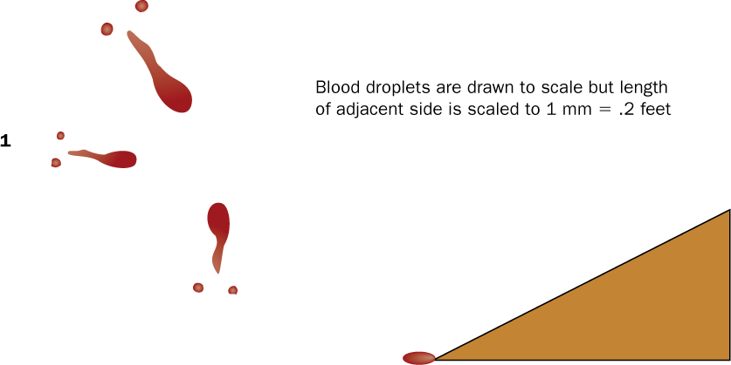

Show Calculation Here:

Problem 2:
A 30-year-old man was found shot in the head in his garage. The suspect claims he was being attacked by the victim and shot the victim in self-defense. Refer to the Blood-spatter Sketch 2. From these drops of blood, determine the point of origin of the blood. To determine the point of origin, you will need to:
1. Determine the direction in which the blood was traveling.
2. Draw lines of convergence.
3. Draw a small circle around the intersection of the lines of convergence to indicate the area of convergence.
4. Measure the distance in millimeters from the area of convergence to the front edge of the blood spatter using a metric ruler.
5. Use the scale of 1 mm = 0.3 feet to determine the actual distance.
6. Use blood droplet 2 to determine the angle of impact:
a. Measure the width and the length of the blood droplet.
b. Divide the width/length ratio for the blood droplet.
c. Using a calculator and the inverse sine function, determine the angle of impact for that blood droplet.
7. Use the Law of Tangents to determine the point of origin or the height of the source for blood droplet 2.

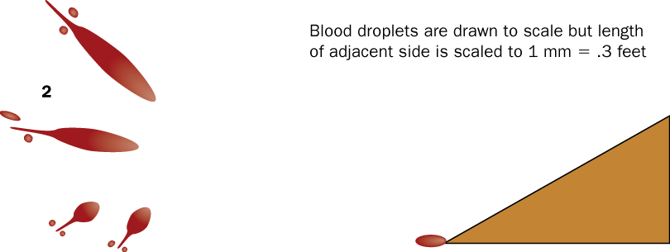

Did the suspect really shoot the victim in self-defense? Explain.
Problem 3:
A victim was found at the foot of a ladder with a chest wound. What is the approximate height of his wound when he was shot? Refer to the blood-spatter sketch below. From these drops of blood, determine the point of origin of the blood. To determine the point of origin, you will need to:
1. Determine the direction in which the blood was traveling.
2. Draw lines of convergence.
3. Draw a small circle around the intersection of the lines of convergence to indicate the area of convergence.
4. Measure the distance from the area of convergence to the front edge of the blood spatter using a millimeter ruler.
5. Use the scale of 1 mm = 1.5 feet to determine the actual distance.
6. Use blood droplet 3 to determine the angle of impact:
a. Measure the width and the length of the blood droplet.
b. Divide the width/length ratio for the blood droplet.
c. Using a calculator and the inverse sine function, determine the angle of impact for that blood droplet.
7. Use the Law of Tangents to determine the point of origin or the height of the source of blood for droplet 3.

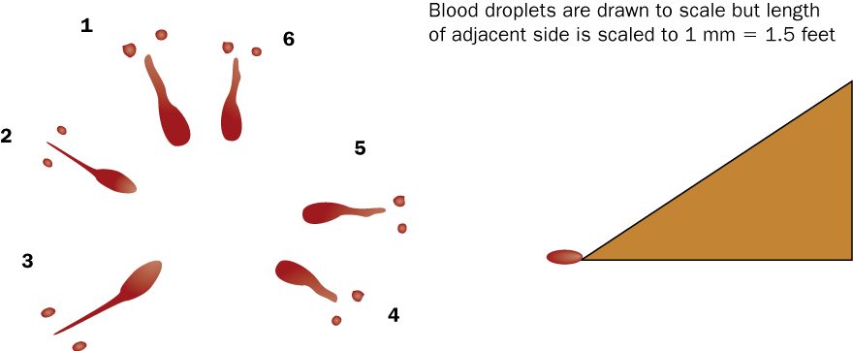

What is the approximate height of his wound when he was shot? ______________________

Background info:
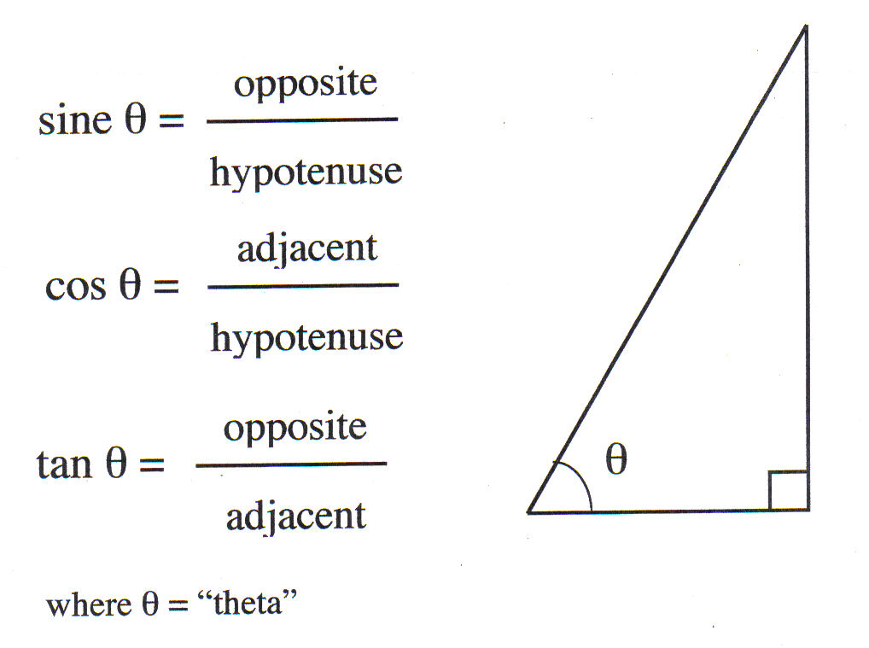
Trigonometric Equation

Determination of Point of Origin in Space

pt of origin in space

Z

Y
θ

Solve for the length of Z (D to B). hint: ∠θ (angle of impact) is known, and Y is given.

