Taxonomy Quiz #1
Name the 5 Kingdoms
1.
2.
3.
4.
5.
Give the Kingdom for the following group of organisms:
6. mushroom, lichen, mold
7. moss, fern, spruce
8. tapeworm, sponge, sea cucumber
9. Whose cells do NOT contain a nucleus: eukaryotes or prokaryotes?
10. What is the difference between an autograph and a heterotroph?
EC-
- What two groups of classification are used in the scientific name of an organism?

- In what language is the scientific name written?

Taxonomy Quiz #2
On the line provided below each drawing, write the name of the phylum to which the invertebrate belongs.

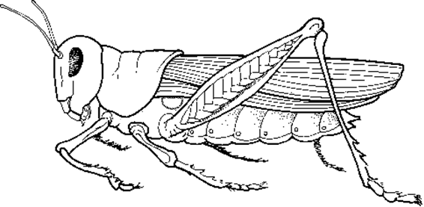
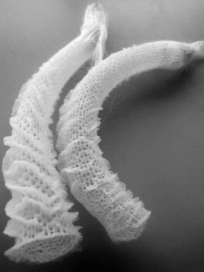 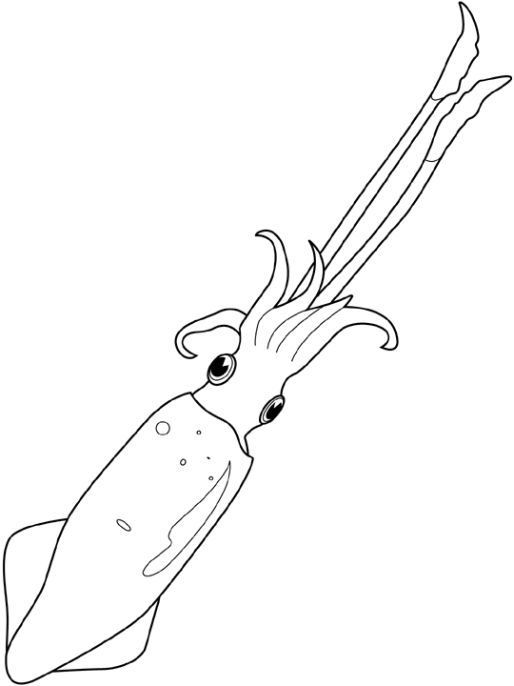
Grasshopper Venus’s flower basket Squid
- ______________ 2. _________________ 3._____________________
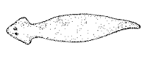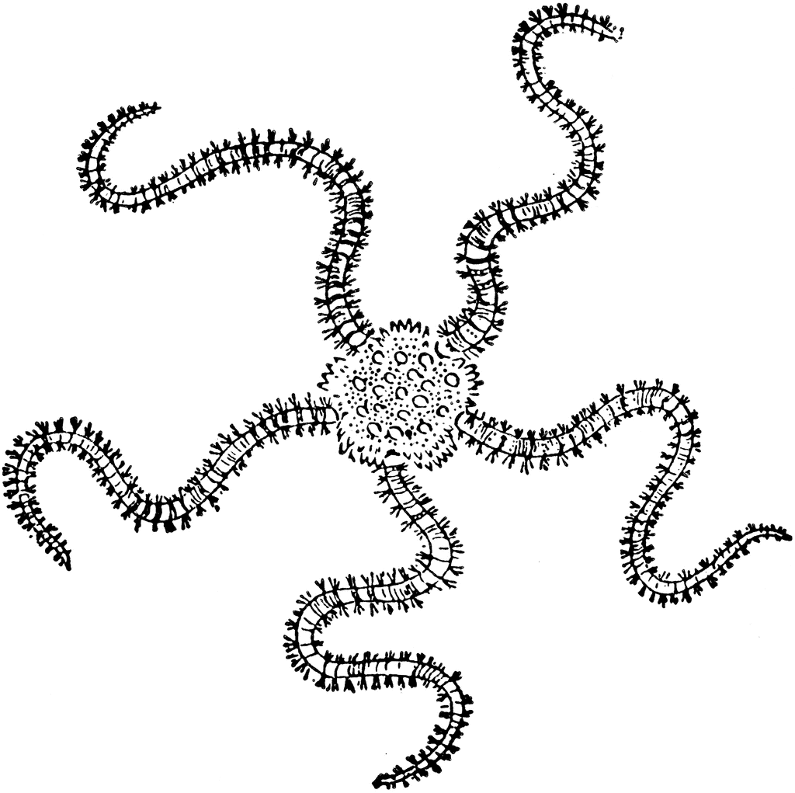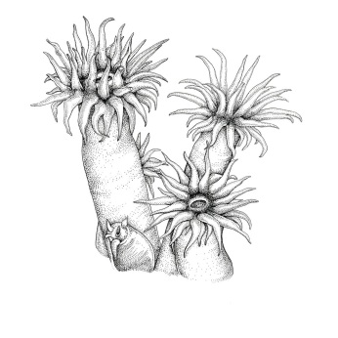
Planarian Brittle Star Sea Anemone
4.______________ 5._________________ 6.___________________

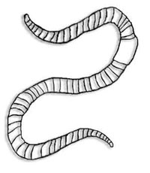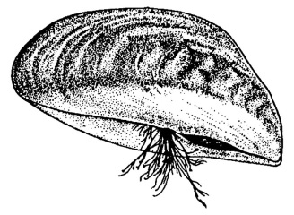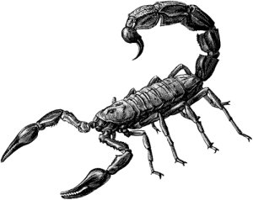
Earthworm Mussel Scorpion
7._______________ 8.__________________ 9._________________

Taxonomy Quiz #3
- Write the classification categories in the proper sequence moving from largest to the smallest group of organisms. (5pts)

- Write the phylum each of the following organisms belongs to (20pts)
  - Grasshopper
  - Squid
  - Planarian
  - Sea anemone
  - Earth worm
  - Mussel
  - Brittle star
  - Scorpion
  - Sponge
  - Human

- The following are characteristics of a certain animal phyla. Write the phyla that each of the following characteristics describes (5pts)
  - Full of holes, no tissue, organs or systems

  - Soft body – stony shell, muscular foot

  - Segmented, two opening for digestive tract

  - Nerve cord in back, backbones, internal skeleton, four appendages, advanced body system

  - Flat, mostly parasitic, many but not all body systems

