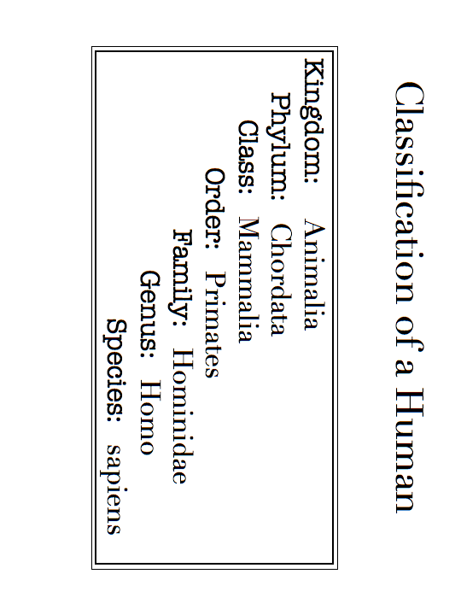
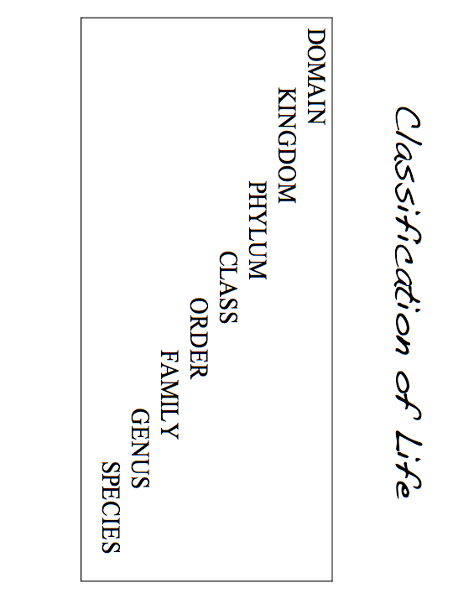
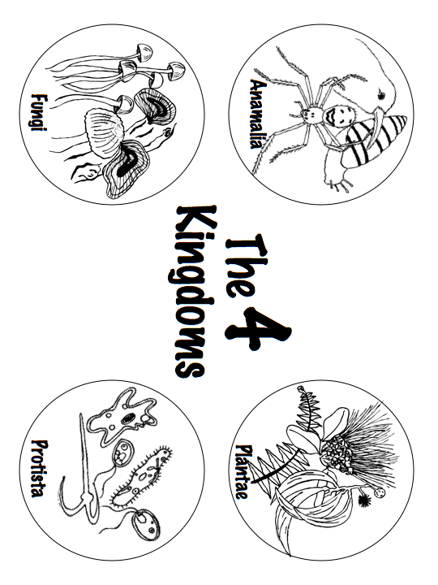
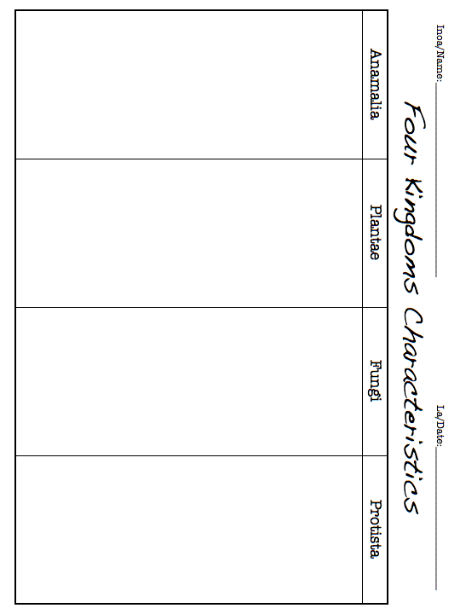
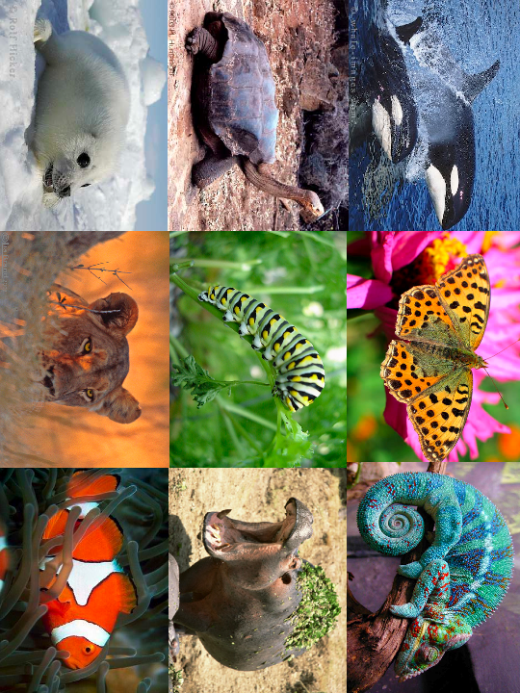
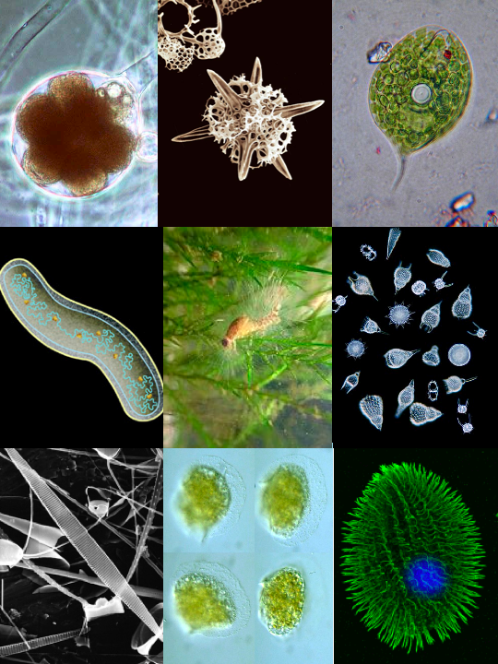
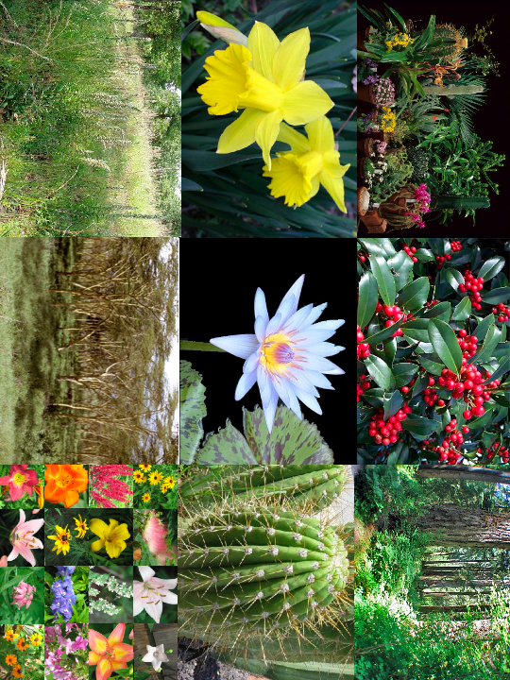
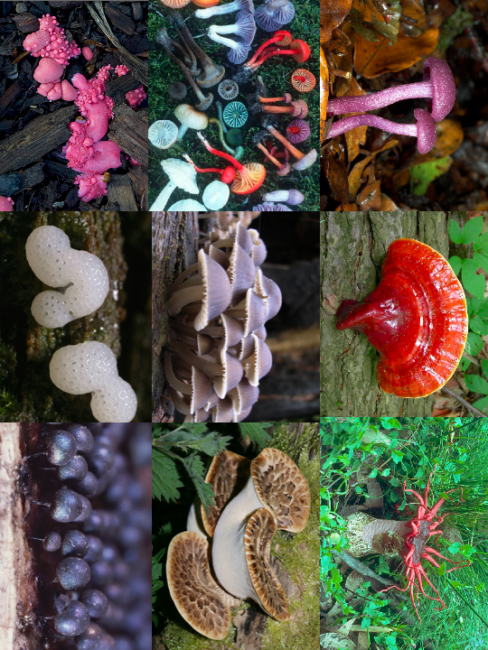
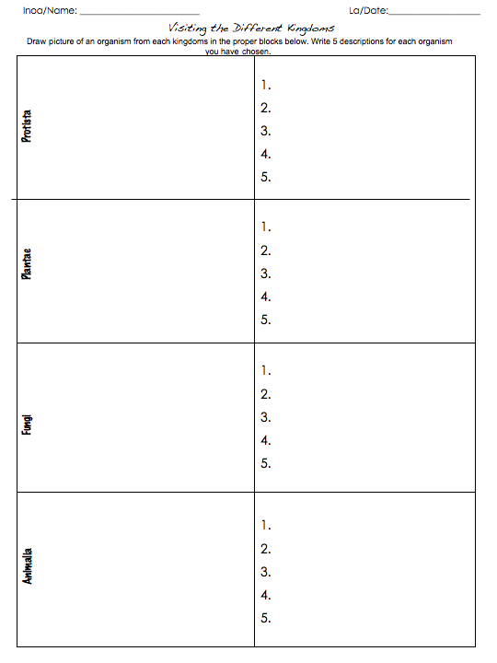
Taxonomy and Me! Test *
Name: __________________________ Date: ________________________ Period: _______
Work Bank can be used for questions 1- 4.
Word Bank: Two, Four, Characteristics, Genus, species
- How are the organisms separated into the different kingdoms? __________________
- How many names make up a scientific name? _______________________
- Scientific name is made up of _________ and _____________.
- How many Kingdoms are there in domain Eukarya? __________

- Choose any organism you can think of ____________ (for example: bear, lion, snake, fish, mushroom, or plant)
List three characteristics:

1.
2.
3.

*this packet is from Taxonomy and Me! Partnerships for Reform through Investigative Science and Mathematics

