PBS Evolution
Great Transformations

- If the world’s history were compressed into one hour, what kind of life appeared during…

  - The first 50 minutes?

  - The last 10 minutes?

  - The last 0.01 second?

- How long ago did mammals first appear on earth?

- What physical traits (adaptations) do all mammals have in common that relate to living on land?

Whales and Wolves

- What type of animal did the Creodont skull that Dr. Gingrich discovered resemble?

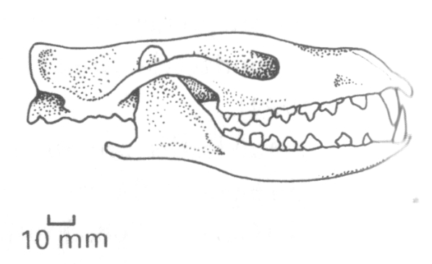

  - What was unusual about this skull?

  - This skull is believed to be a transitional form. Explain what this means.

- Whale Valley is an archeological site located in the Sahara Desert. How could there be whale skulls here?

- What vestigial structure did the Basilosaurus have that modern whales do not?

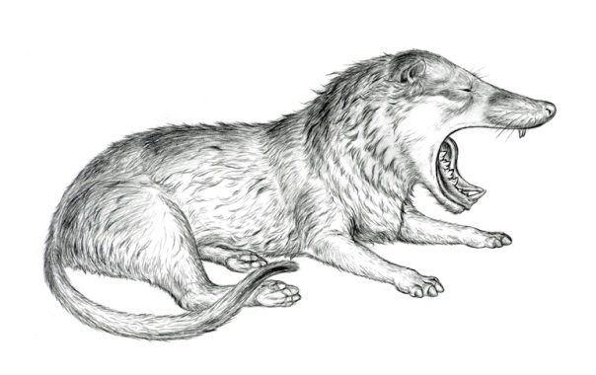
- Describe the theory of transformation from the Sinonyx, a wolf-like ancestor, to whale.

- A major pieces of evidence behind this hypothesis of transformation is the mechanism of movement.

  - Describe how fish swim:

  - Describe how otters swim:

  - Describe how whales swim:

  - Describe how land mammals run:

From Water to Land

- All land mammals are classified as tetrapods. What does this mean?

- Why did the paleontologists search for tetrapod fossils in Pennsylvania?

  - What unusual feature did they find at the end of the early tetrapods’ limbs?

  - What is this evidence of?

- How do the bones of the early tetrapod fish, such as Acanthostega, resemble ours?

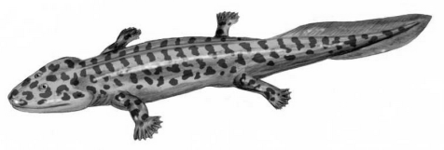

- The early ancestors of fish had many unique adaptations to aid their survival. Describe one:

- What advantage did the first limbs with digits provide?

- What is the “Cambrian Explosion”?

- What are trilobites?

  - Who are their descendants?

- What makes the fossils of the Burgess Shale so important in studying evolution?

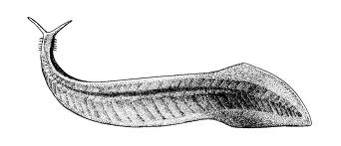
- One of the fossilized organisms discovered in the Burgess Shale, called pikaia, is believed to be one of the earliest ancestors of all vertebrate animals. Why?

Genes, DNA, and Evolution

- How do all embryos start out?

- A scientist, Dr. Bateman, was studying the similar segmentation patterns of animals. What mutations did he observe that related to these segmentation patterns?

- How do these segmentation patterns relate to DNA?

- How could mutations be purposely caused with fruit flies?

- What does the antennapedia gene control? What happens if it misfires?

- When the mouse “eyeless” gene was implanted into the fruit flies, what happened? What implications does this have for the study of evolution?

Bipedalism and Quadrupedalism

- Lemurs are considered a living analogue to ancient primates, because they move in multiple ways. Describe the three different types of movements shown.
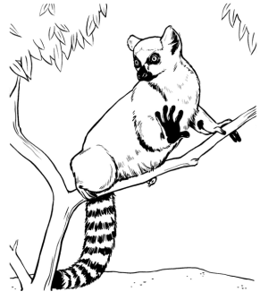

- What primate is the closest living relative to humans?

- There are two main pieces of evidence that establish this close relationship. List them.

- What type of movement do chimpanzees rely on that humans do not?

- Use this table to compare the skeletal differences between humans and chimpanzees.

 | Humans | Chimpanzees
Spinal column
Pelvis
Position of the knees

