PBS Evolution
Why Sex?

- What is unusual about the reproduction of the desert grassland whiptail lizard?

- What are three disadvantages of sexual reproduction, particularly the presence of males?

- Most species on earth use ( sexual / asexual ) reproduction.

Sexual vs. Asexual Reproduction

- What percent of the Poeciliid (minnow) population was affected with black spot disease?
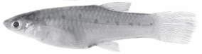

- Which minnows were affected by the disease more, the sexual or asexual reproducing group?

- Describe the “Red Queen” theory of evolution.

- How are the sexually-reproducing minnows like a “moving target” for the bacteria?

- Why did the sexually-reproducing fish suddenly become more susceptible to disease following the severe drought?

- What experiment did Robert Vrijenhoek conduct that reversed this trend?

Origin of Sexual Reproduction

- Describe the theory of how sexual reproduction began with single-celled organisms.

- Given the characteristics of sperm and eggs, why does evolution favor females that are selective or “choosy”?

Darwin’s Dilemma and Sexual Reproduction

- Explain why Darwin may have wrote “the sight of a peacock makes me sick.” How does its physical appearance seem to contradict natural selection?

- Why did it take so long for the idea of female-driven sexual selection to be accepted?

- What two characteristics of a male peacock do females look for in choosing a mate?

- What impact did intentionally pairing females with males with more elaborate tail feathers have on their offspring?

Monogamy and Gender Roles

- What is monogamy?

- Why is it an advantage for songbirds (and humans) to practice monogamy?

- Explain how the behavior of cheating might be an evolutionary advantage for songbirds.

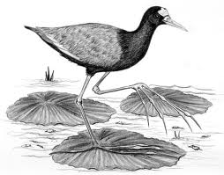
- Jacanas are tropical birds that lose a lot of offspring to crocodile predators. How has evolution changed their behavior to overcome this?

Chimpanzees and Bonobos

- Compare the behavior and social structure of chimpanzees and bonobos.

- How has infanticide influenced the reproductive behavior of chimpanzee females?

  - How has this affected the reproductive anatomy of chimpanzee males?

- How are bonobo females able to avoid being dominated by males?

- Explain the differences between the ecosystems of chimpanzees and bonobos that may be responsible for their differences in behavior. What single event led to this change?

Evolutionary Psychology

- Why does waste or garbage smell bad to humans, but not to dung beetles?

- If human attraction were based on smell alone, what kinds of mates to women choose?

- When given the choice, what types of characteristics do women prefer for a short-term relationship? A long-term relationship?

- How might sex and attraction be related to artistic expression?

- From the perspective of evolution, why is sex pleasurable and parenting rewarding?

- What single behavior do humans have that is unique in the animal world?

